Envision NEXT

USER MANUAL

Contents
3

Signing Up and Signing In 3
5

Navigation 5
13

Patient Registration & Appointment 13
Patient Dashboard: 16
Generating ID Card for Patient: 16
Creating an Appointment for the Patient: 17
21

Whiteboard 21
Whiteboard Features: 22
Search Features: 22
Column Features: 24
Reservation Worklist: 26
Preparation Worklist: 28
Vital Signs 35
Imaging: 36
49

Nursing 49
62

Device Management 62
78

Disinfection Worklist 78
78

BI 78
78

Administration 78

Document Version No- 1.1.2

Last update Datetime- 14/06/2022

Last update by-Wasiur Rahman

Applicable Software no-0.8.0

Signing Up and Signing In

Before you can login to Envision Next, you will need to gather your username and password from an administrator. An administrator will have to register you from within the system, and provide you with your proper credentials. The Sign In page looks like this:-

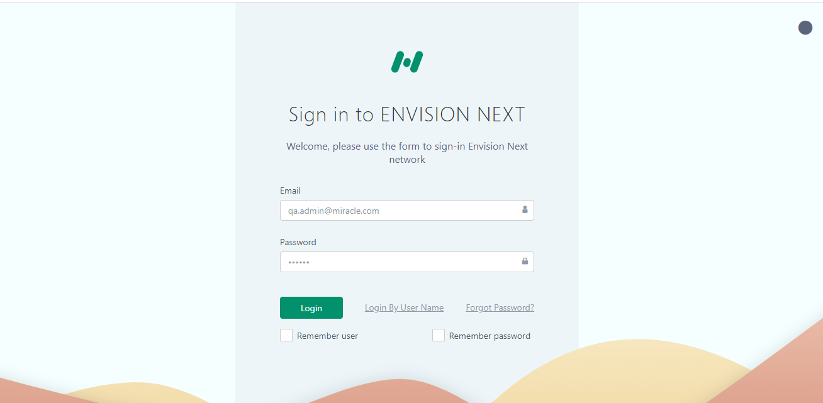

You will have a number of options in the sign in page that you can use to customize or facilitate your next logins.

Sign in Page Theme: You can for example, click on the dark grey dot on the top right corner of the login page to change the theme of the login portal to a dark one.
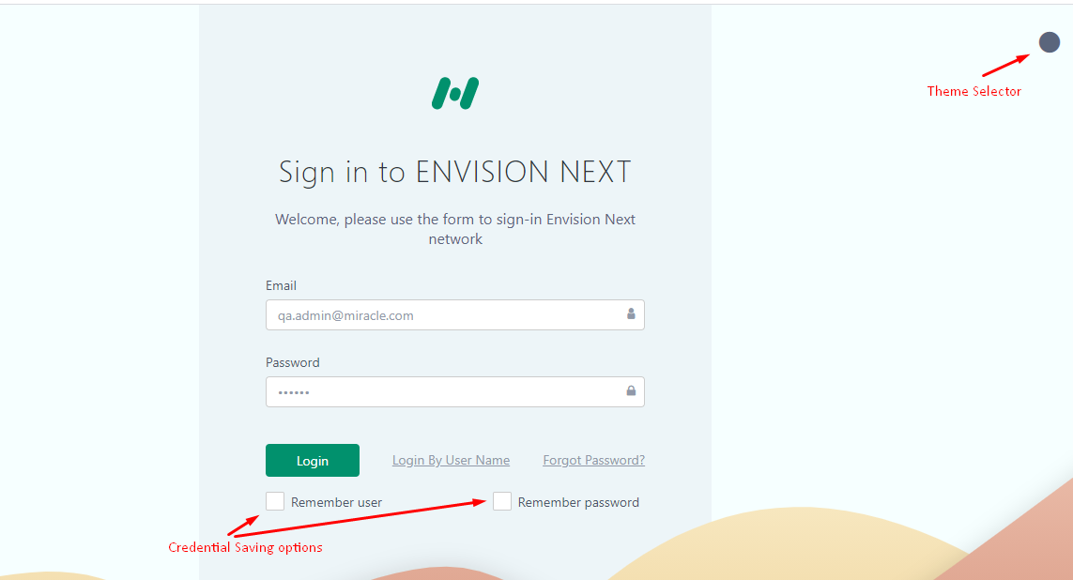
You can also:
- Login with your username instead of your email
- Choose which information (user/pass) you want the application to remember
In case you’re curious, here’s what the dark login theme looks like!
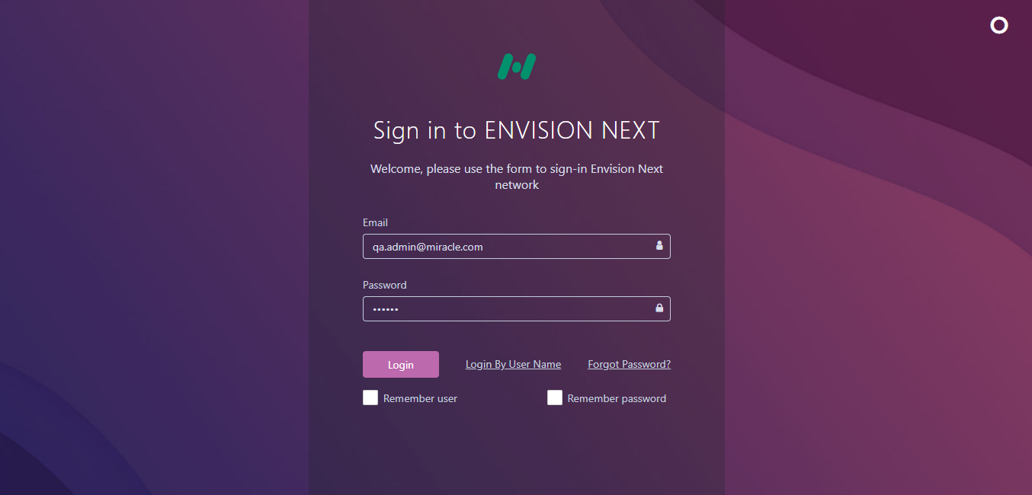
After clicking the Login button, the user will get a Confirmation message for replacing another session.
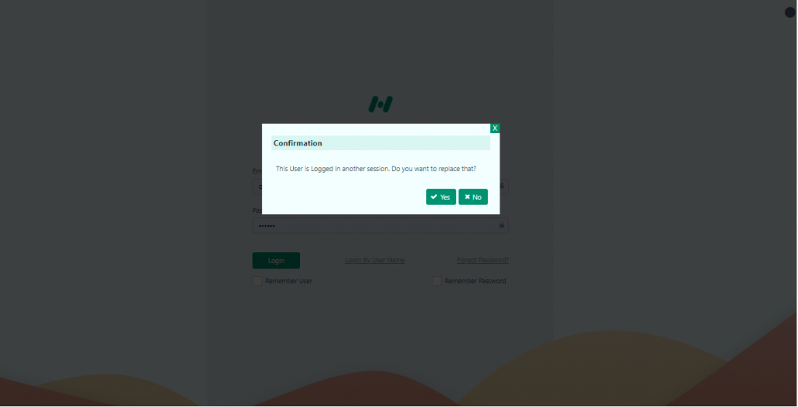

After clicking the ‘Yes’ button the user will successfully login to the system.

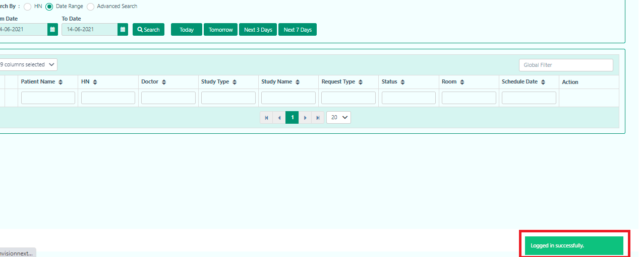

Navigation

Here’s what the application will look like once you're logged in. The page you see may be different depending on what you want to see as your homepage.

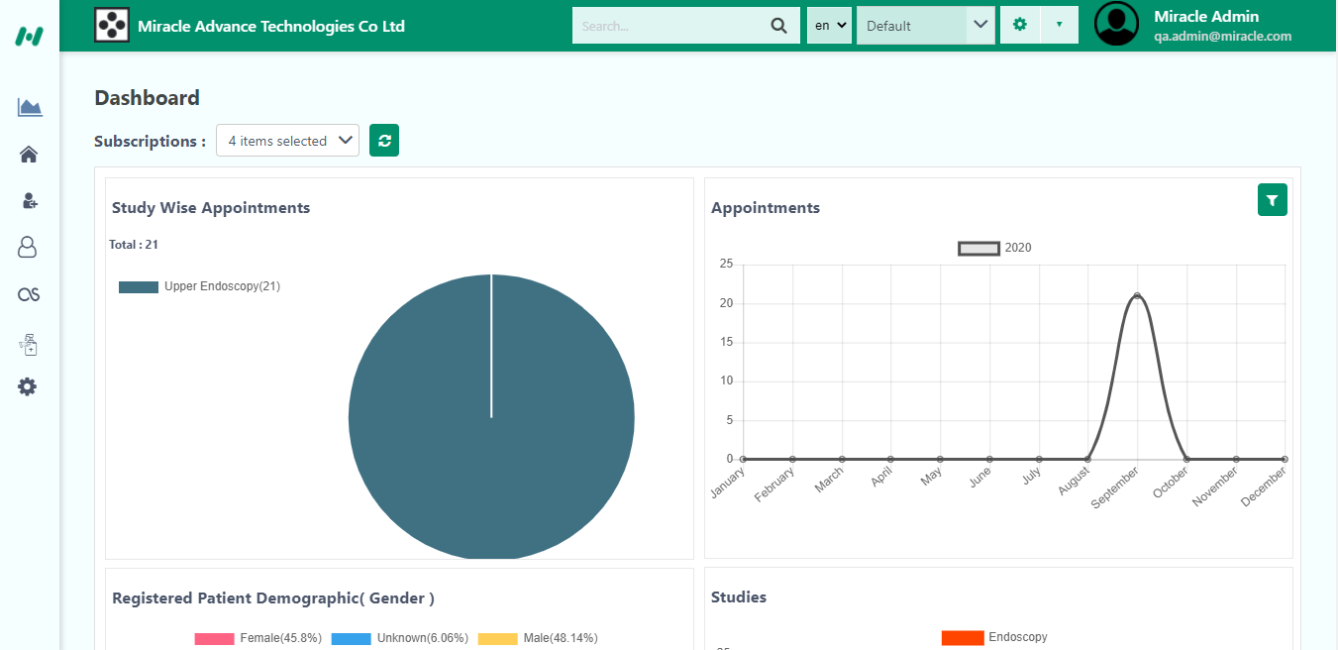

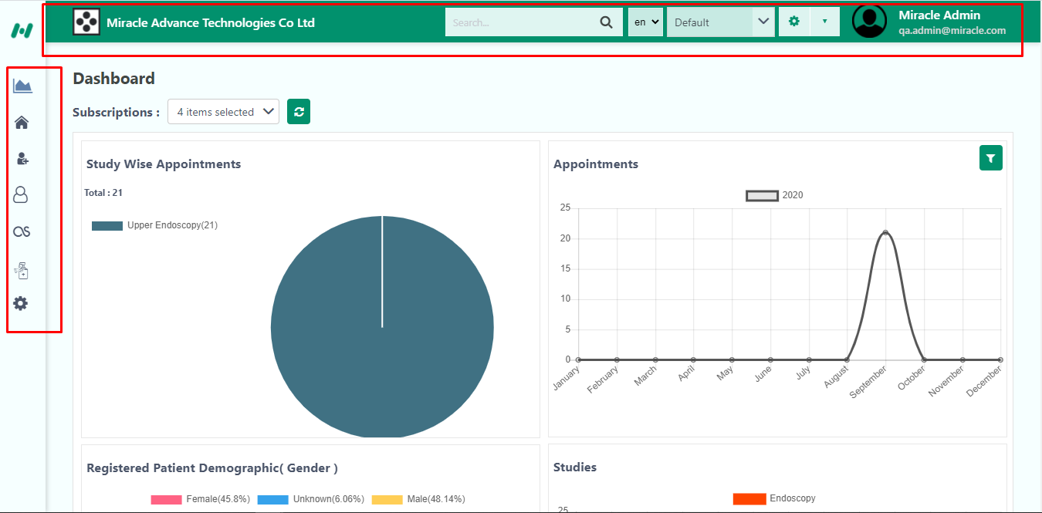
The left-hand Main Menu contains all the sections that you will need to use throughout the application.

The Top Bar/Menu contains the following features:
- Search bar: Here you can search anything regarding any patients or appointments, or both at the same time (see the 2nd screenshot below) just by selecting or deselecting the option.
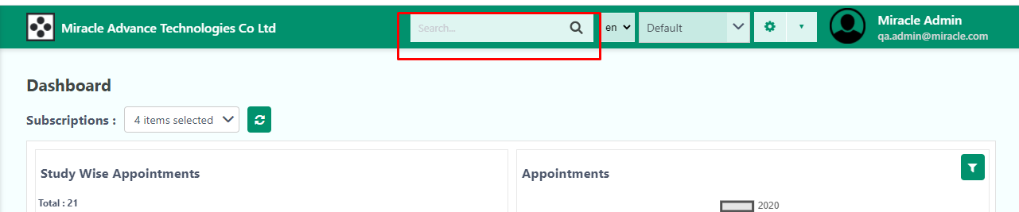

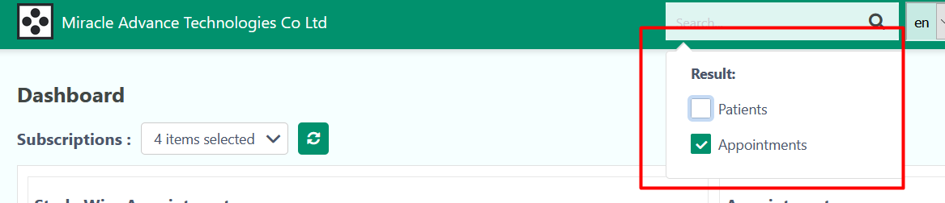

- Language Selector: You can select what language you want to use.

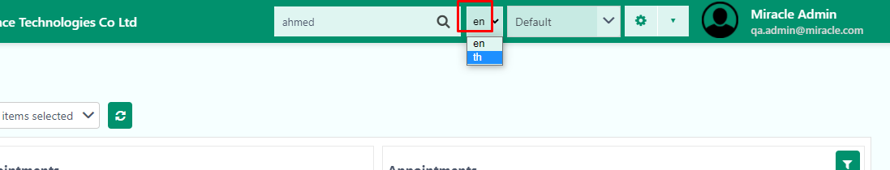

- Theme Selector: You can choose what type of background you can use , for instance, ‘ Default’, ‘ Blue’ or ‘Dark’.
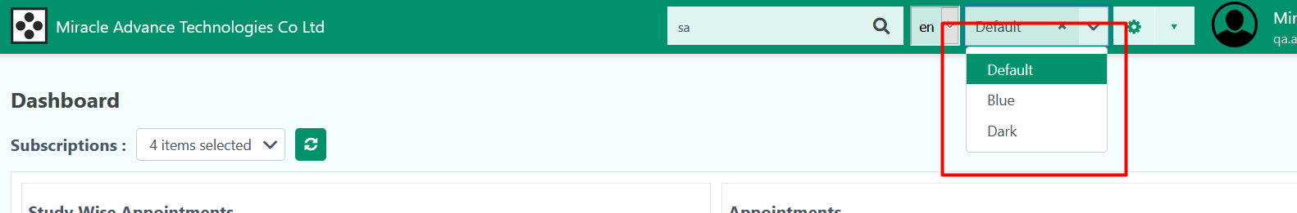

- Settings
- Set As Home: By pressing this, you can set any page as the home page when you log in, so for example if you want to set “Whiteboard” as the home page, you can just go to WhiteBoard and set it as home screen.
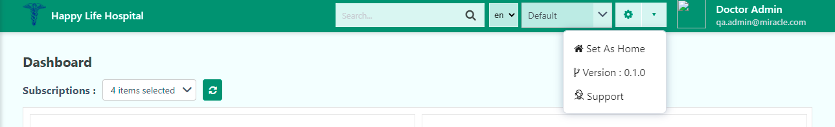

- Version Number: This shows what version of the software you are using, what date it was published on and any new features /updates that version brings to the software.
- Support: This helps to get any kinds of complaints from the users.
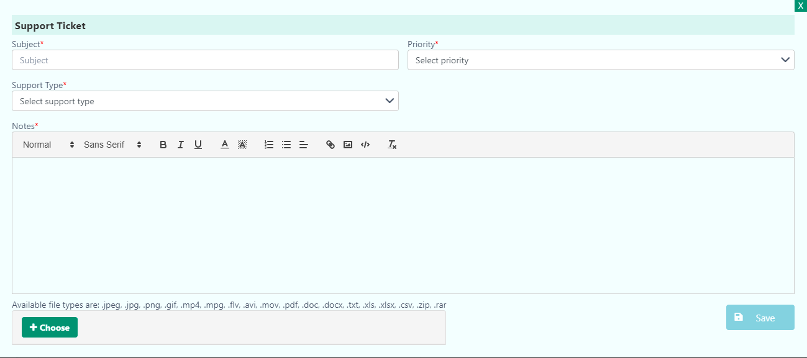

The user when they find any difficulties using this application, he/she simply uses this support option. The support option provides a form. It contains-
- Subject: The user writes the issue in this field when they are really facing the problems.
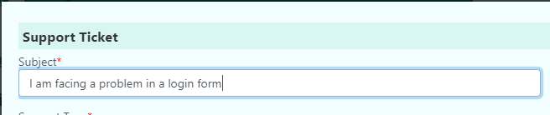

- Priority: The user can select the priority when they are facing the problems with the help of High, Medium and Normal. According to the priority the developer will try to solve the problems.
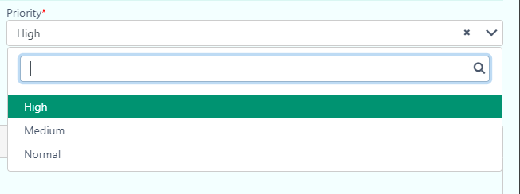
- Select support type: The user can select Error, Bug, Query according to the issues while using this application.

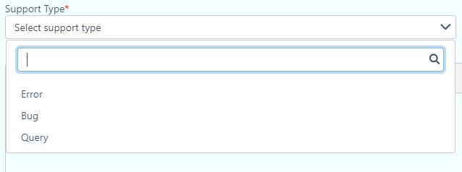

- Notes: The user can explain details about the issues while using the application through this section. They can include files in any format. Example- .jpeg, .jpg, .png, .gif, .mp4, .mpg, .flv, .avi, .mov, .pdf, .doc and so on.

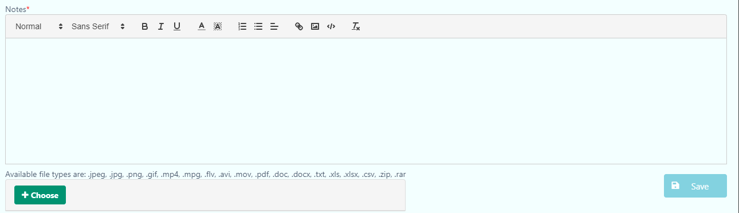

When all the procedure is over the user has to press the ‘Save’ button in the below right corner of the Support page.

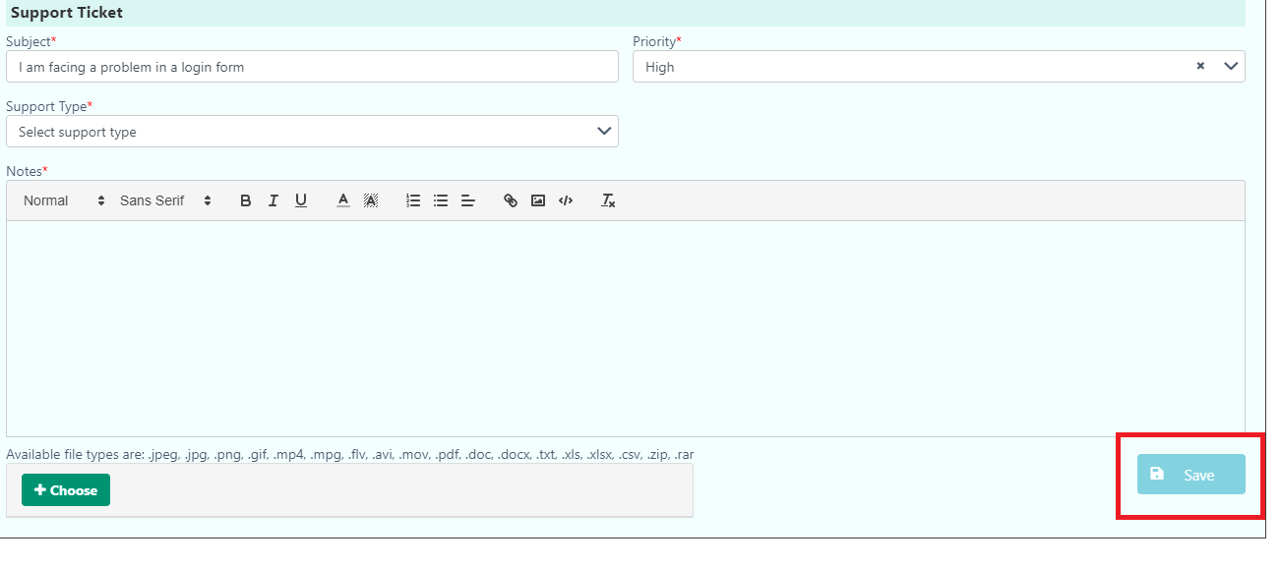

- Profile Options:
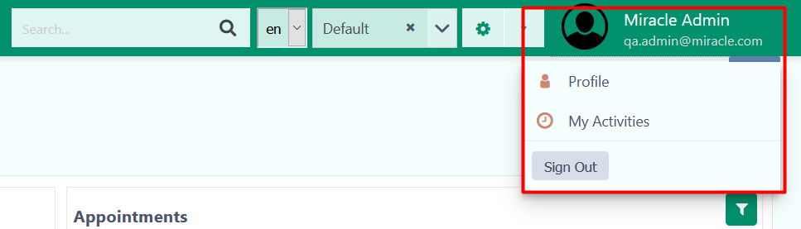

- Profile: Here you can view your Profile and change your photo, edit user, provide signature and your Password.
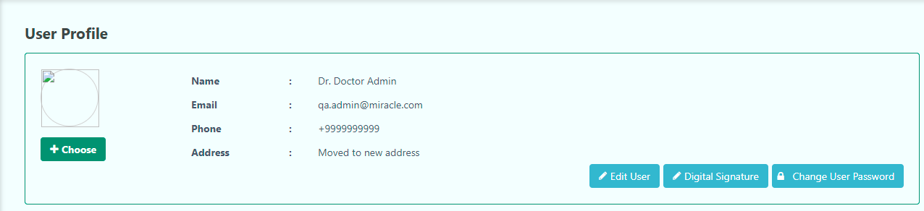

- My activities: See what page in the software you visited the most, and the most time you spent on pages. You can even select for how many days you want to see your activities e.g. for one day, one week, etc. This option is at the top of the page.
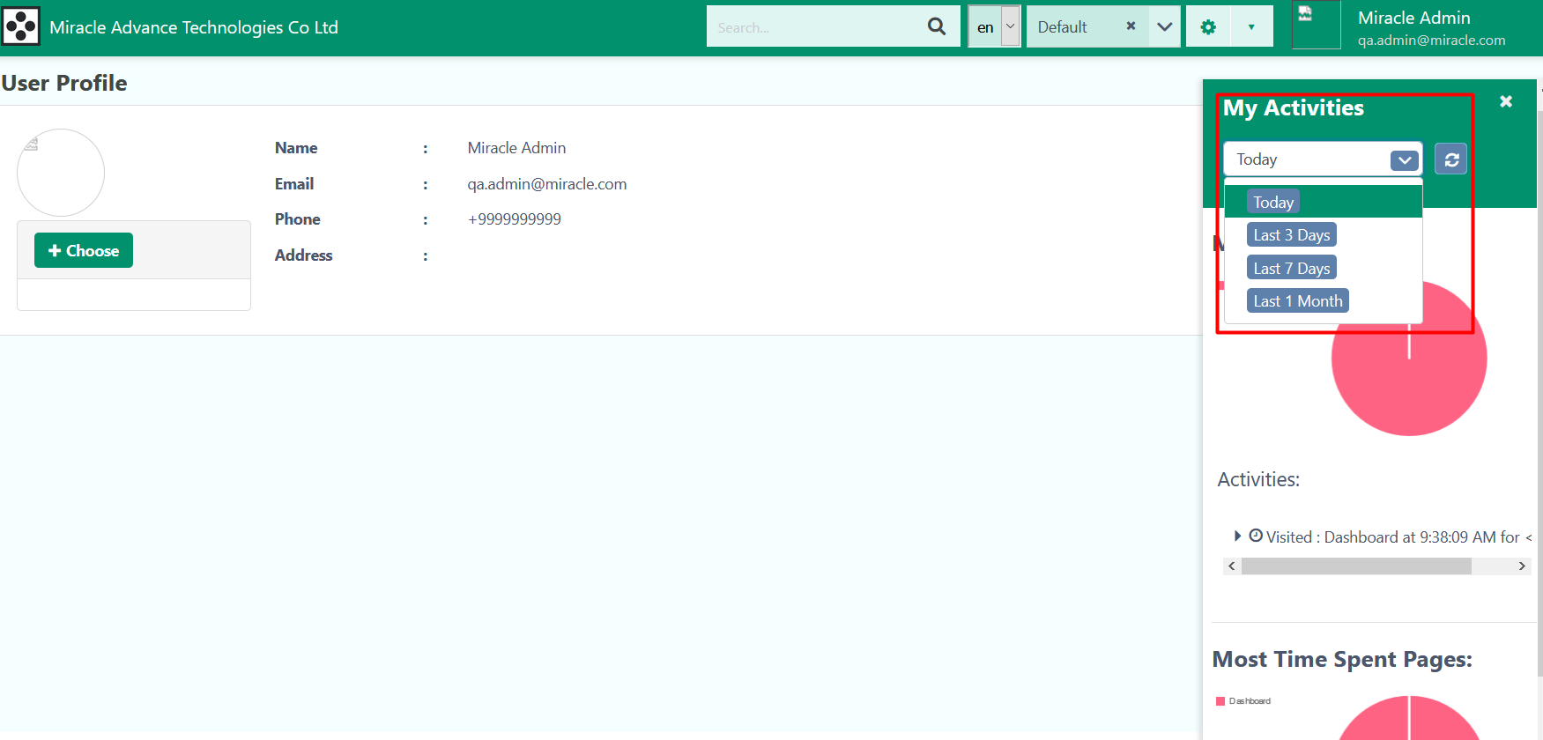
- Sign Out: You can sign out from this dropdown
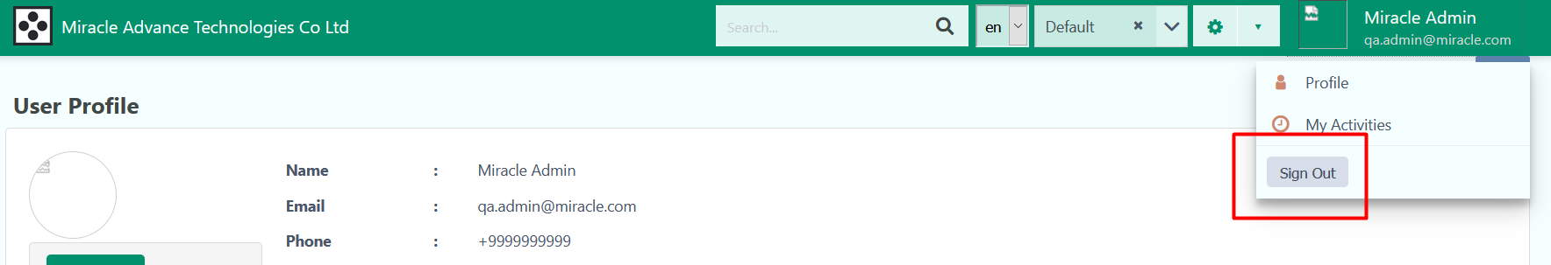

Main Menu: Moving your mouse to the left side of the screen shows the Main Menu. You can select where you want to go from here
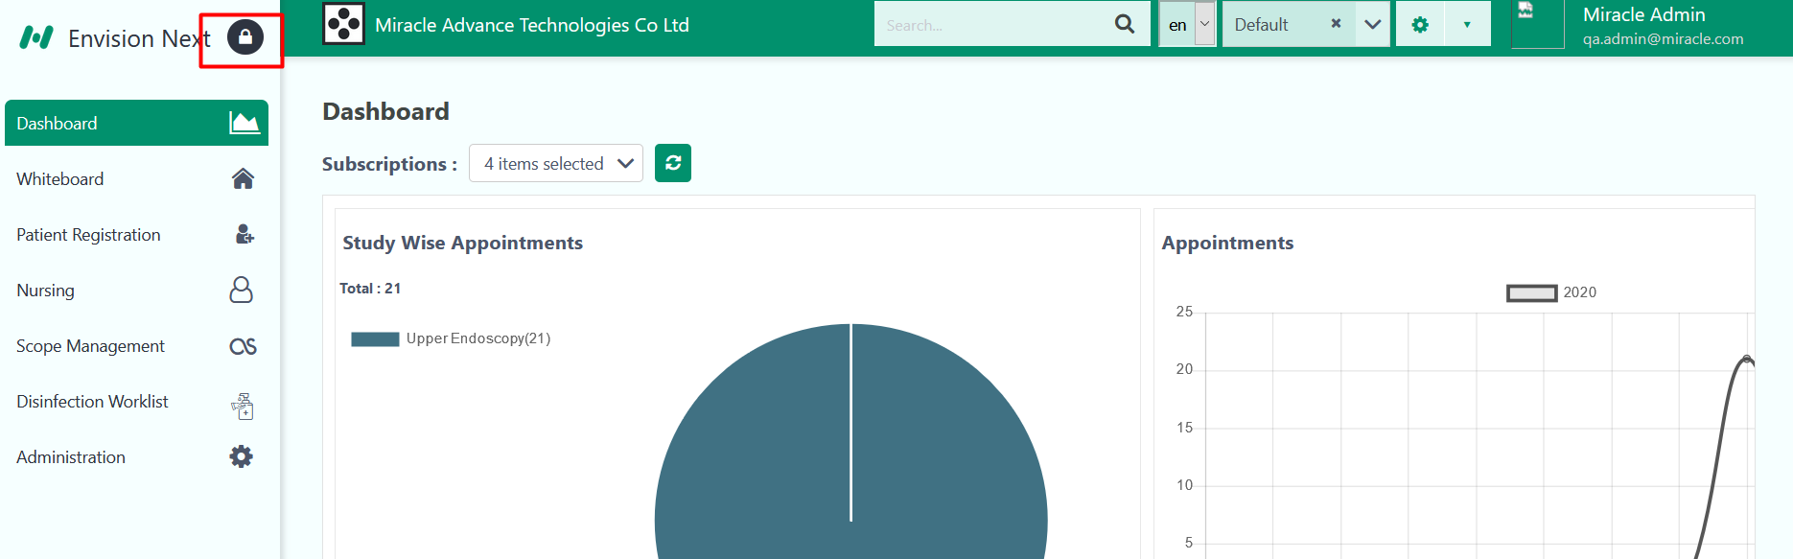You can lock the main menu, so that it always stays there even if you move the mouse away from it, by selecting the lock button on the top right side of the main menu.

Patient Registration & Appointment

From the Main Menu on the left, you can start a Patient: -
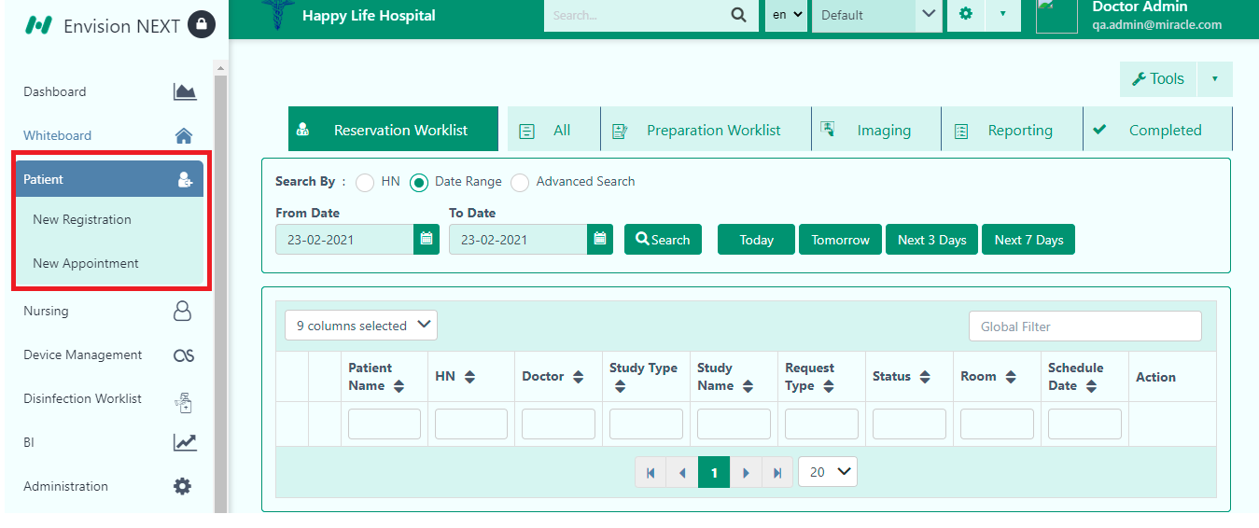
This takes you to sub menus- New Registration and New Appointment.

The New Registration form has 3 sections that you can fill up -
- Patient Information
- Additional
- Emergency contact
- Patient Allergy

Note: You will need to fill up the (minimum) mandatory fields in the form before you can successfully complete a patient registration. Mandatory fields to be filled are marked with red asterisks (*)
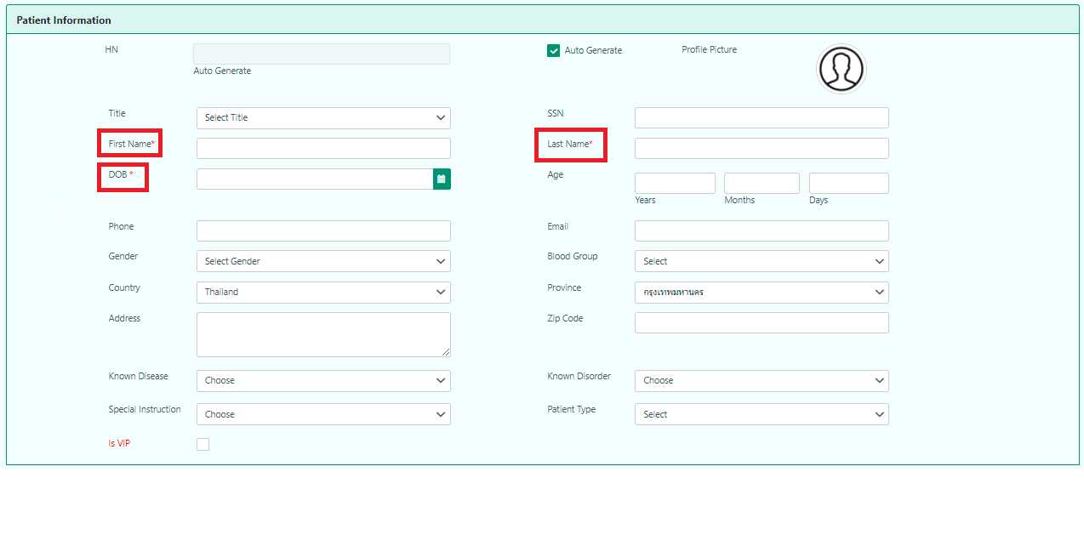
Mandatory fields are highlighted in red*
Note that you can add multiple options for fields like ‘Known Disease’ and ‘Known Disorder’. You can search for the diseases at your convenience.

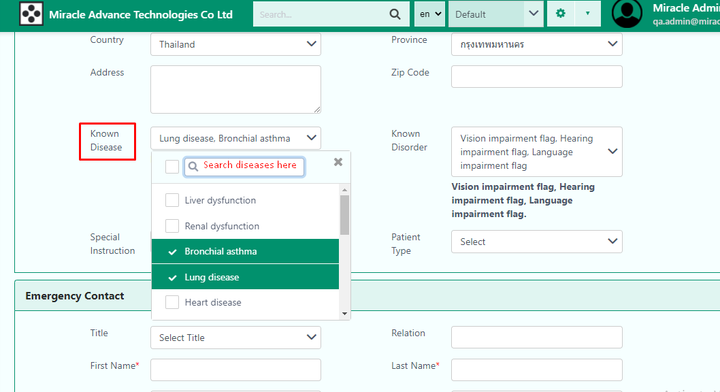

Note: Is VIP option protects the user data. Only the admin can read the data.
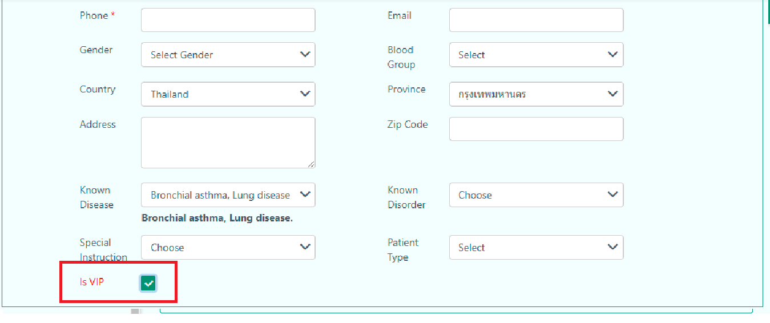

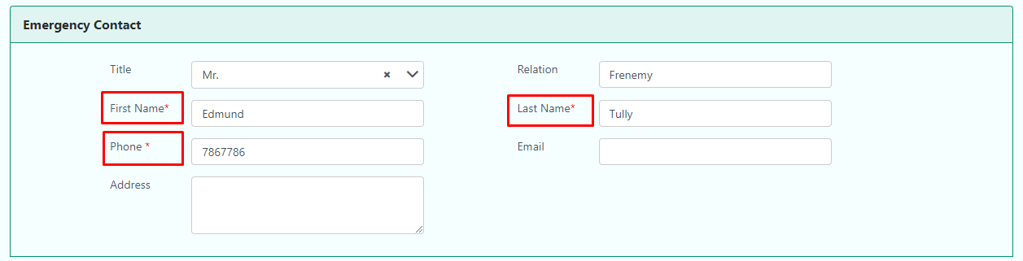
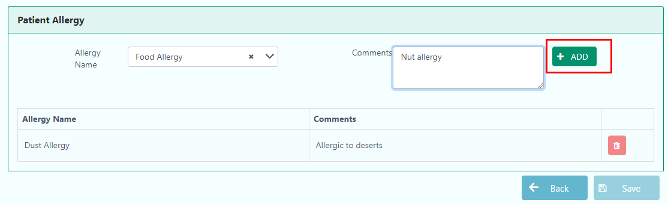
Mandatory fields are highlighted in red*
Note: When adding allergies, please note that you will have to click on the ‘ADD’ button to be able to list the allergies successfully.

Once you’ve filled all the sections, you can click on Save. You will now be taken to the Patient Dashboard: -
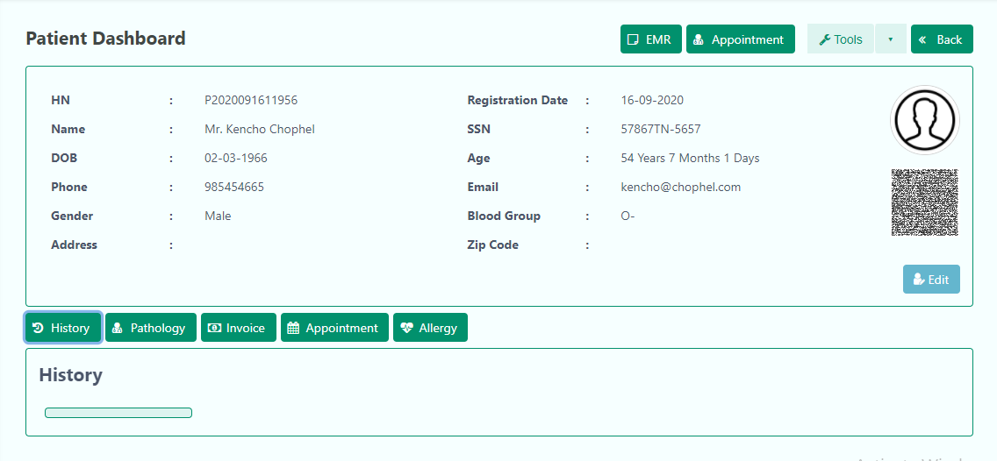

Patient Dashboard:

The Patient Dashboard is where you can access information about the patient, edit the information and view useful details such as Invoices and History.

Generating ID Card for Patient:
From Patient Dashboard, go to Tools on the top right corner:
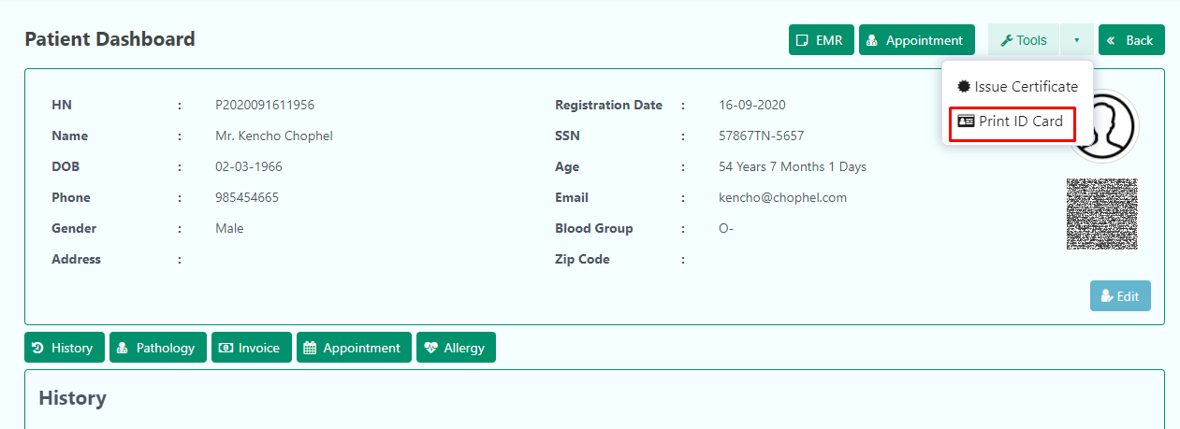
An ID card print is generated!

Creating an Appointment for the Patient:
Right before Tools is the Appointment button. It takes you to the Patient Appointment.
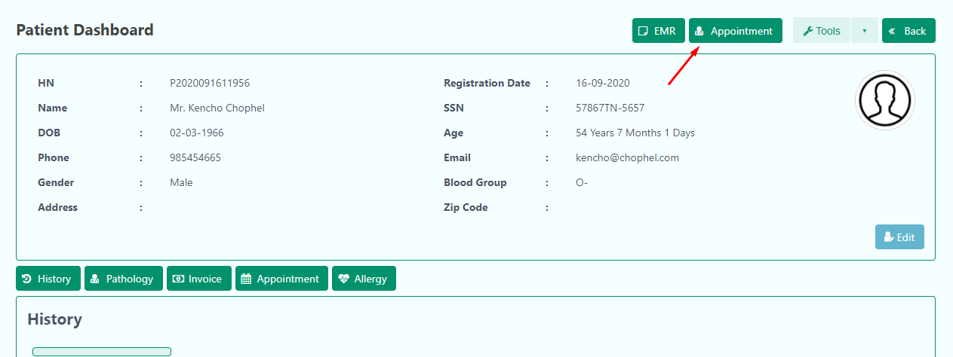

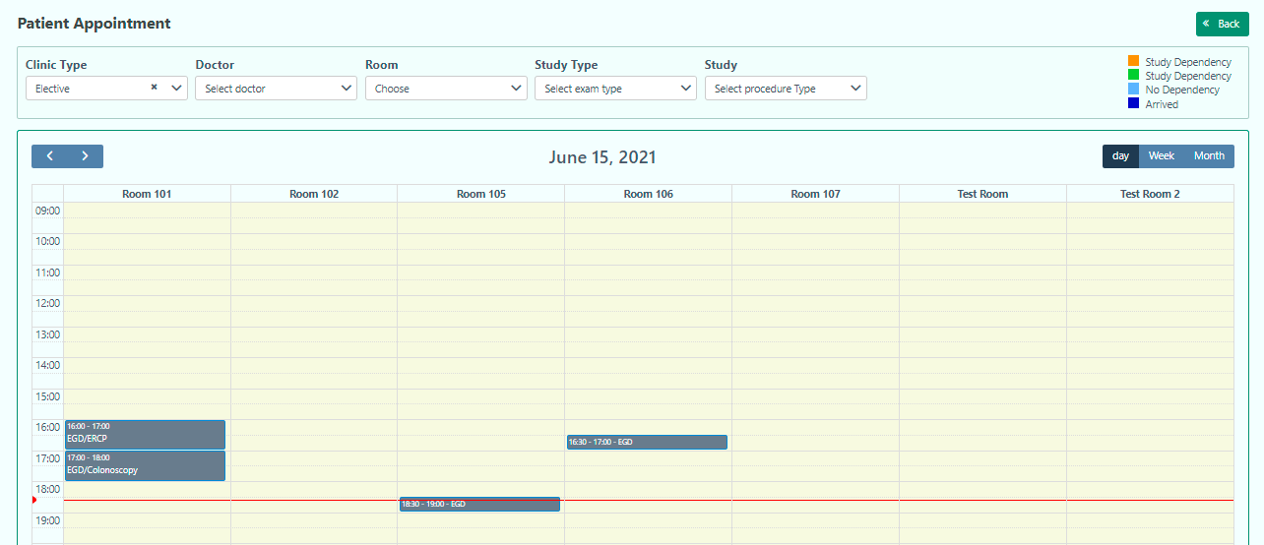

The Appointment calendar is where you can select a slot [example: red area] (by clicking on it) and set an appointment for the patient from the Patient Dashboard that you just came from. You can select an appointment Room Wise.
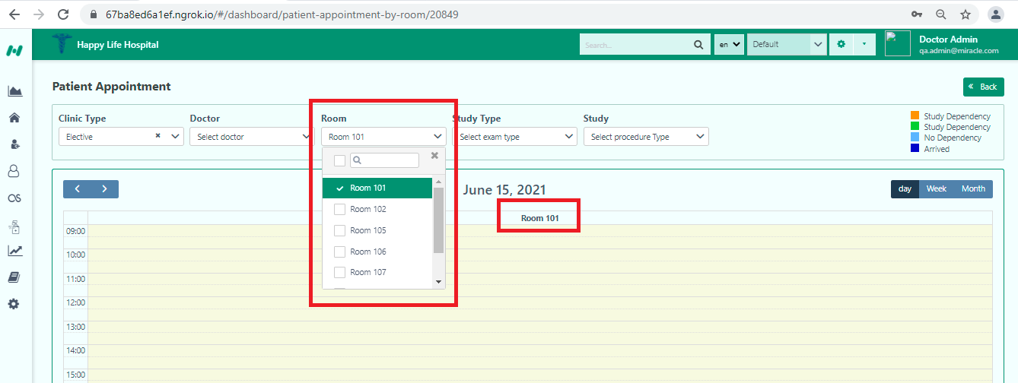
Clicking a slot takes you to the Appointment card where you can input details-
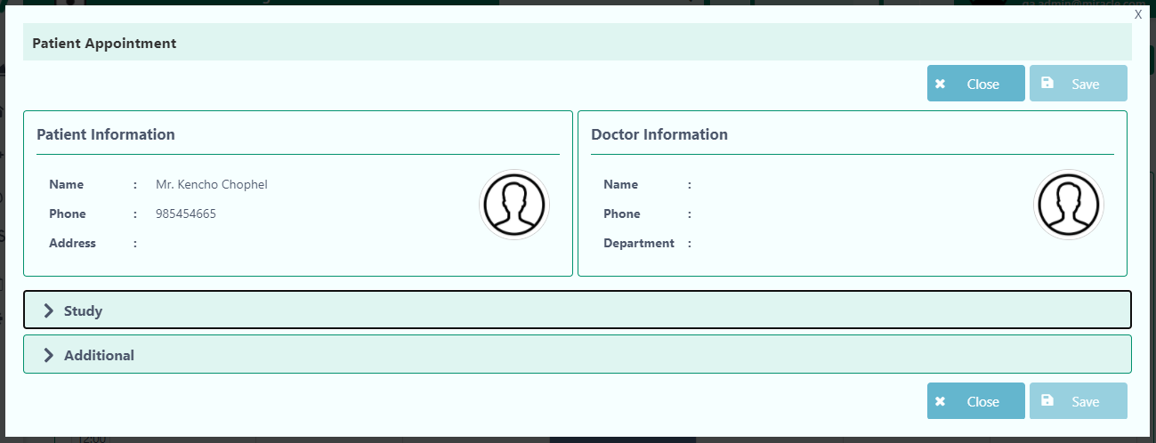

Note- When you click Mark As Arrived it will take you to the Preparation Worklist. Otherwise, the patient will go to the Reservation Worklist.

Fill in the rest of the information in the two tabs.
Please note that you will not be able to Save the information until you have filled out all the required fields.
The fields are highlighted in the screenshots below-
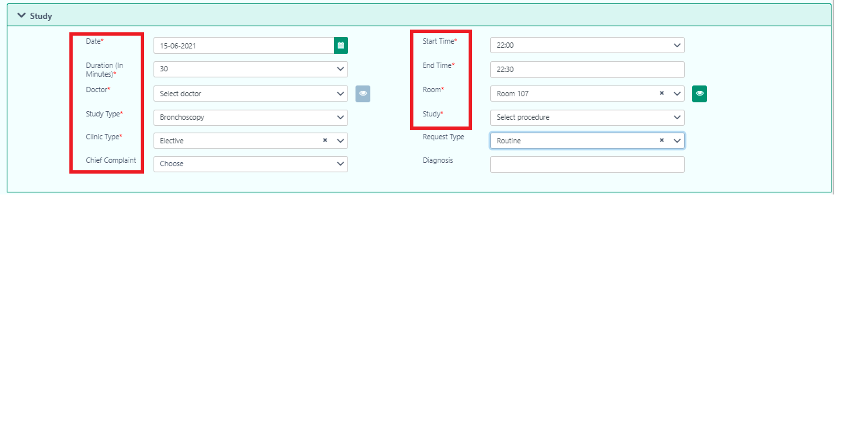
Mandatory fields are highlighted in red*

Note-You can also search patients in the search bar.
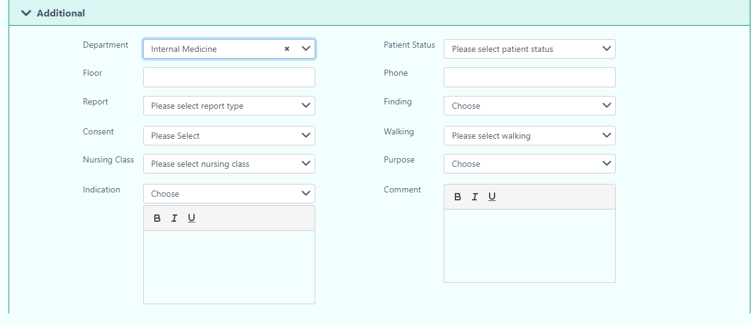

Once you have saved the information, you will be taken back to the calendar to show the appointment that was being made.
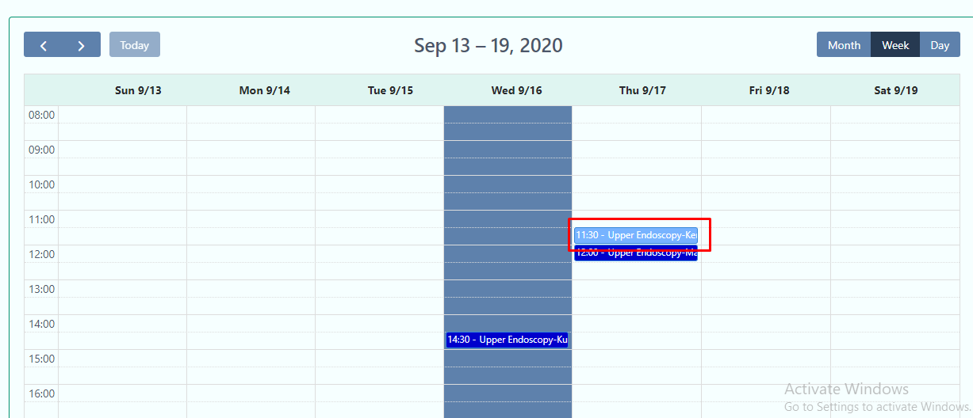
You can extend the slot duration by simply dragging the bottom of the coloured box that reserves the slot. You will consecutively be asked for a reason for the time change-

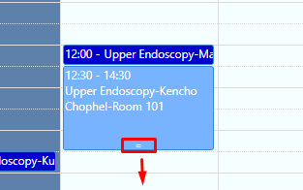

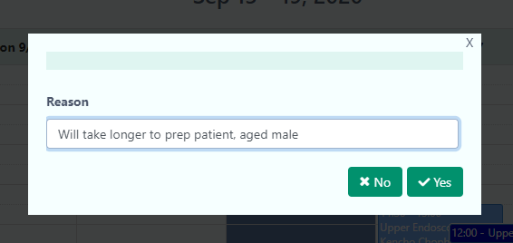
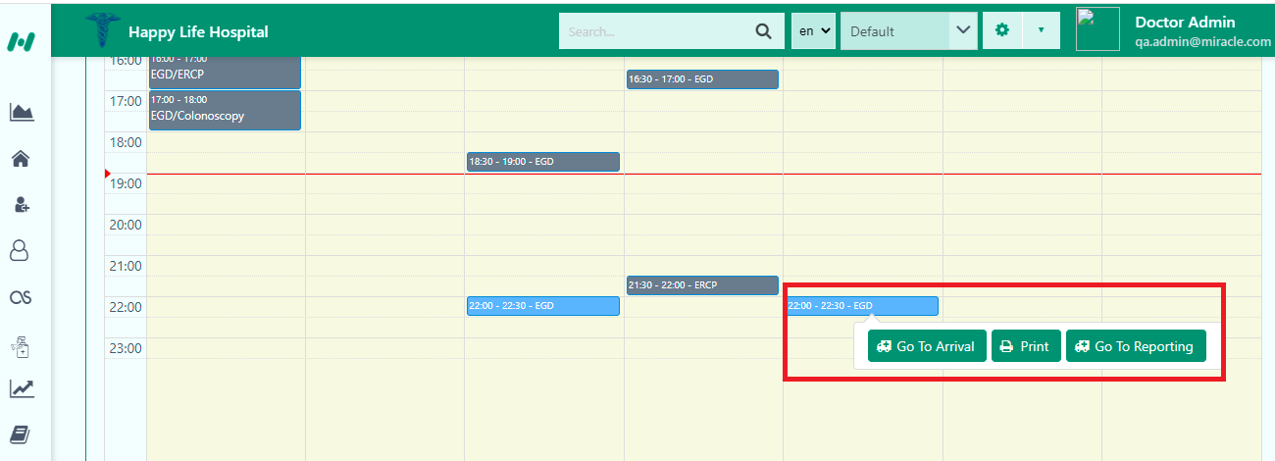

You can also register a patient and make an appointment from the Tools section in the Whiteboard.
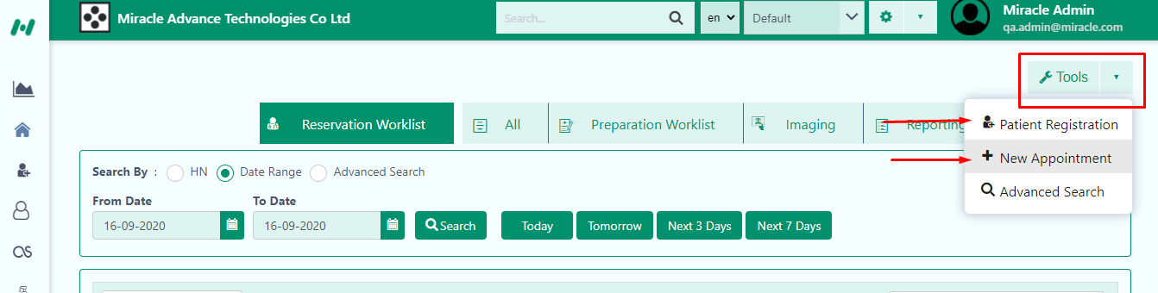

Whiteboard
Inside the Whiteboard, you can view statuses of a patient, what stage they are in, and in general, the whole process/cycle that a patient will go through from the moment s/he registers until the completion of the billing.

Whiteboard is organized with tabs that will carry a patient record form one tab to the next, until the client has completed the payments.

Once you have made an appointment (either from Tools or from Patient Dashboard), it will show in the Reservation Worklist under the respective date inside the Whiteboard.
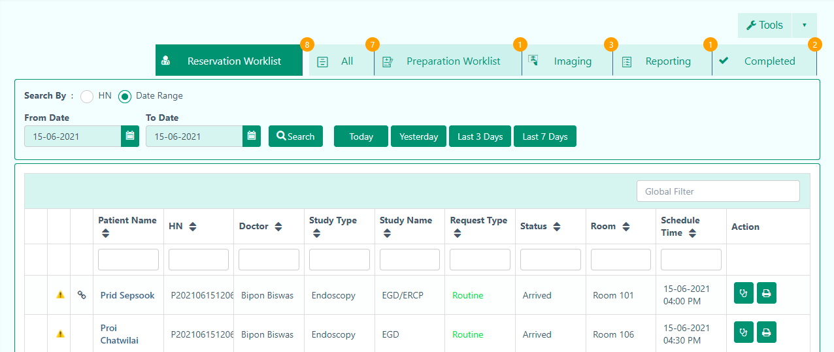
Tip: You can directly go to Whiteboard from the Main Menu, and even set it as your default home page.

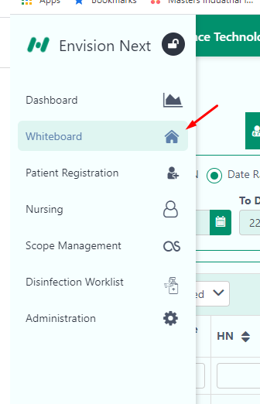

Whiteboard Features:

Search Features:
The application offers 3 types of search, namely HN, Data Range and Advanced Search. Date Range is selected as the default search type.

Date Range: The From and To dates are selected to be the present day by default. It means you will only see reservations made for the day in the Reservation Worklist, until you change the date range.
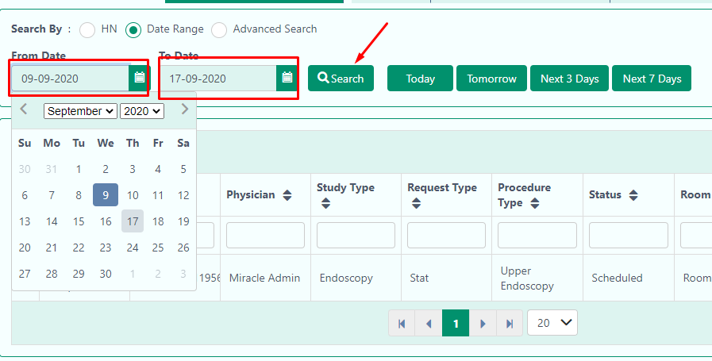
Click on Search to show the results from the date range.
To reduce your work, we have also set buttons that can directly show results for the past one, two and next three and next seven days.
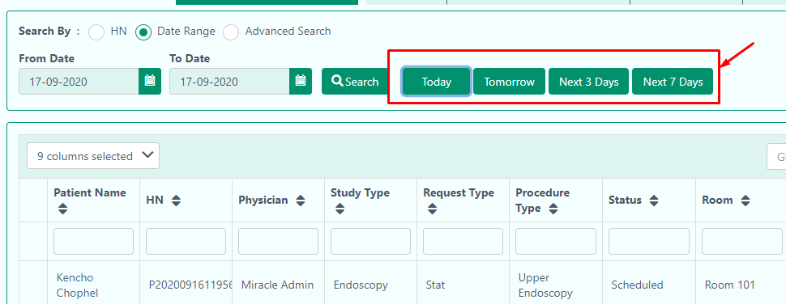

HN (Hospital Number):
Let’s you search according to a specific hospital number-
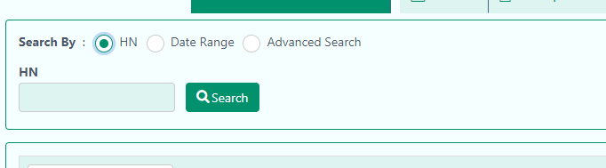

Advanced Search:
In any case, the results may require you to make your filters as specific as possible, requiring many fields. Advanced Search gives you that option, and includes both HN and date range searches also. 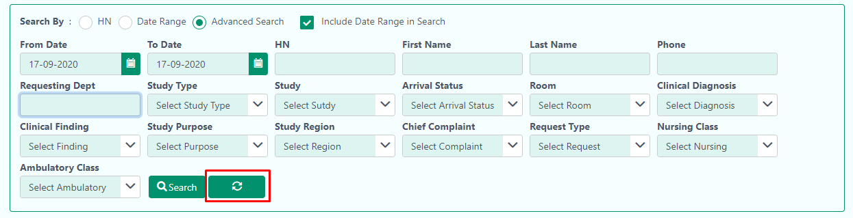

Column Features:

- Selecting fields to show: select the specific fields you want/don’t want to see
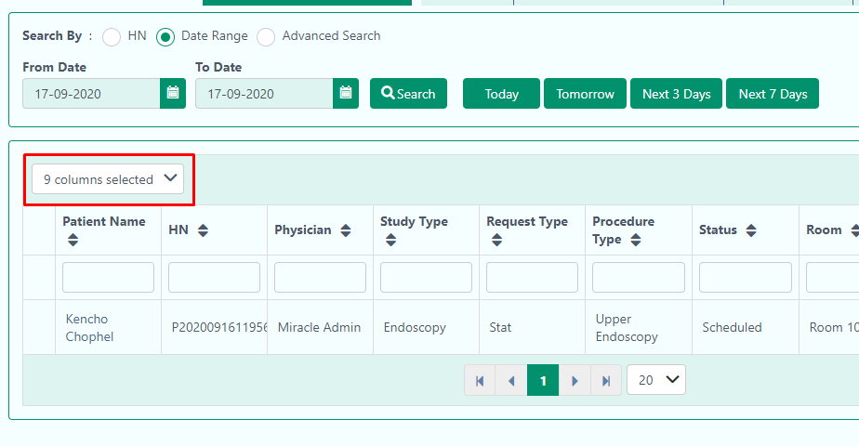
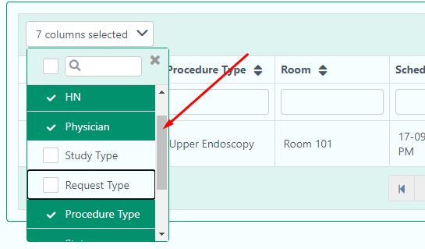
- Type Search in every column: Use this feature to look up a specific value in a column
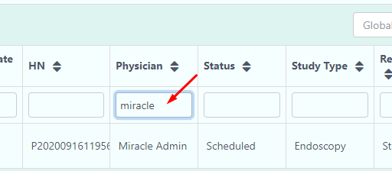

- Global Filter: keywords you type are run in a search that covers data from all columns.
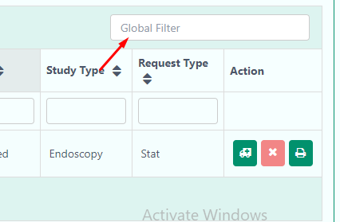

Reservation Worklist:
This worklist shows all the appointments for the day. From this worklist, you will have to mark arrival for the patient before he/she can be sent for preparation. This is done from the Action column:
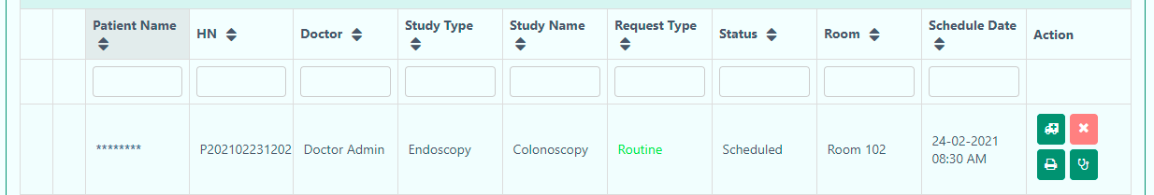
Note: You can also arrive a patient from the Appointment Calendar
This takes the patient information to the Patient Arrival page-

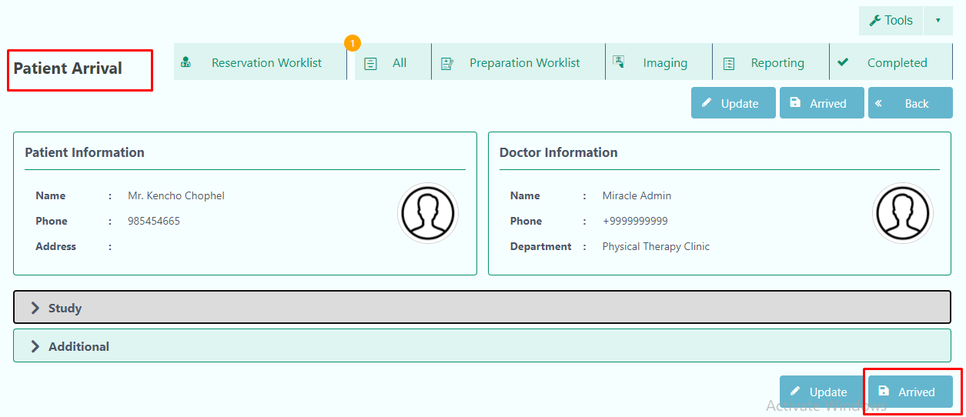
Study and Advanced sections are made “collapsible”-
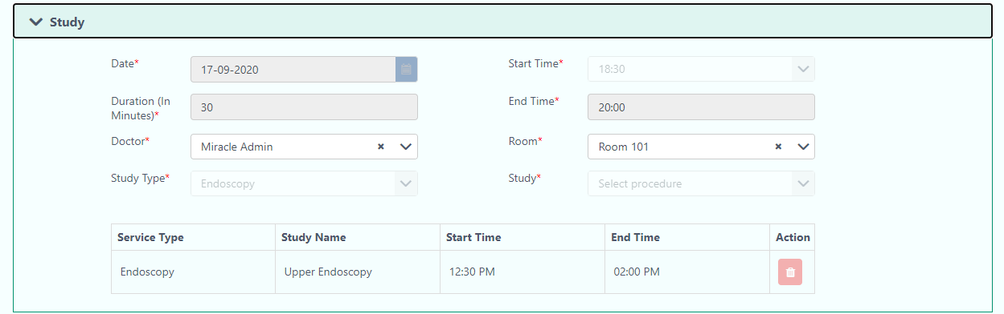
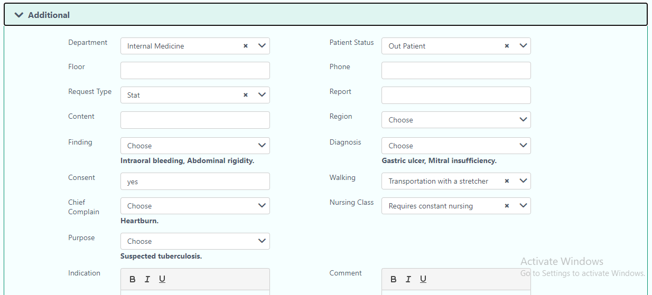
You can change information from the Patient Arrival page, and Update the information before you mark the patient “arrived”.

You will be asked to select the Clinic Type after you click on Arrive:
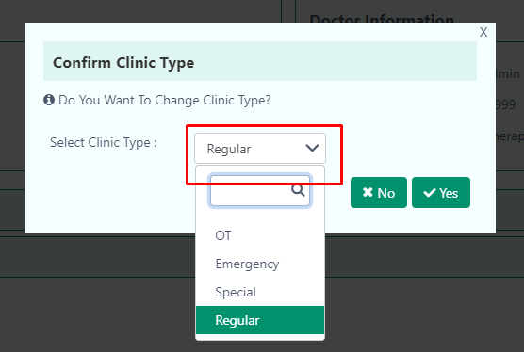
The patient information is now moved to the next stage: Preparation Worklist

Preparation Worklist:
The Preparation is the next step after a patient has arrived. It shows up in the Whiteboard like this-
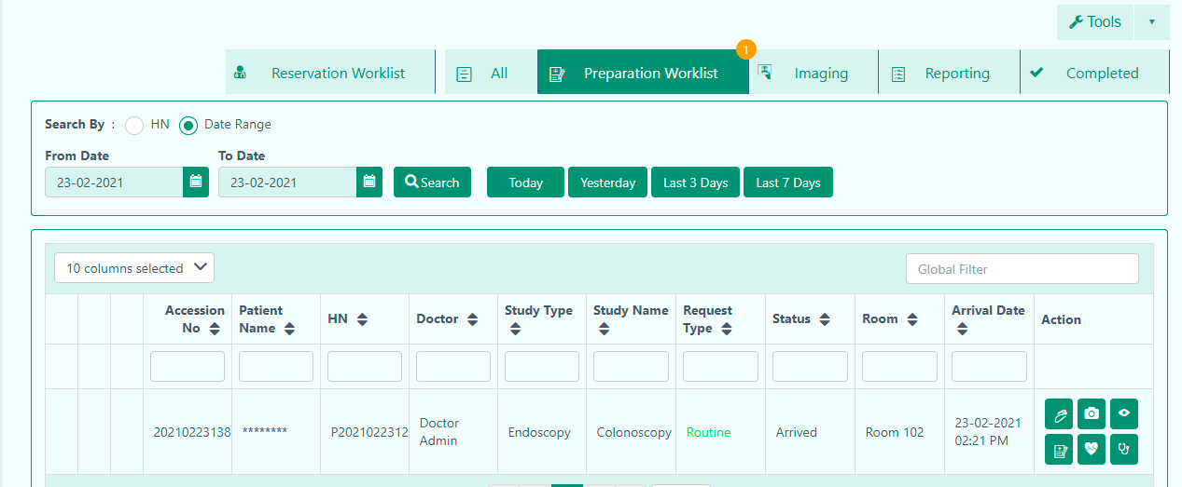

You can start preparing (and perform a number of other actions) the patient from this section.
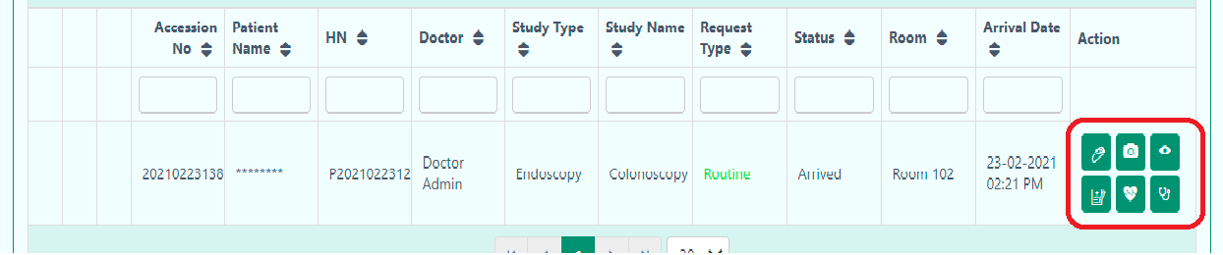

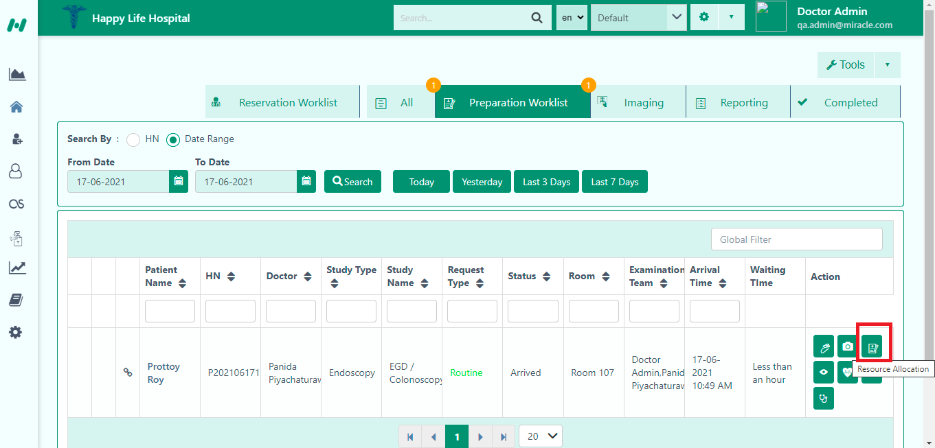
The button indicates Resource Allocation. After clicking the button, the user will get the Endoscopy Preparation page. Here they will find-
- Team settings
- Study
- Scope List
- Endoscopy Machine
- Patient Information

In the team settings, the user can set their desired team from the dropdown. They will get confirmation notification when adding the team.
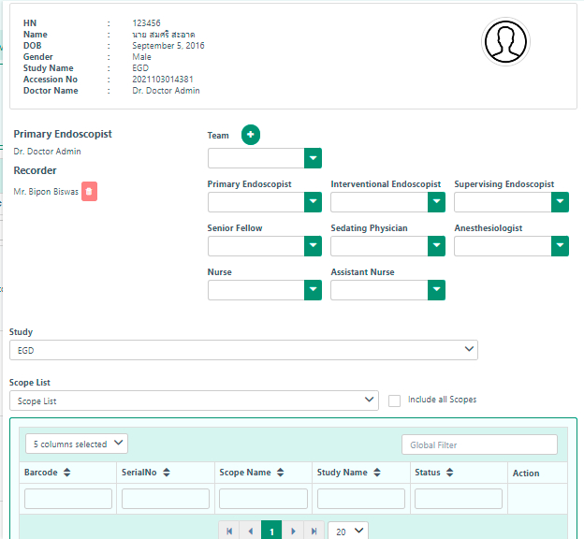
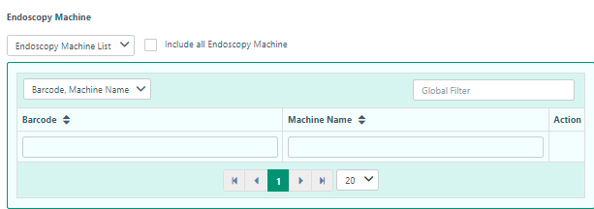

In the Examination Team, the user can add team members to unlock some features of the Action and also as a helping hand to operate the patient efficiently.

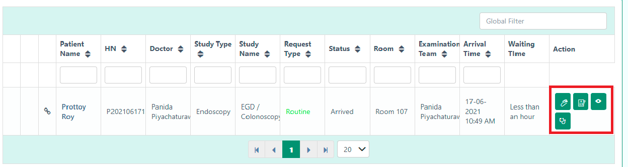
The team member who has no access, they cannot operate to-
- Transfer to Imaging
- Vital Sign
- Patient History

When the team member has the access, the user will find the interface like-

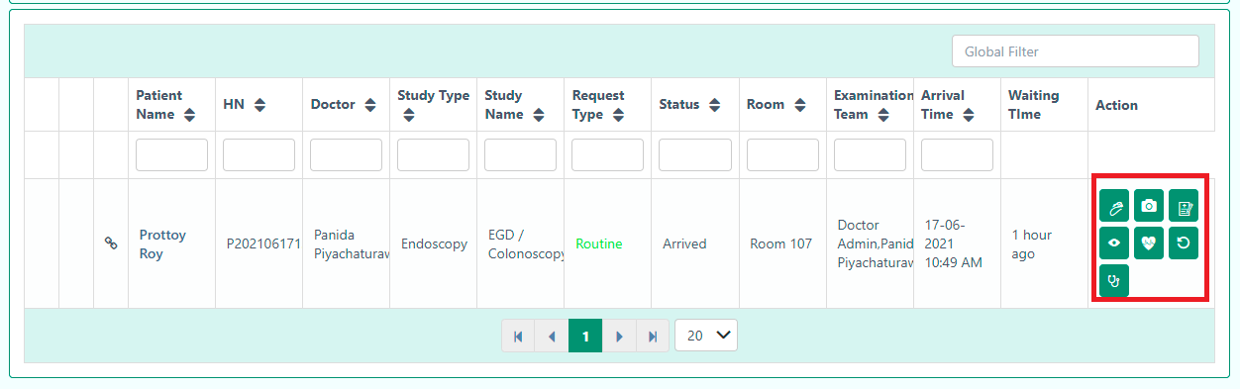

the user can include all Endoscopy Machine, Study, and Scope List.
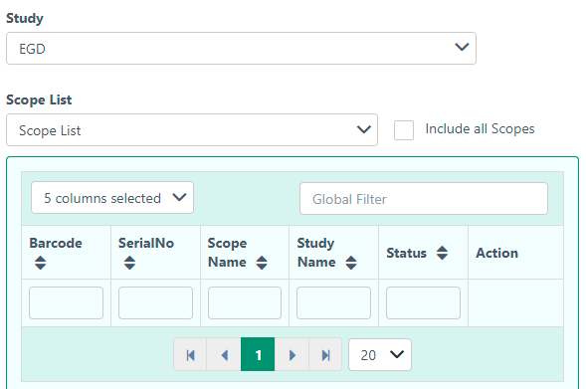

To add Vital Signs, scroll, simply select the Vital sign icon from the Action column-
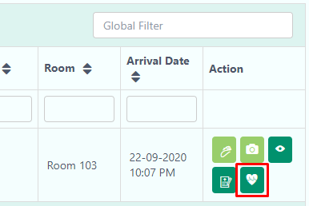
This opens a panel from the left, where you can put in the information, Save, or Close the panel. This panel can also be helpful in providing you the patient’s basic details (name, DoB, Gender, HN) at a glance.
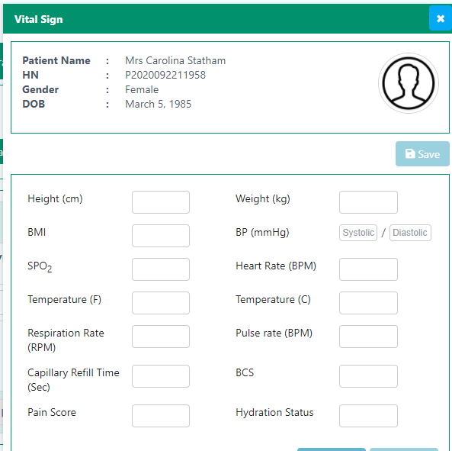
We can now move on to Preparation.

The first option is Prepare PreScope, that preps the patient for the endoscopy-
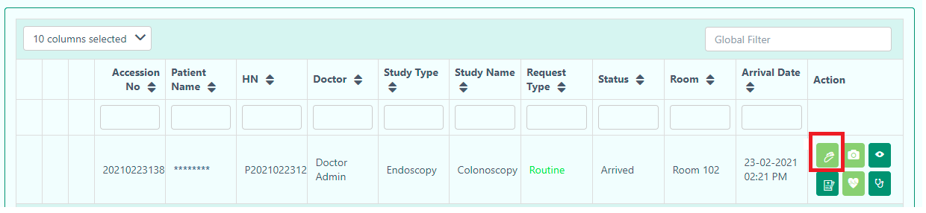

This takes you to the Prepare Prescope section:
(not full section shown here)
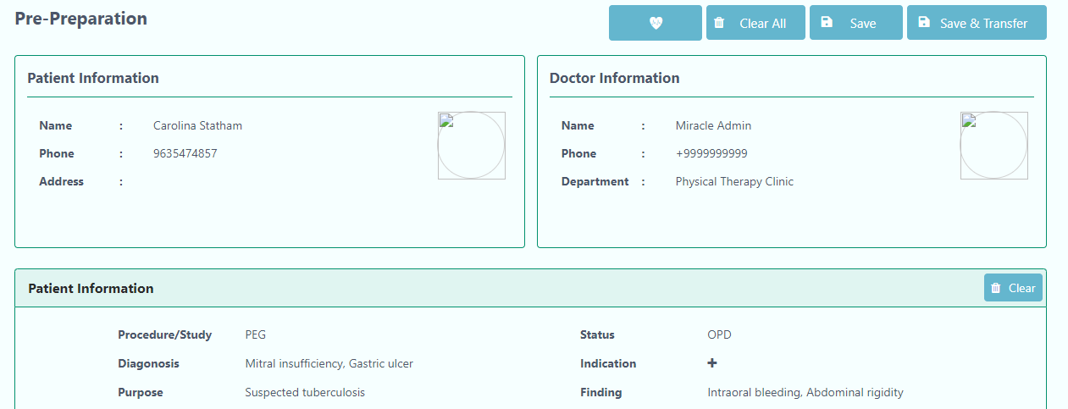
This section contains a number of forms that are not collapsible. If you keep scrolling, you will find all the options that you can select/fill in. The sections include:
- Patient Information
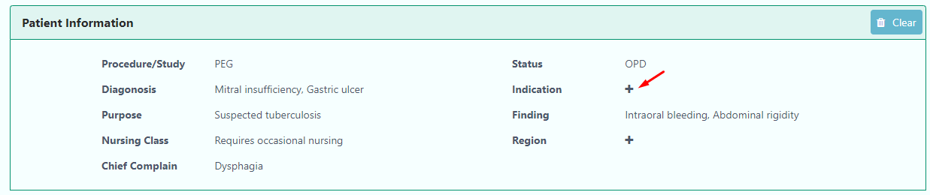
Clicking on the plus sign lets you enter text information:
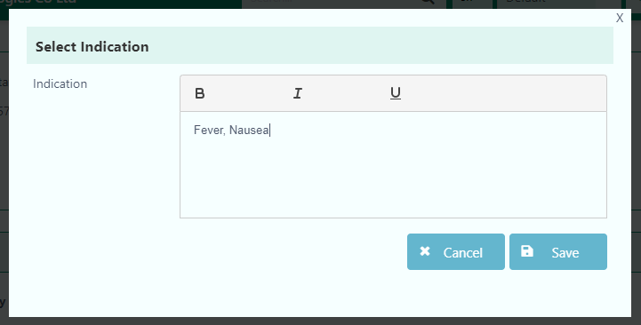

- Check List
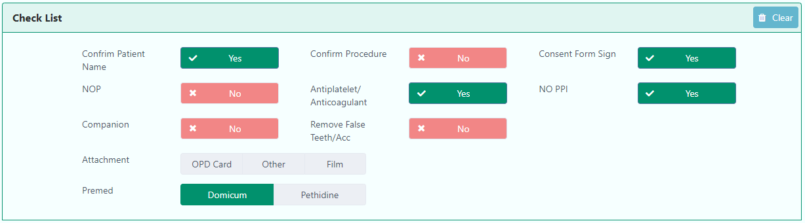
The default choice for all items in the list is set to ‘No’. Clicking on it will set it to ‘Yes’

- Patient History
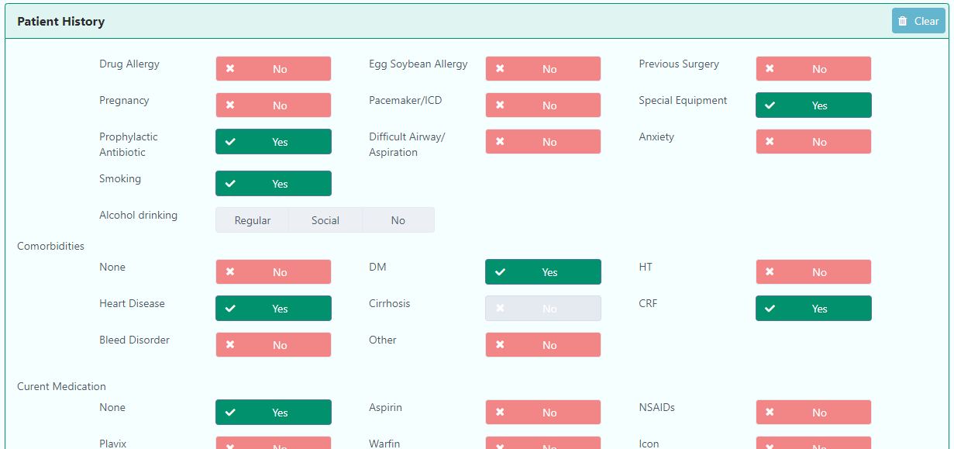
(not full section shown here)
This is the same as Check List, the default choice for all items in the list is set to ‘No’. Clicking on it will set it to ‘Yes’.
- Patient History
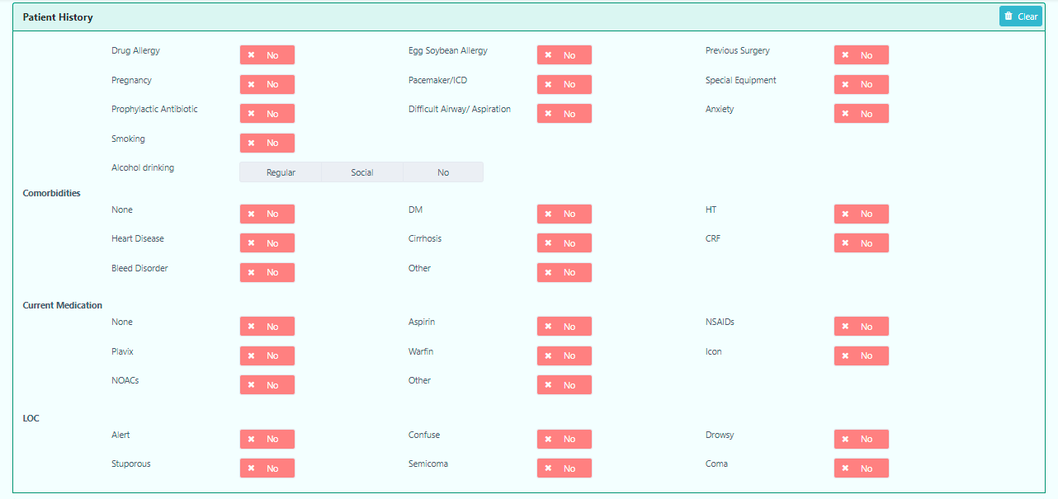

- Breathing
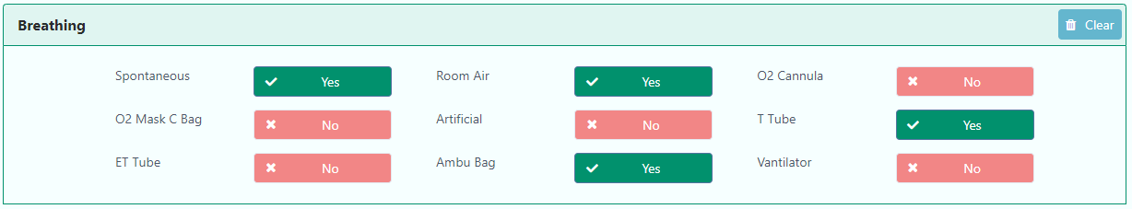
- Blood Component
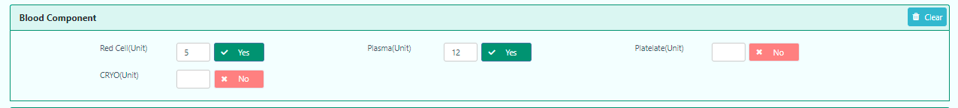

This is also the same as CheckList, the default choice for all items in the list is set to ‘No’. Clicking on it will set it to ‘Yes’. When you click ‘Yes’, the user can give input. Otherwise, the user can’t give input if it is ‘No’.

- Complete Blood Count
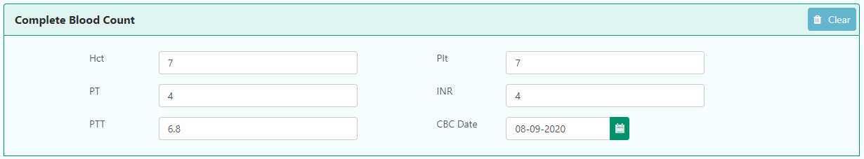

- Blood Chemistry
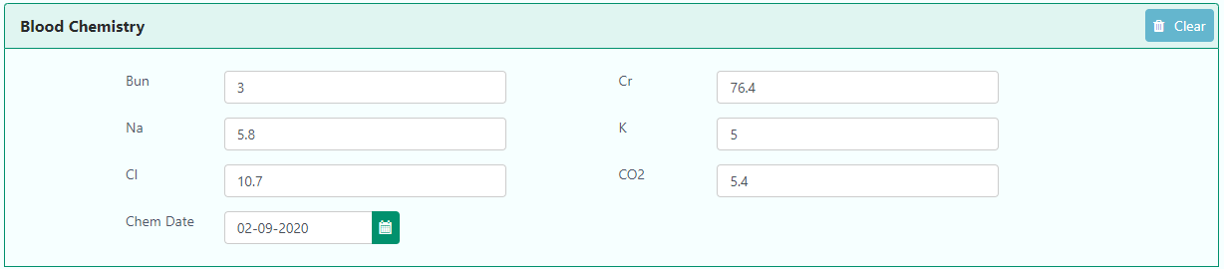

- Liver Function Test
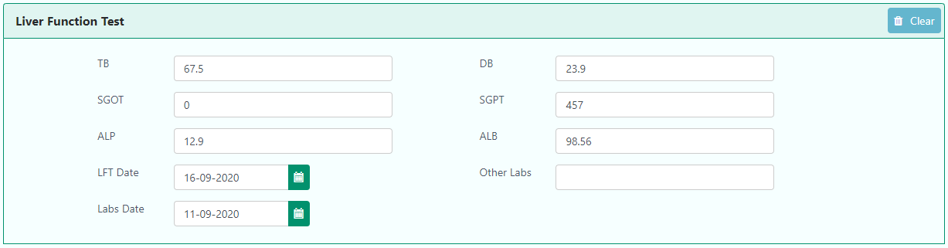

- Check List
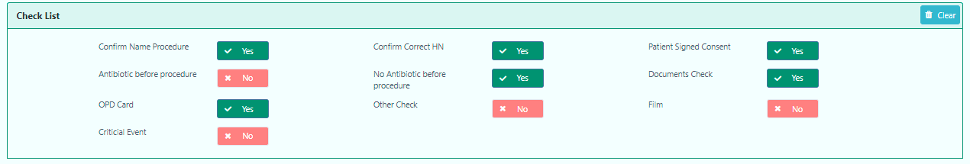

- Nurse Info
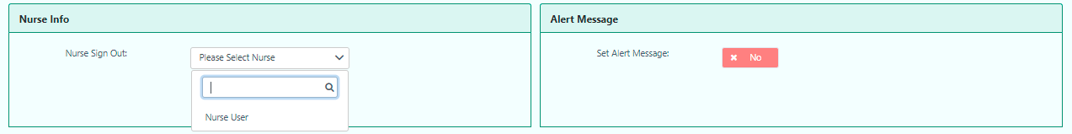

The nurse can set an Alert Message for the doctor if needed.
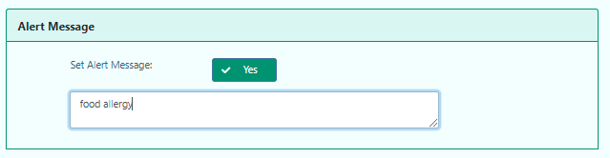
The user has to enable Yes to write the alert message for the patient.

The last option is Chief Complaint and Diagnosis, that prepares the patient for the endoscopy-
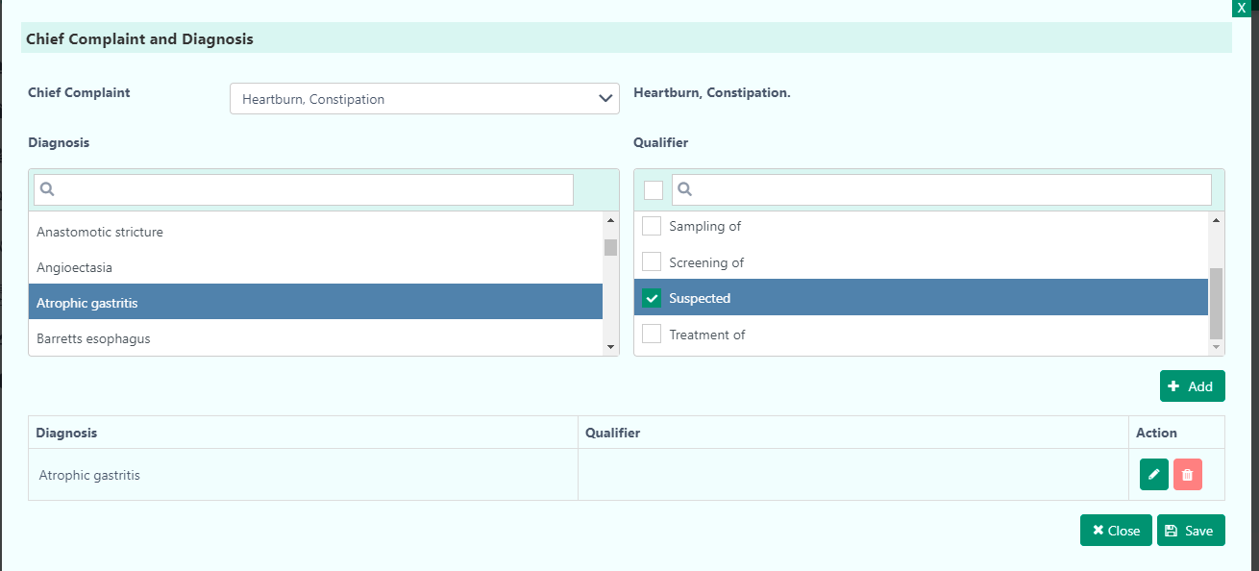

After selecting the Diagnosis and Qualifier, the user will get a confirmation message by clicking on the Save button.

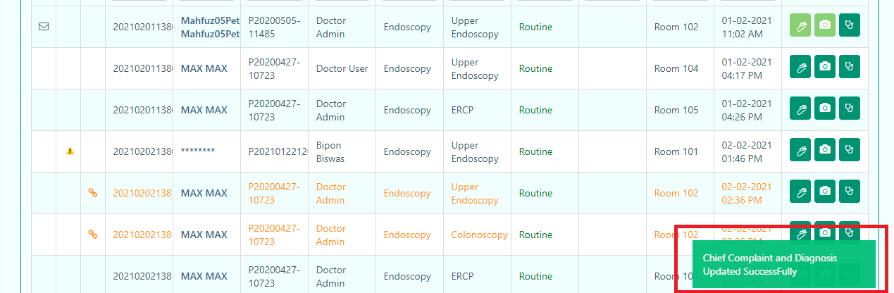

Vital Signs
You can add a patient’s Vital signs from the Preparation Worklist or from the Pre-preparation section. To add from the latter, click on the Vital Signs icon at the end of the form:

This opens the Vital Sign form as a panel from the left-
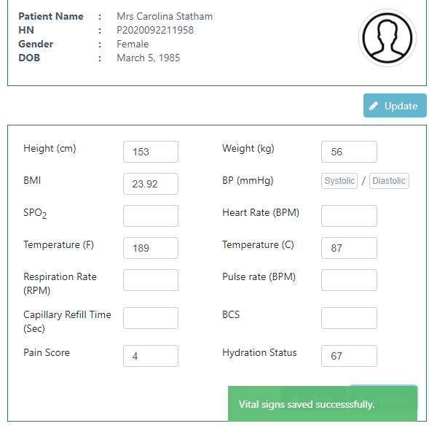
You can now save the details and transfer the patient for Imaging, using the Save & Transfer button. If you wish to just save the information and not Transfer yet, you can select the Save button, and Transfer later.
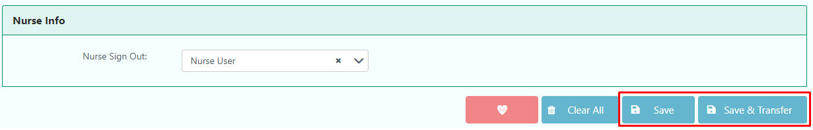
Note that the Vital Signs button is now red, indicating that it has information in it.
Once you transfer the patient, the patient information moves to the Imaging tab.

Imaging:
From the Imaging section, you can-
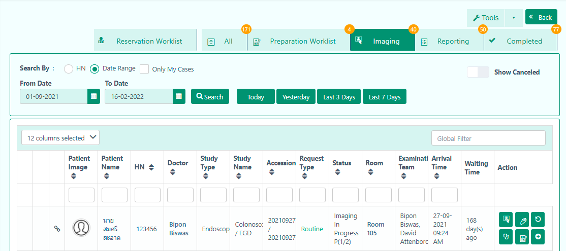

- Start imaging
- Patient PreScope
- Patient History
- Chief Complaint and Diagnosis
- Resource Allocation
- Add Consumable Item

Patient History: As a doctor, you might want to take a look at the patient’s History. Click on the icon that takes you to the patient’s past records:
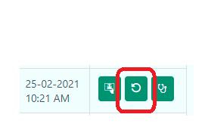

Updated:23/2/2021

Start imaging: When the patient is ready, the user can start imaging by clicking the start imaging button.

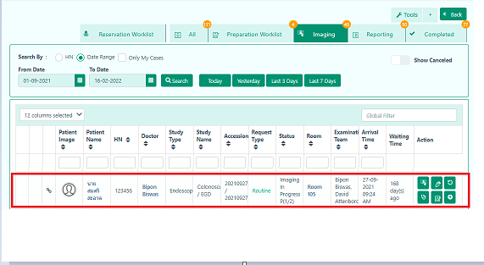

Note: If you do not select the scope in the previous step , it will continuously give notification for selecting the scope.
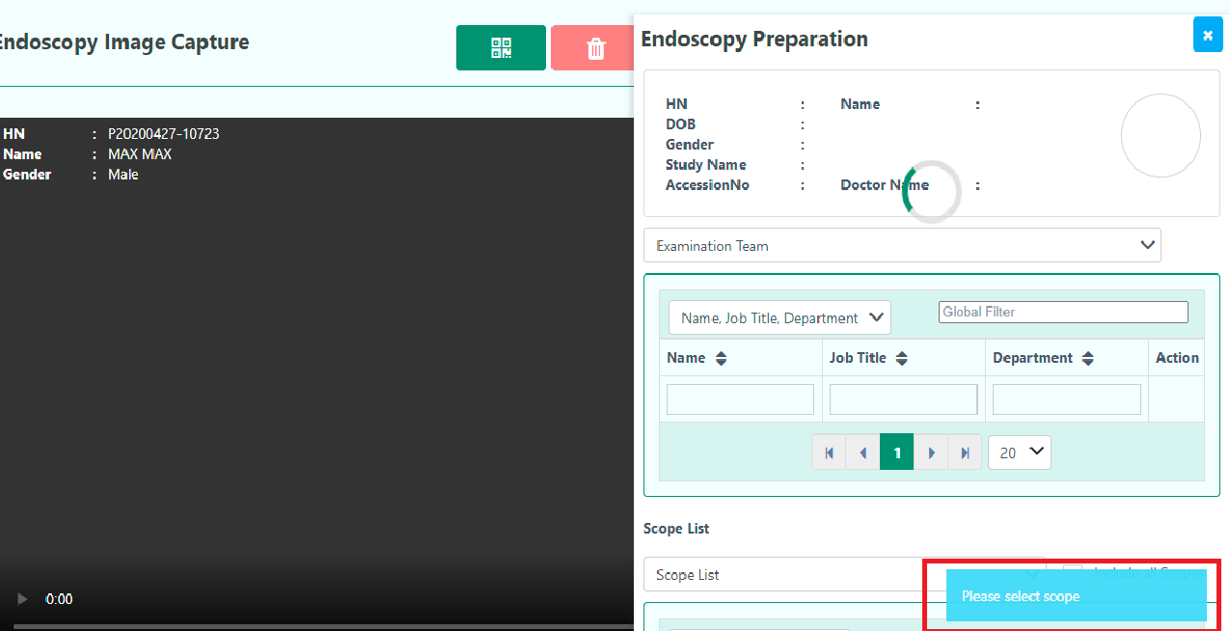

The user has to select the Resource Allocation for selecting the scope.

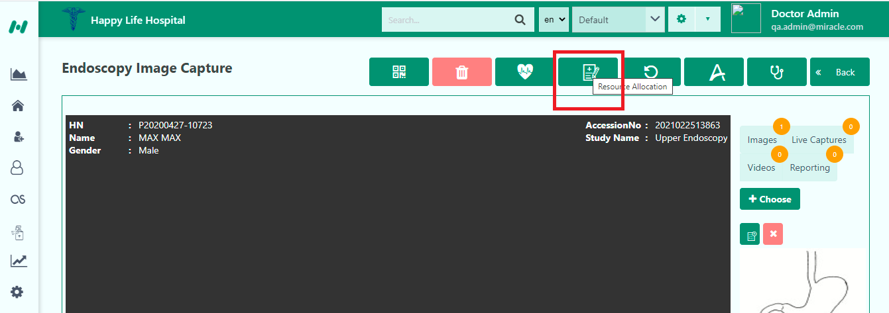

After selecting the Resource Allocation, the user has to select Include all Scopes. Then, select Scopes from the dropdown.

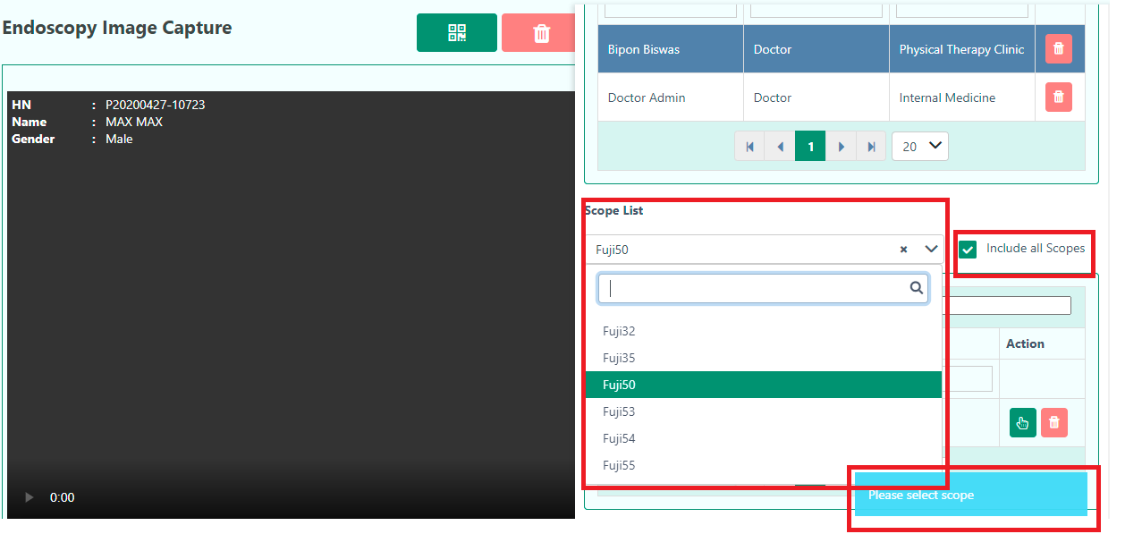

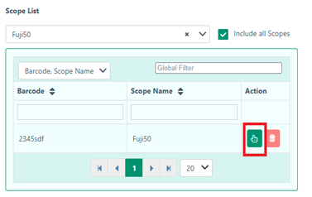
After pressing the select button, the user then selects the Scope in button to start the procedure.

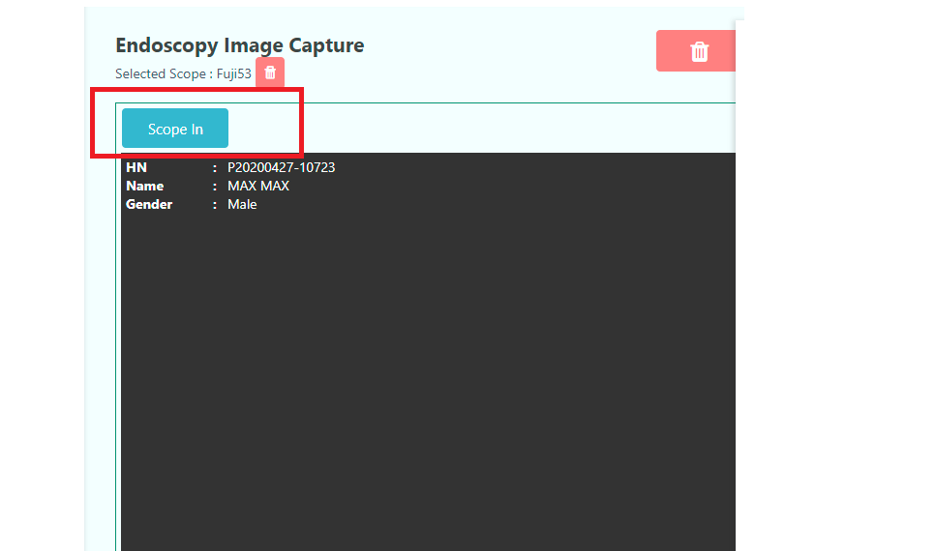

Note: When the user presses the Scope in button, the Action list in the right corner becomes disable. The user should disinfect the scope later to use it again.

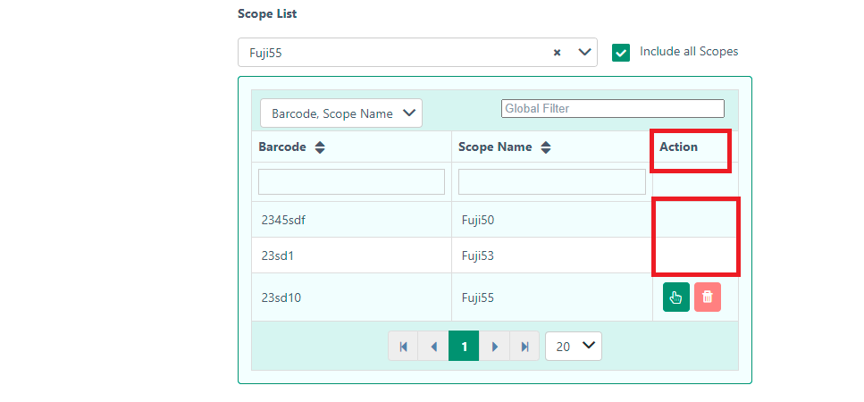

The user then starts the imaging process by selecting the video source.

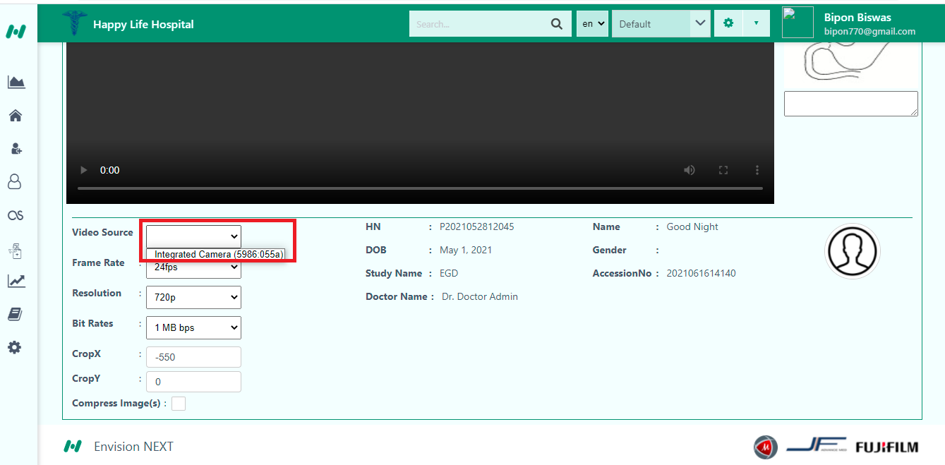

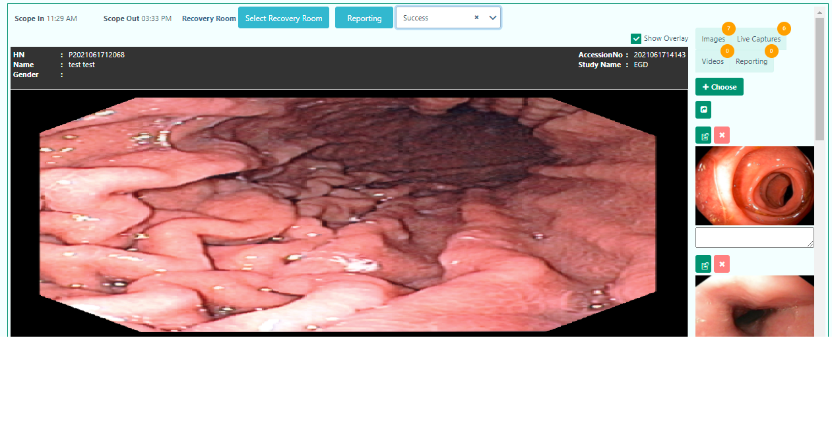
The user can notice the number of images and Live captures from the above.
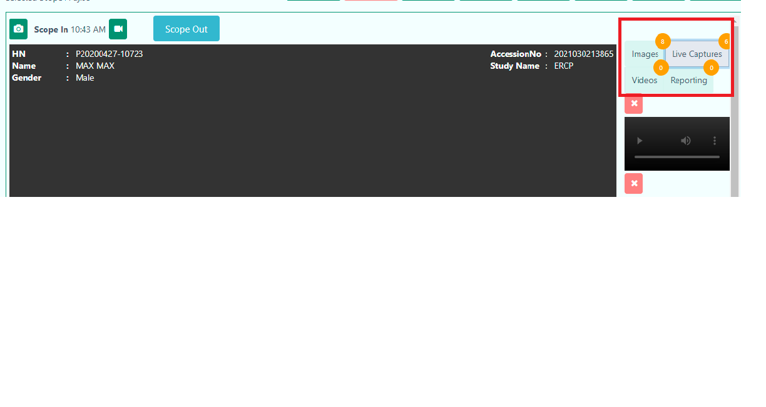

The user can see the video where the image is captured by simply clicking this button.

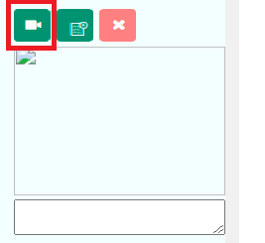

Note- Keyboard Shortcut-
- Alt+ c= Take Picture.
- Alt+ r= Start Recording.
- Alt+ s= Save.
- - = Capture Image

Moreover, the user can crop video by giving start and end value.
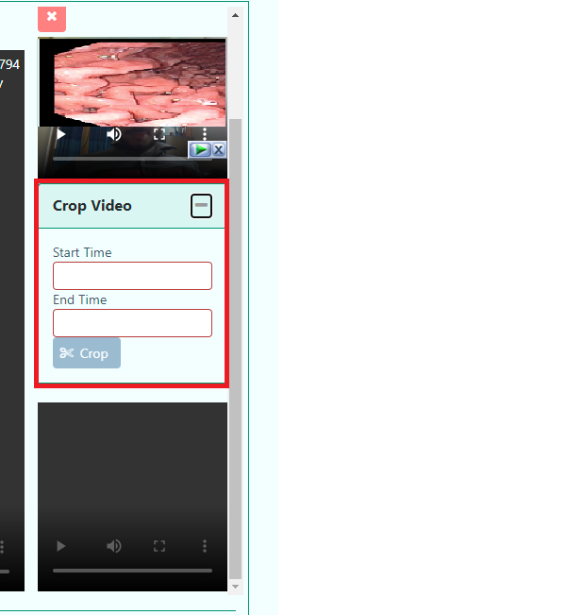
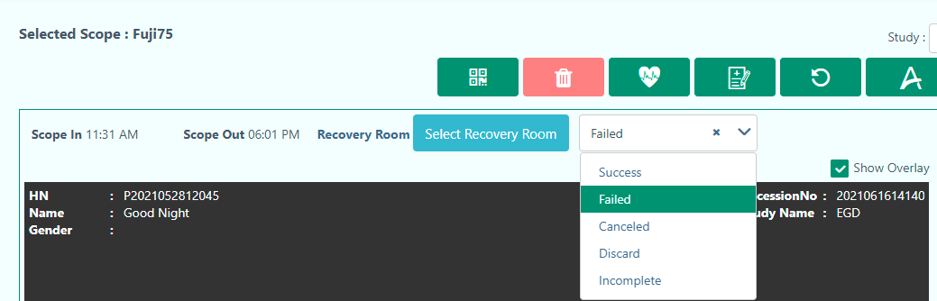

The user has to select procedure status to enable the Reporting button. The button will enable when the status is Success.

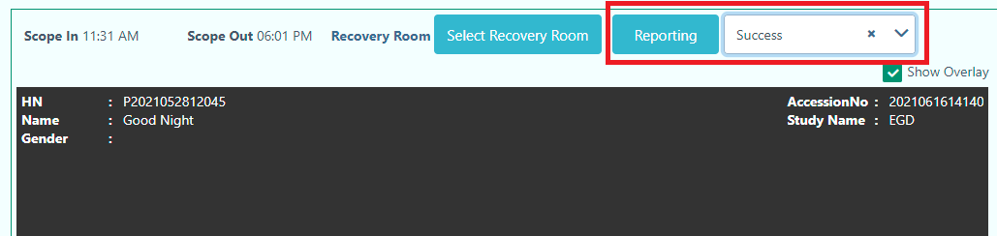

There are five procedure states.
- Success
- Failed
- Canceled
- Discard
- Incomplete

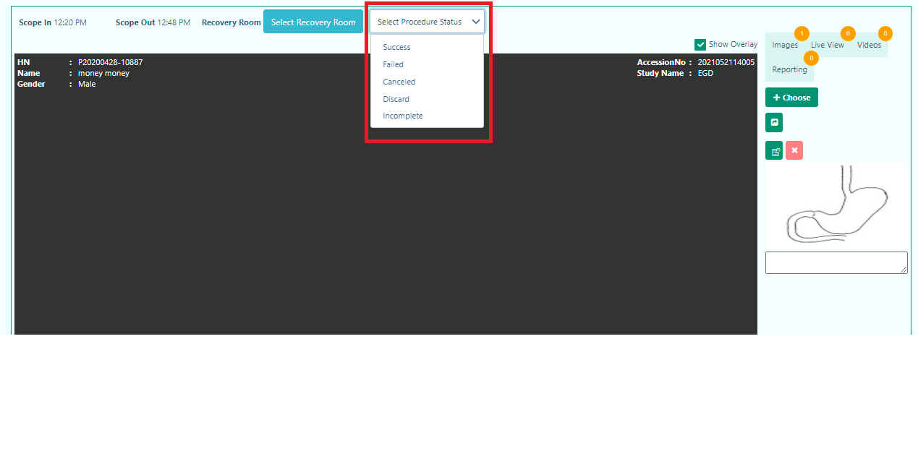
The procedure depends on the study. When you finish the study successfully,you can select Success. Otherwise, you can select according to your result.

The user can also control the overlay of the screen by simply clicking the “Show Overlay” option.
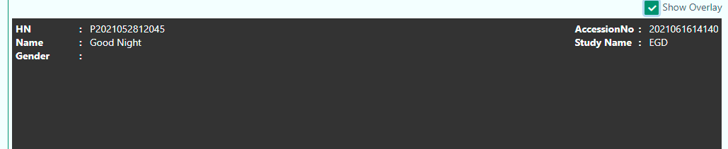
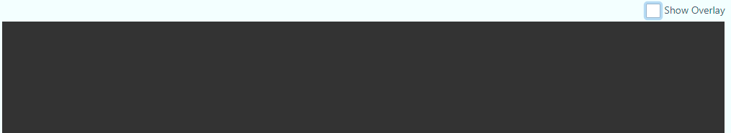

In the imaging section, the user can also check the Vital Sign of the patient.
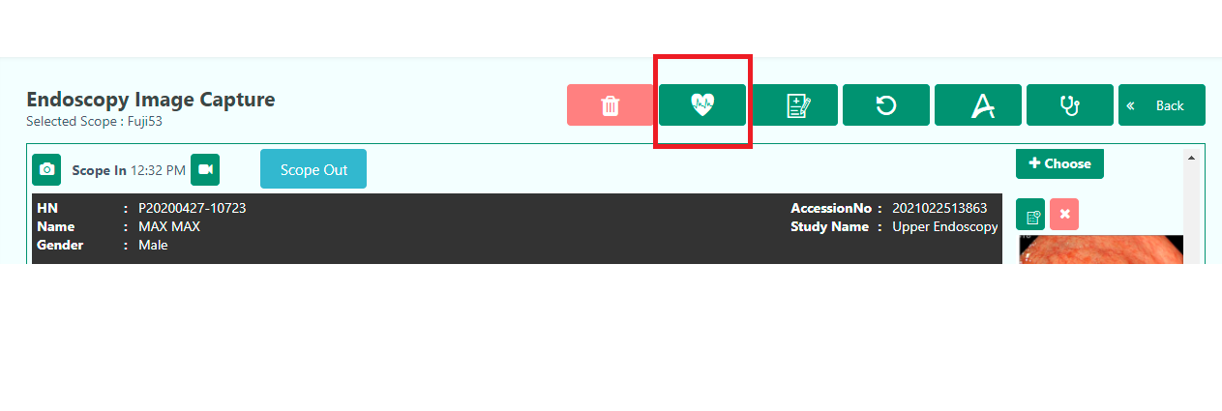



The user can also check Patient History and Chief Complaint and Diagnosis accordingly.

The user can add all Images to Reporting and also they can select one by one to Reporting.

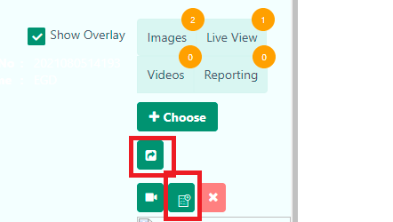

Updated:25/2/2021

Reporting:
The user can go to Reporting from Imaging by selecting the Procedure status to Success. 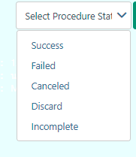

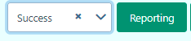

Also the user can easily generate reports for the patient from this section.

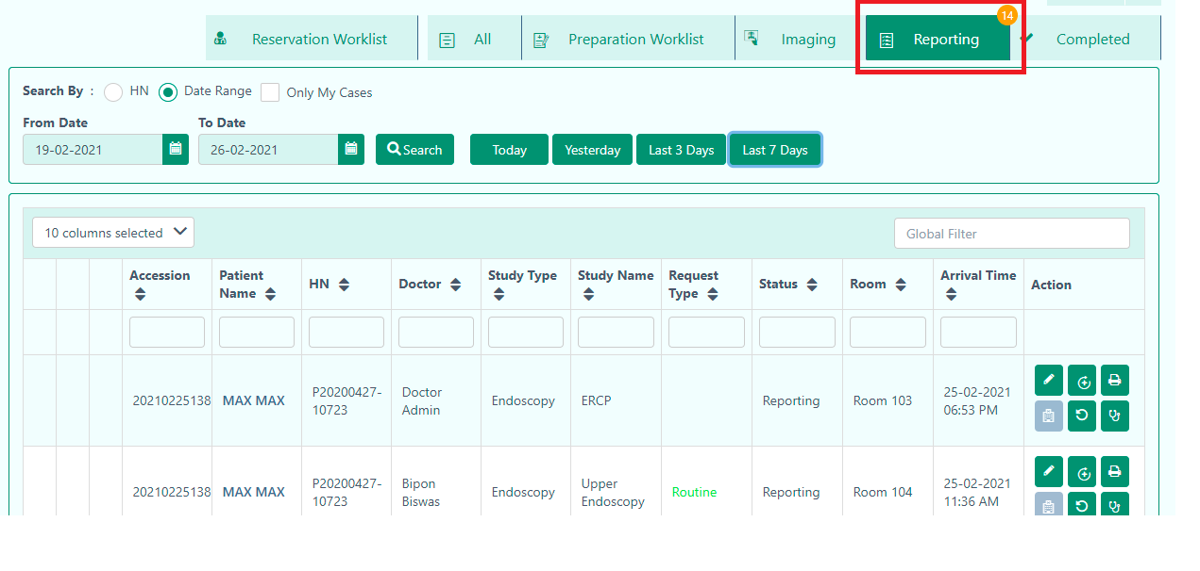

From the Reporting the user can-
- Write Reporting.
- Go to PostScope.
- Discharge.
- Patient History.
- Chief Complaint and Diagnosis.
- Report.
- Consumable Item.

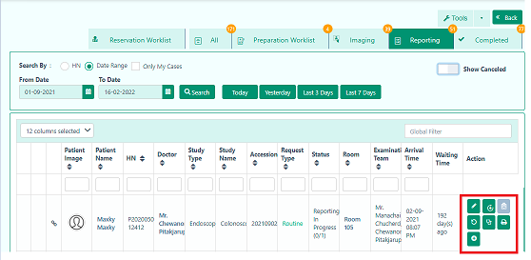

Write Reporting: When the imaging part is done, then the user can start this operation by clicking this button.

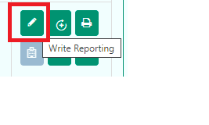
In this section, the user will find two sections.
- The Information of the Patient
- Captured Files.

In the first dropdown, the user will find the patient information.
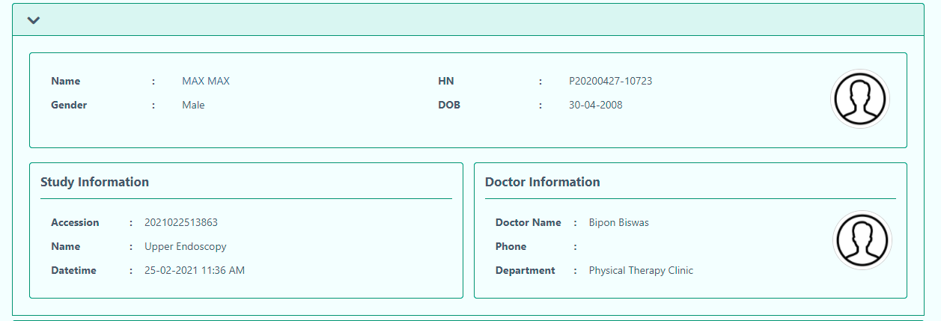

Captured Files: The section contains the data from the Imaging. The user can see the images, Live captures, and Videos. They can also choose images from their devices also. There are also some buttons where the user can control the images like- minimize, sorting, maximize, and select specific selected images for adding it to reporting.
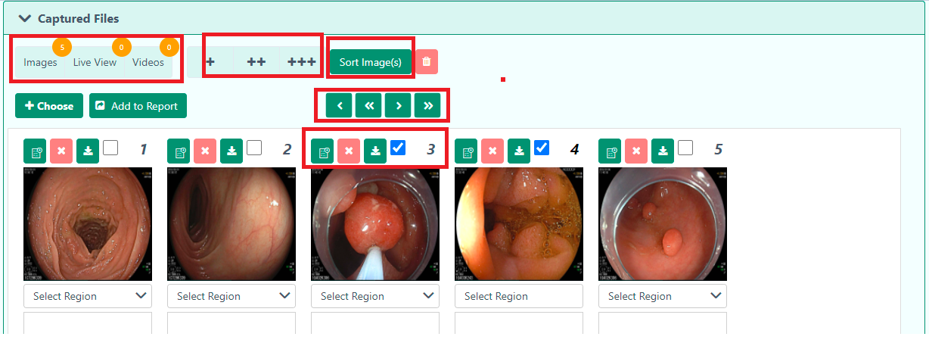

Note: The user can comment inside the comment box in each image.
Finally, the user can add the images to the reporting. 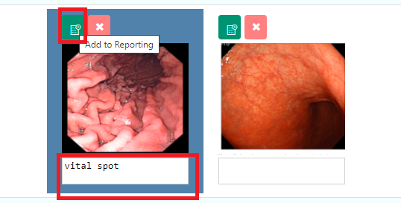

The user can easily delete the picture with the above cross sign button.
Note: If the user deletes the picture mistakenly, they can simply restore the photos.

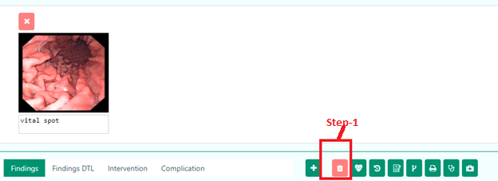
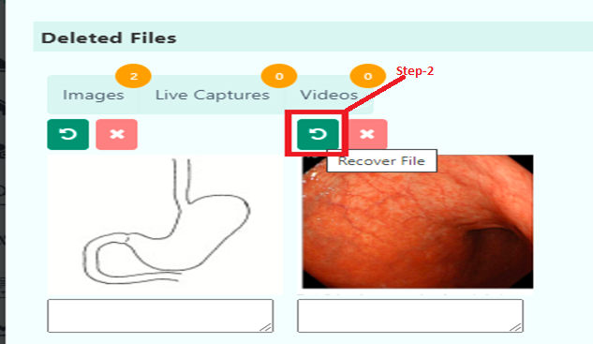

Study Metrics

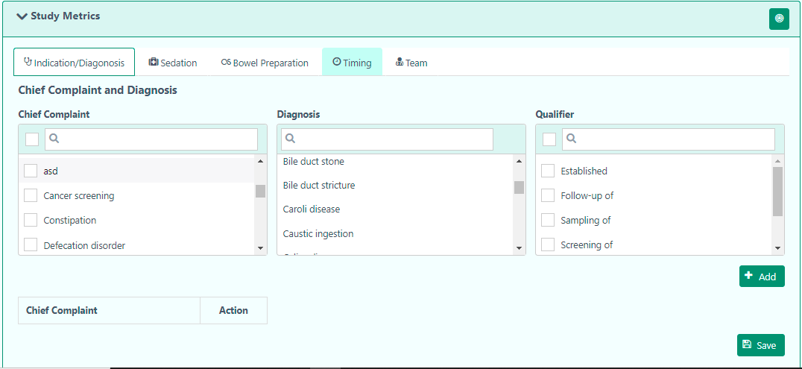

The user will find five sections in Study Metrics.
- Indication/Diagnosis
- Sedation
- Bowel Preparation
- Timing
- Team

Indication/Diagnosis-

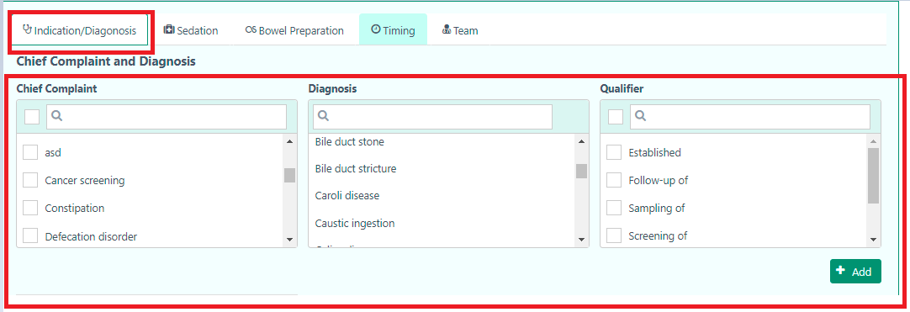

Add Sedation
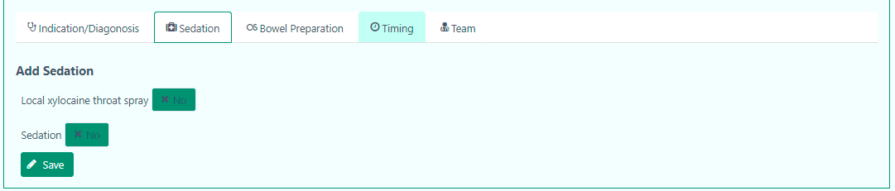

Bowel Preparation

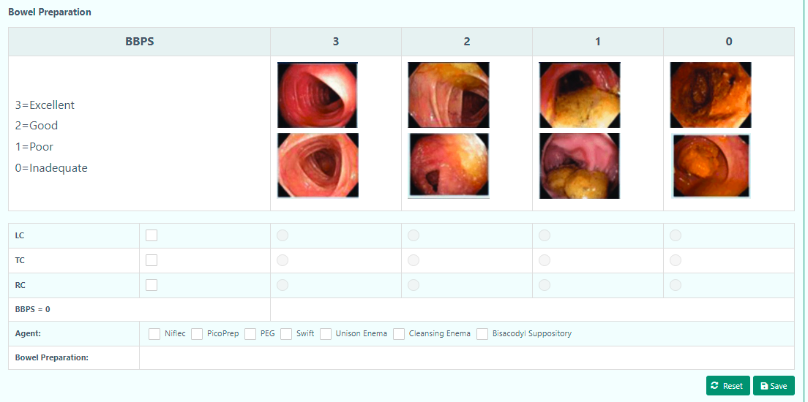

Timing

The user can view the start and end procedural time of the scope. It also provides the duration of the procedural time.
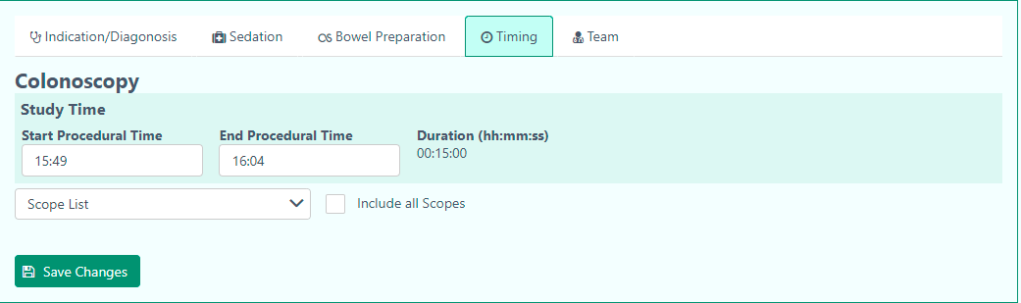

The user can also select scope from Scope list. Moreover, they can select Include all Scopes checkbox where they will find all study scopes.
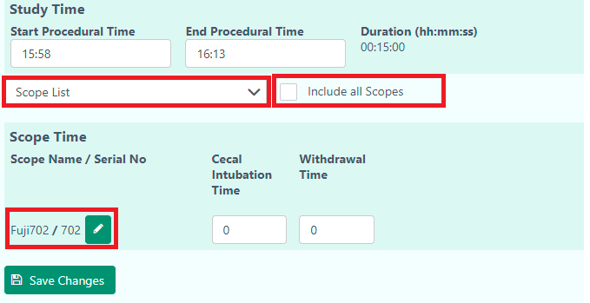

Note: The user can also edit the start and end procedural time.

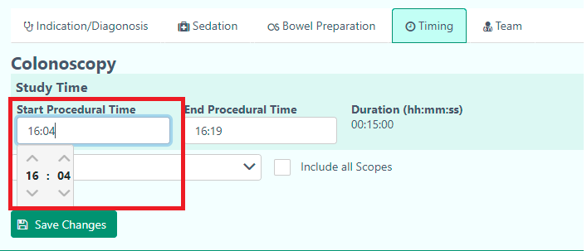

Team
The user can add more teams from this section. They can select the team member from each of the dropdowns.

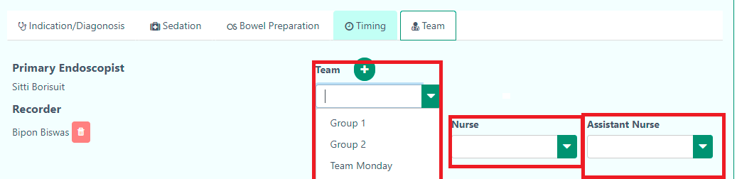

The user can choose the findings of the patient by
- Lesion
- Findings
- Findings DTL
- Intervention
- Complication

The user will find detailed options in every finding. It will help to make a detailed report for the patient.

The user can add a multi-region and repeat the findings of the patient. After selecting the Lesion, the user can add multiple findings by clicking this button. It will help the user to add more findings of the patient if needed.
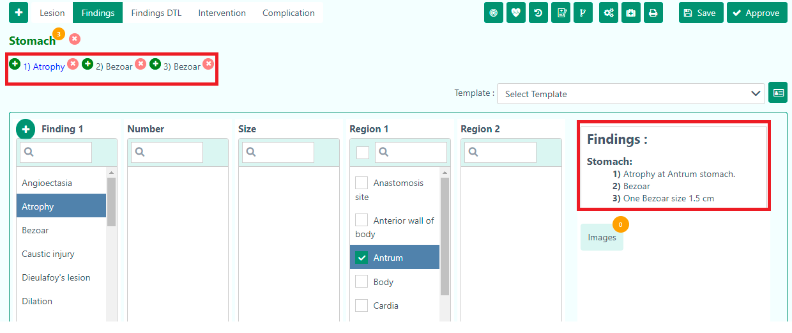

The user can add this report as a template by simply clicking 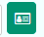this button. After that, the user will find a pop up page where they have to input template name, access type, and description.
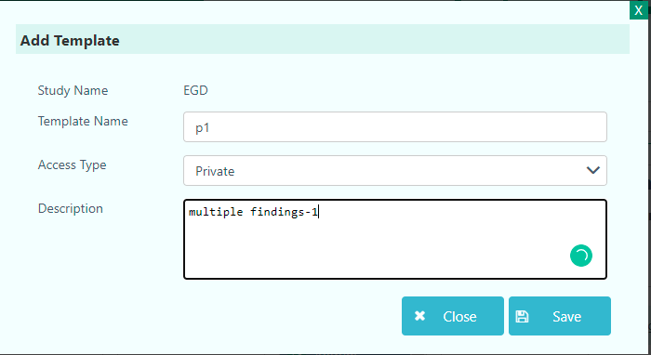

Finally, the user have to click the Save button.
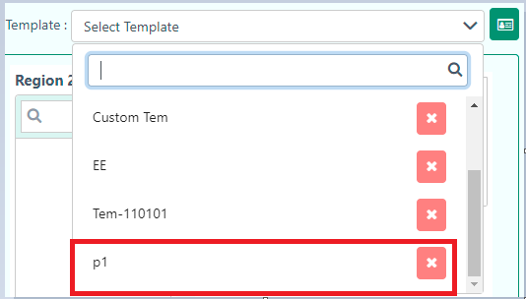

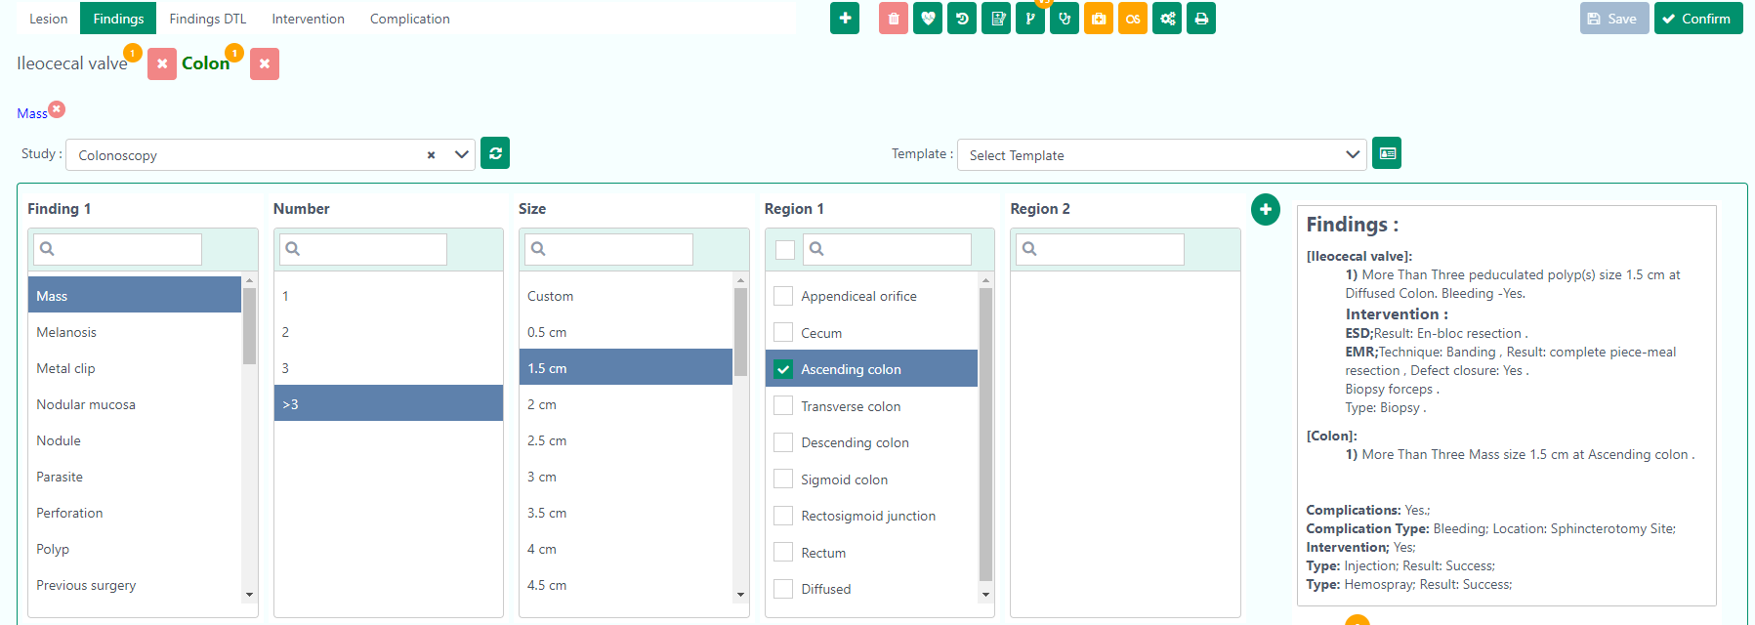

Moreover, the user can save the template of the reporting for similar types of patients.

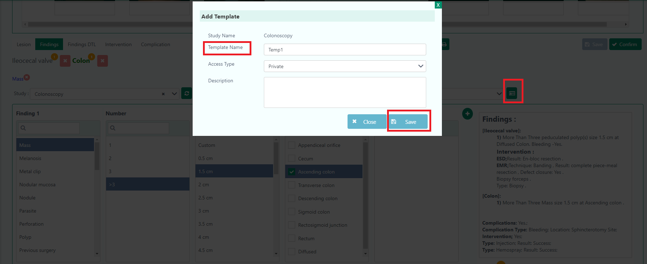

The user will get a confirmation message after clicking the Save button.

The user will find this template in the Template dropdown.

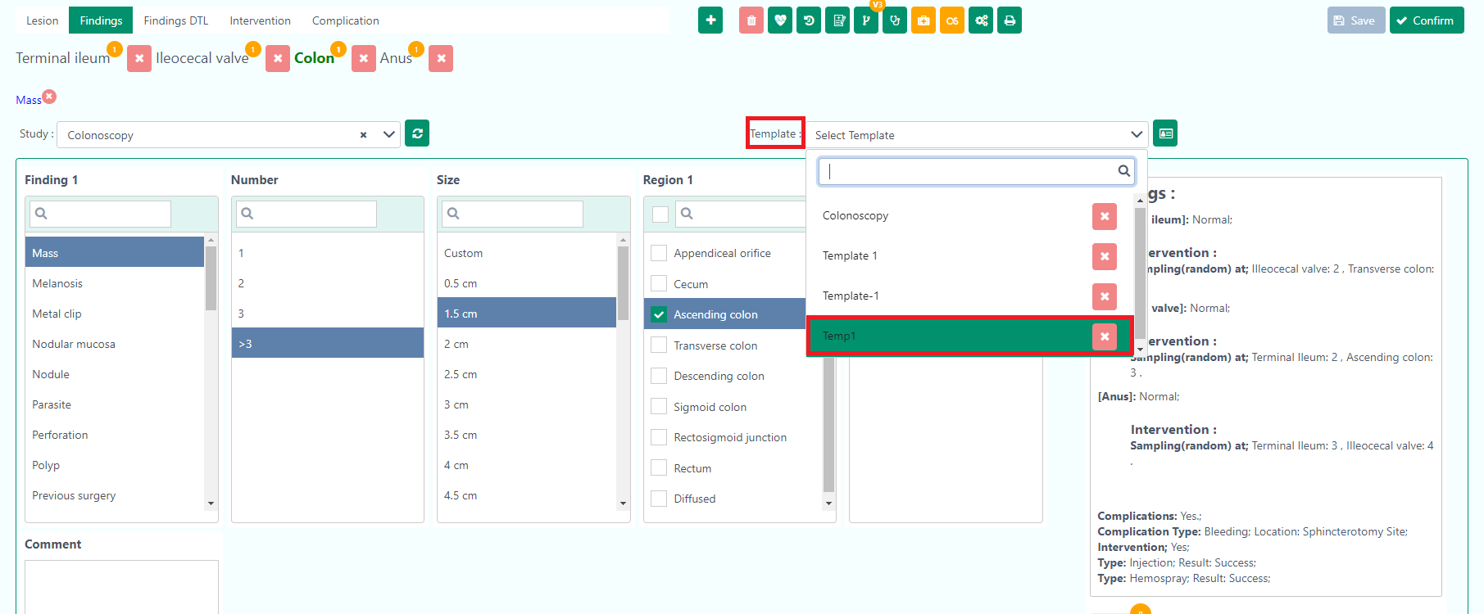

Moreover, the user can select Sedation and Bowel Preparation for Reporting. The user can choose Bowel Preparation only in Colonoscopy.

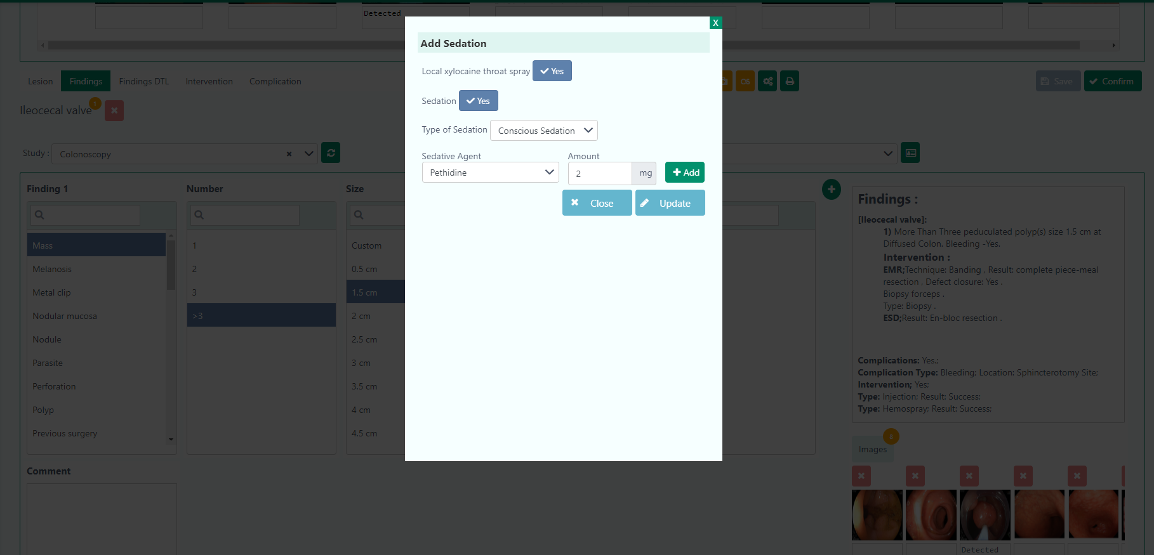
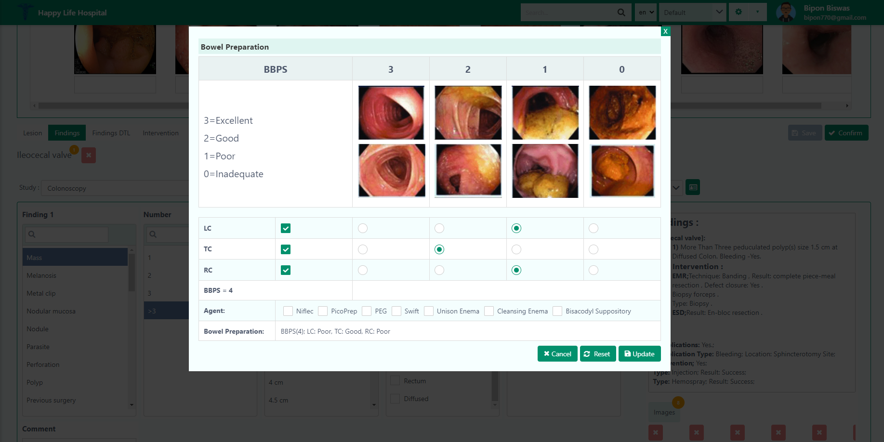

Finally, the user has to select the Confirm button, after completing all the procedure.

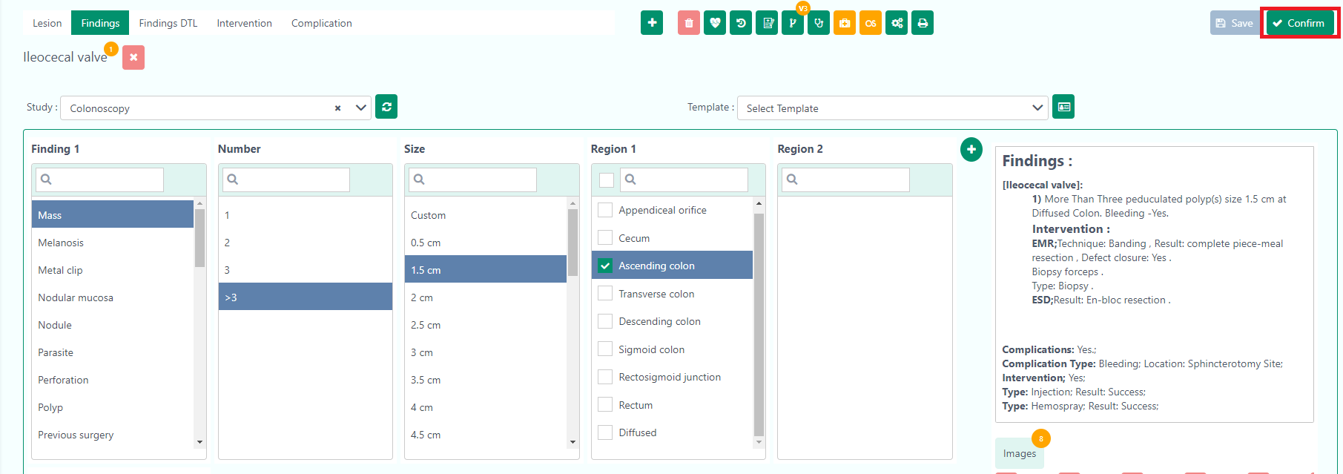

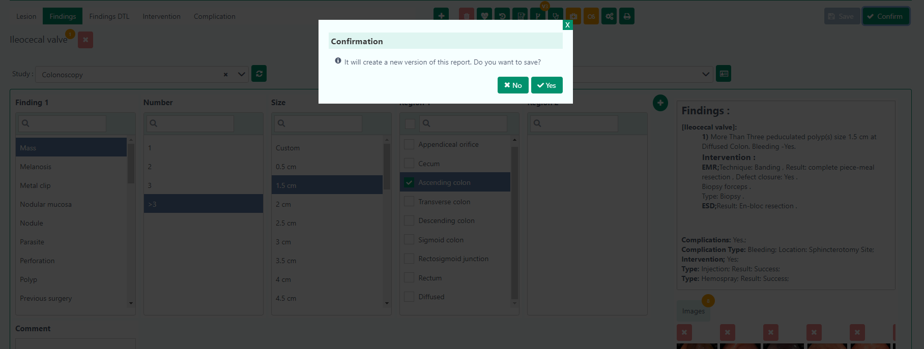

To see the report, the user has to click the Preview Report button.
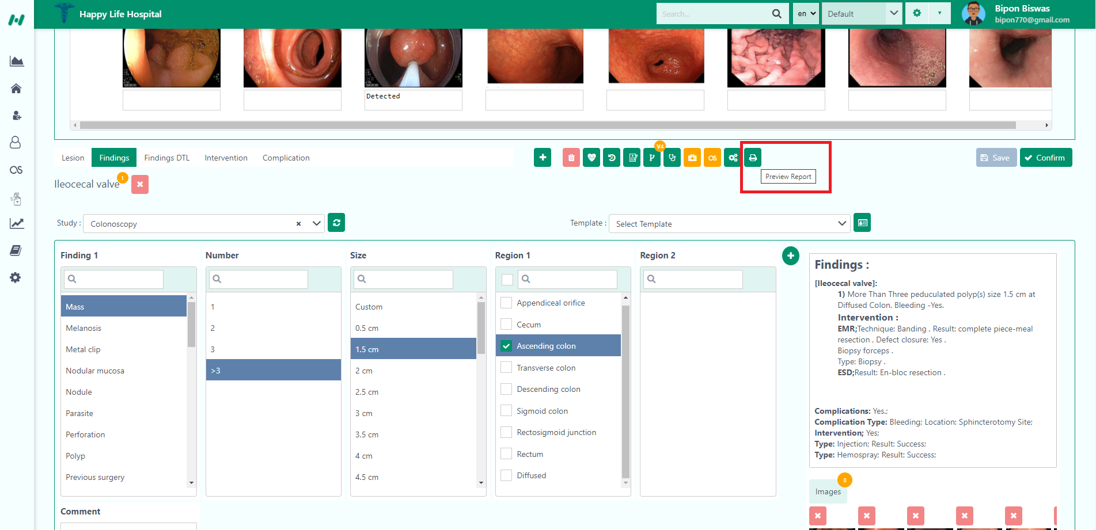
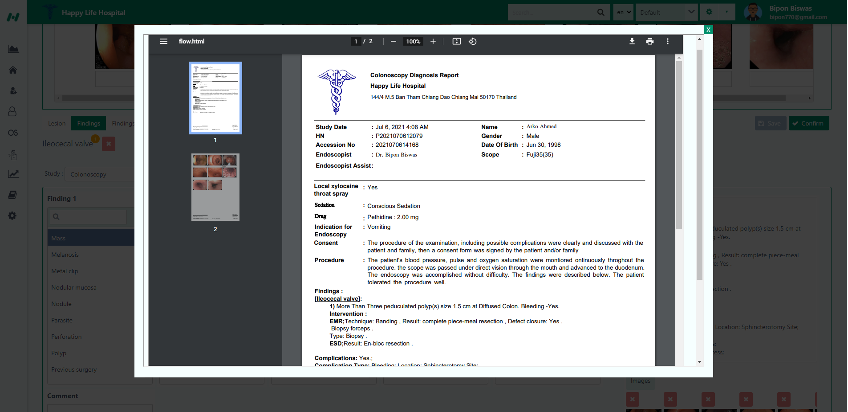

Updated: 3/2/2021

Completed:

Nursing
Inside the Nursing, you can view statuses of a patient, what stage they are in, and in general, the whole process/cycle that a patient will go through from the moment s/he discharged until the completion of the nurses.

Nursing is organized with two tabs that will carry a patient record form one tab to the next, until the client has completely discharged.

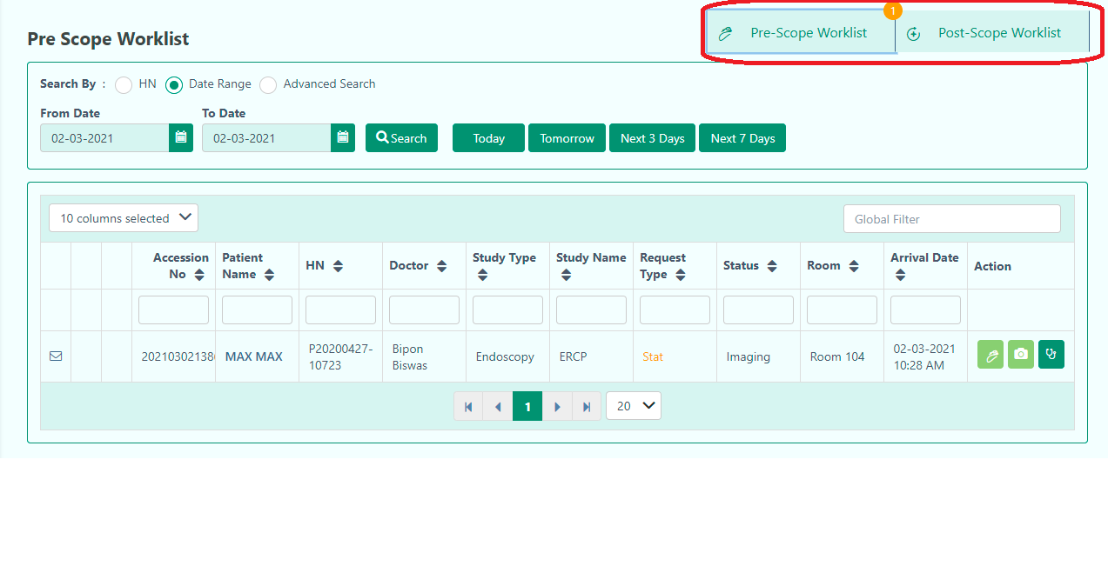

Updated-2/3/2021

Pre-Scope Worklist:

When the user clicks the Nursing button, this page is shown as a default page. When the patient registered, the user can see the data of that patient in this field.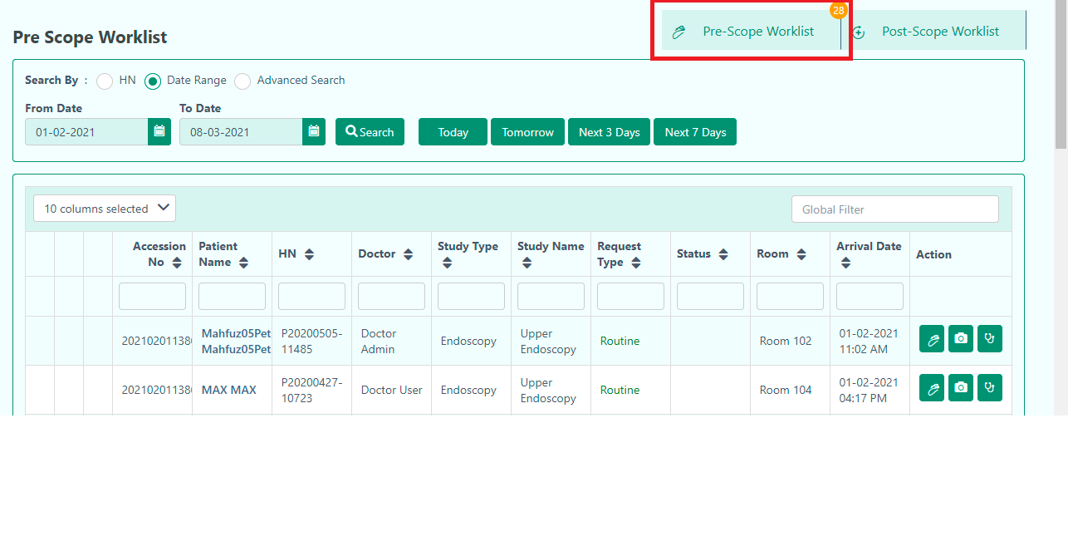
From the Pre-Scope the user can-
- Prepare PreScope.
- Transfer to Image
- Chief Complaint and Diagnosis.

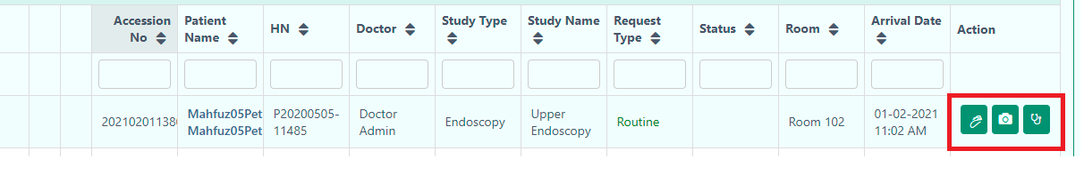

Prepare PreScope
The first option is Prepare PreScope, that preps the patient for the endoscopy-
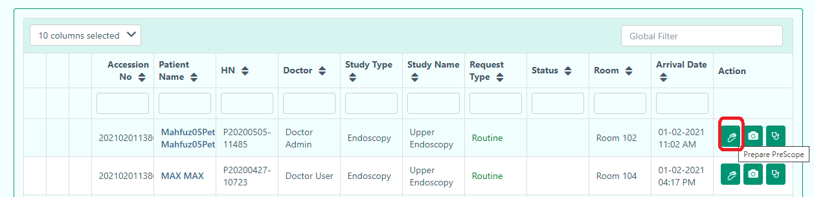

This takes you to the Pre-Preparation section:


This section contains a number of forms that are not collapsible. If you keep scrolling, you will find all the options that you can select/fill in. The sections include:
- Patient Information


Clicking on the plus sign lets you enter text information:


- Check List



The default choice for all items in the list is set to ‘No’. Clicking on it will set it to ‘Yes’.

- Patient History

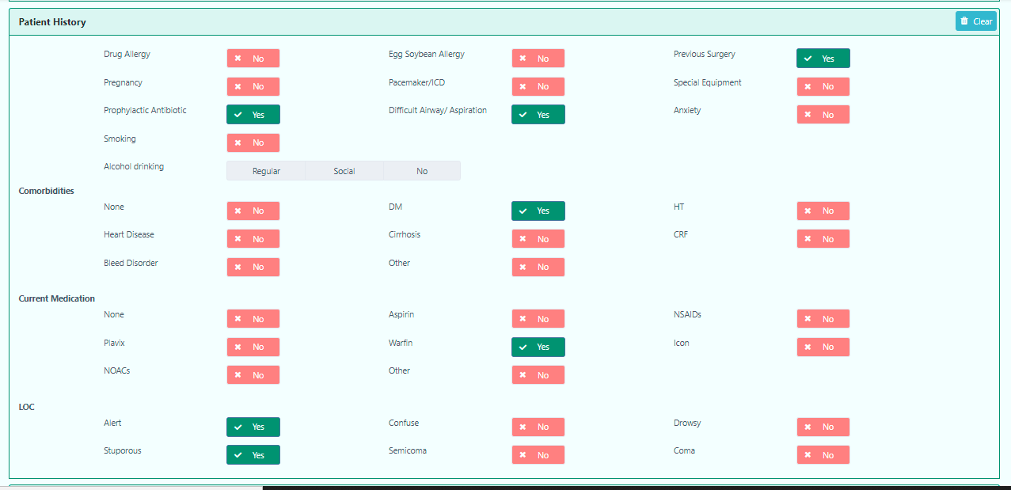
This is the same as CheckList, the default choice for all items in the list is set to ‘No’. Clicking on it will set it to ‘Yes’.

- Breathing



- Blood Component


This is also the same as Check List, the default choice for all items in the list is set to ‘No’. Clicking on it will set it to ‘Yes’. When you click ‘Yes’, the user can give input. Otherwise, the user can’t give input if it is ‘No’.

- Complete Blood Count


- Blood Chemistry


- Liver Function Test

- Check List

- Nurse Info


The nurse can Set Alert Message for the doctor if needed.

The user has to enable Yes to write the alert message for the patient.
When the nurse provides the Alert message, the user can see it in the left corner.

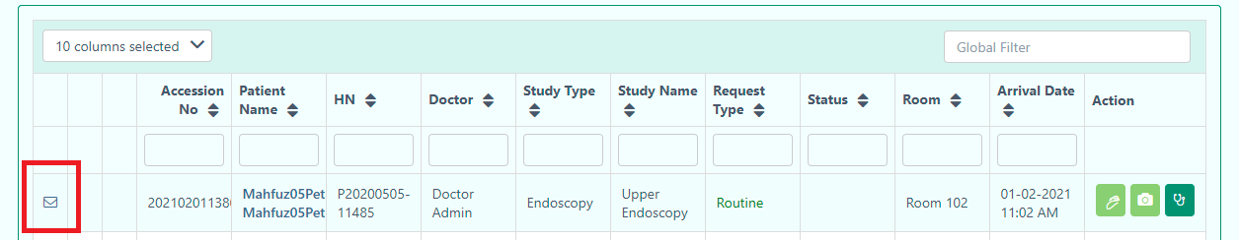
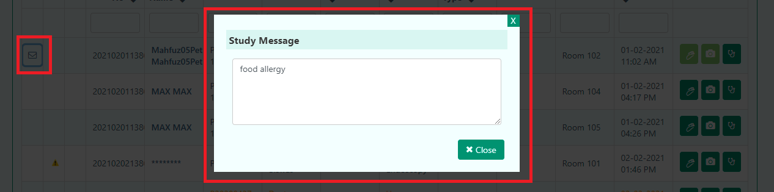

Transfer to Image
The second option is Transfer to Image, that takes the patient to Imaging-
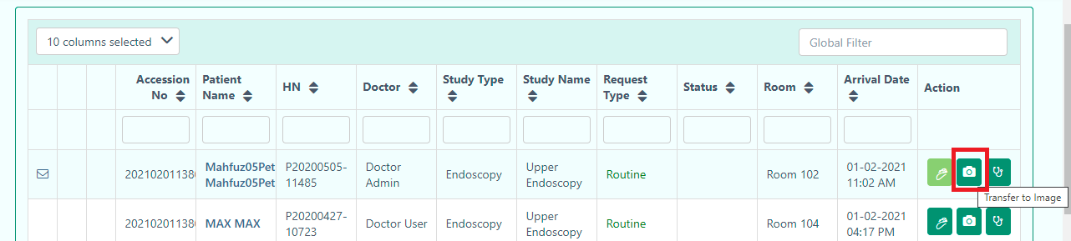

Note: When the user presses the ‘Yes’ button, this will take to Imaging section. Above you will find the details of Imaging.
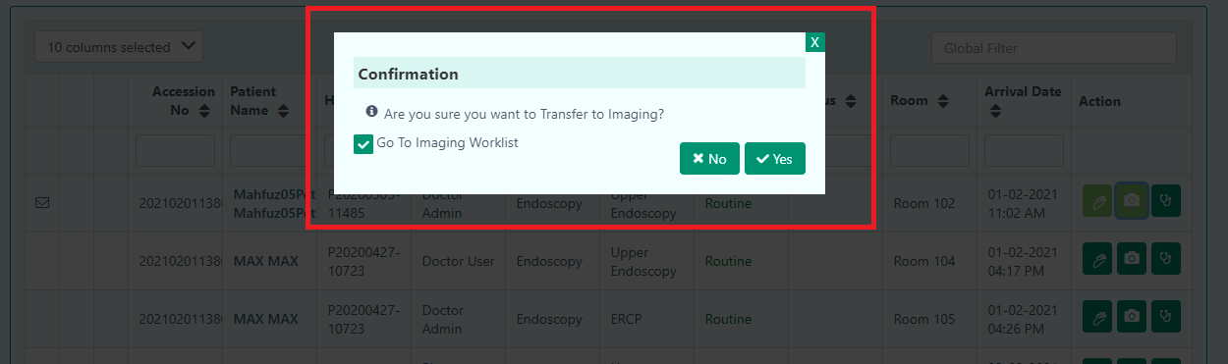

When the Imaging part is completed, the user can see that patient details in the Post-Scope Worklist.

Updated: 8/3/2021

Post-Scope Worklist
After completing the Imaging of the patient, the user can start doing Post-Scope Worklist.
In Post-Scope Worklist, the user can
- Go to Post Scope
- Discharge

Go to Post Scope
By clicking the button, the user will find the Post Scope page.
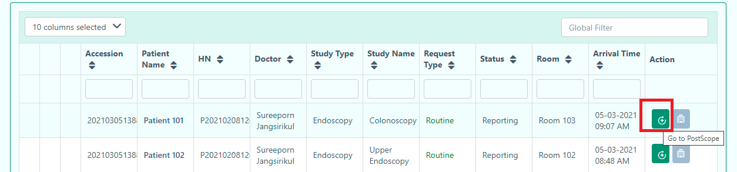

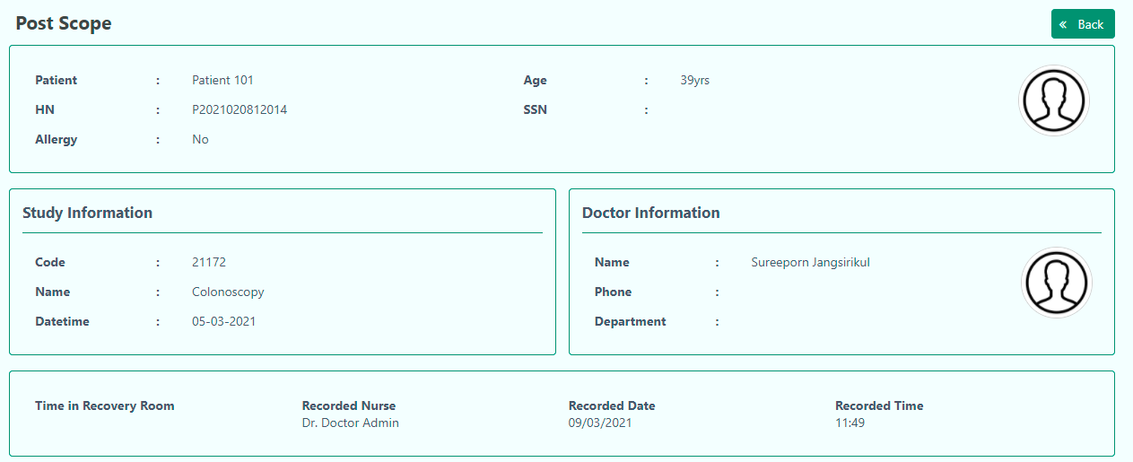

Then, the user can check the patient information in the Vital Sign option where they can Record basic information of the patient for giving discharge or further procedure.

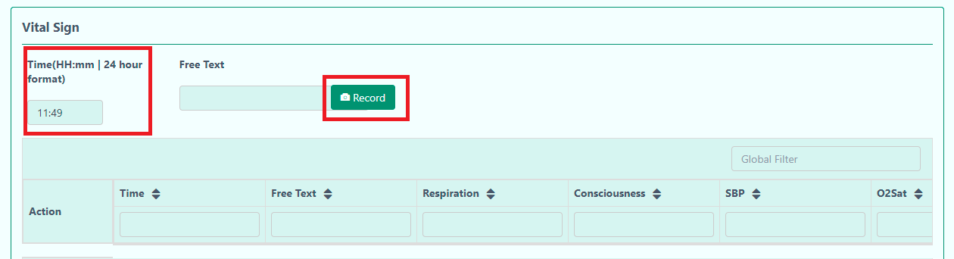
When the patient enters to Post Scope, the timing is also captured in the Vital Sign.

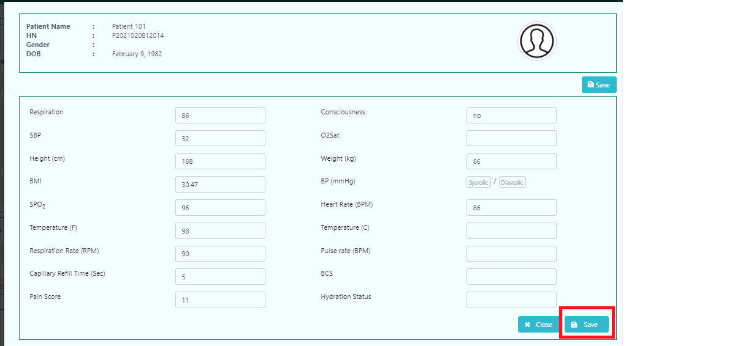
After clicking the Save button the user will find the information in the Vital Sign.
Note: The user can update the patient record or delete the existing one from the Vital Sign.

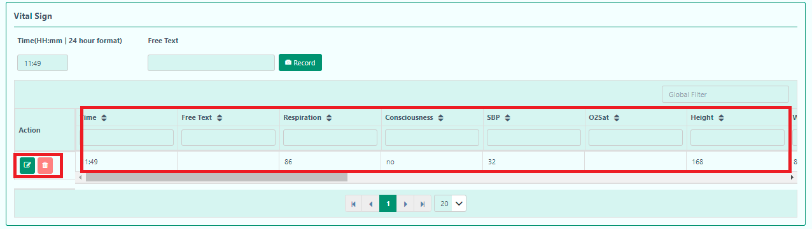

After successfully completing the Vital Sign, the user will find another section Total score for discharge. The patient will be discharge when the score is above or equal 9.
The point will count by checking the below requirements.
- Motor
- Respiration
- Consciousness
- SBP
- O2Sat

Motor
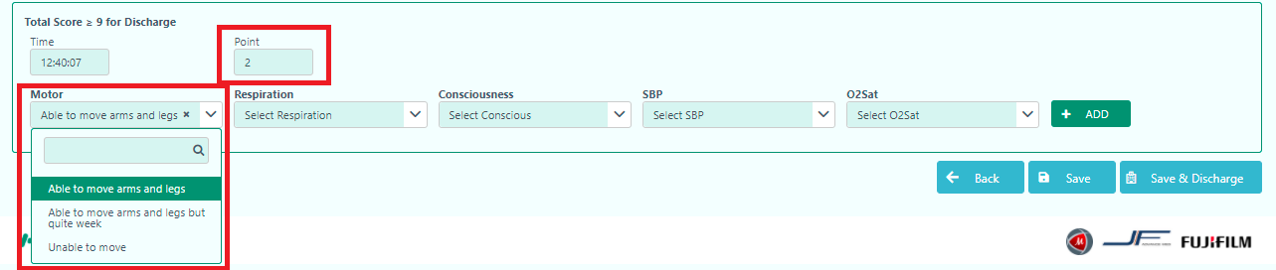
When the user selects the options according to the condition of the patient, the point will be calculated automatically.

Respiration
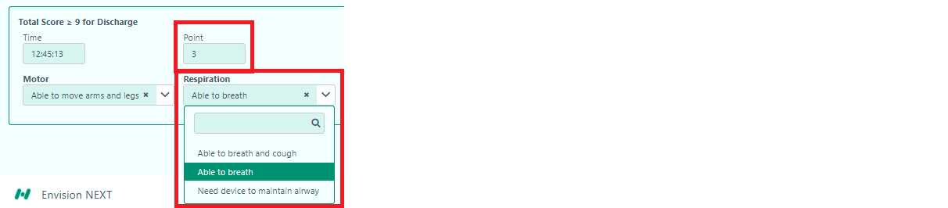

Consciousness
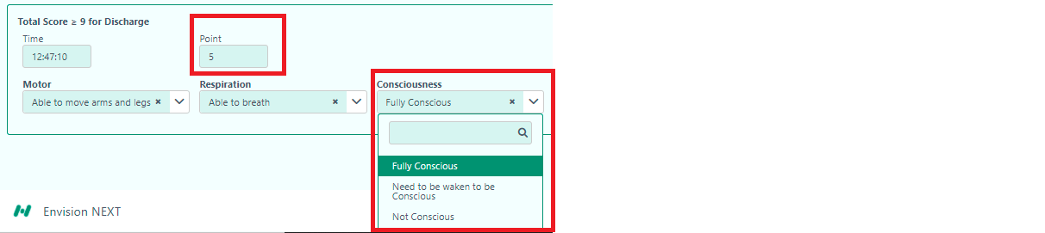

SBP
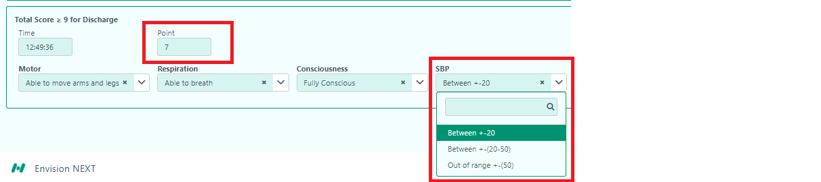
O2Sat
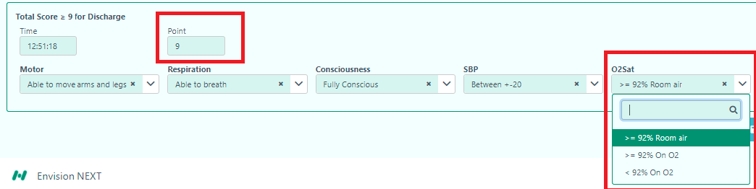
After successfully selecting all the sections, the user has to press Add for further procedure.
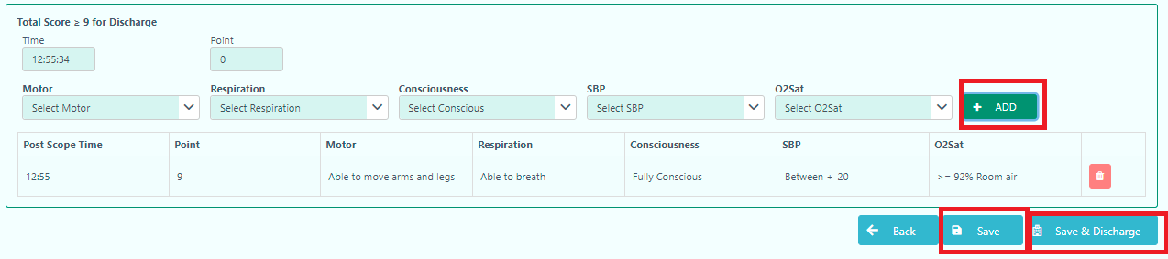

If the user wants to observe the patient more, they can simply press Save button. Otherwise, the user can press the Save & Discharge button.

Note: When the discharge point is below 9, the user can give conditional discharge.
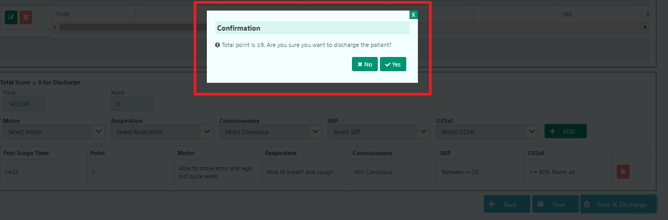

The user has to press ‘Yes’ to open the conditional discharge form where the user provides the instructions for discharging the patient.
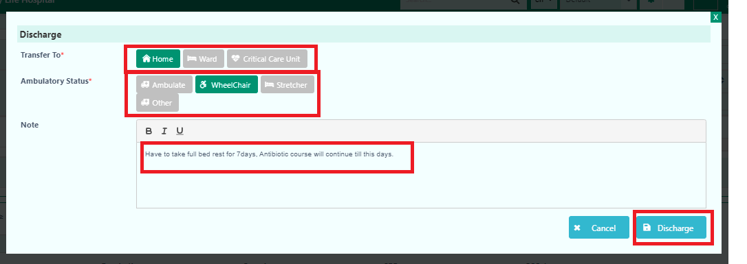

After pressing the discharge button, the user will get confirmation box to proceed.

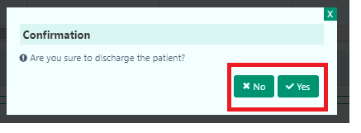
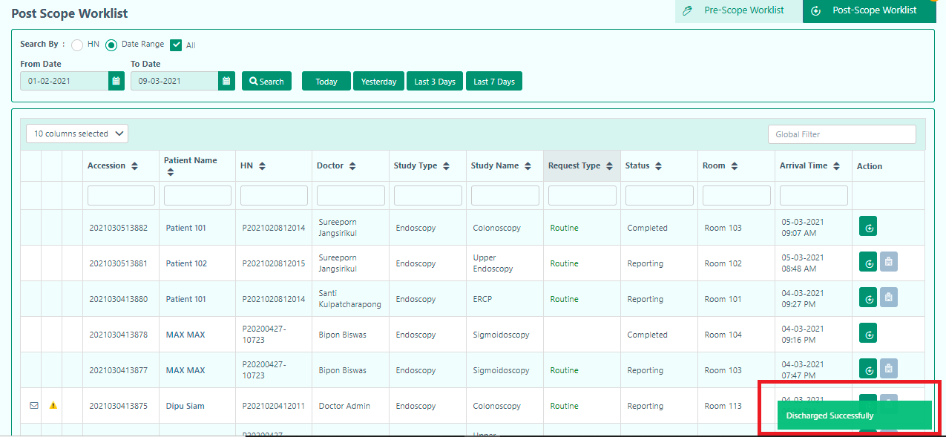

Finally, the user will get successful notification after discharging the patient. The button of discharge become disable when the patient successfully discharged by the user.
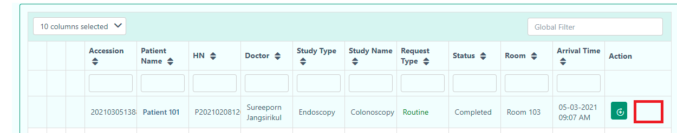

Updated:9/3/2021

Device Management
This section will help the user to maintain the device. The Device Management contains-

- Scope Management
- Endoscopy Management
- Washing Machine Management

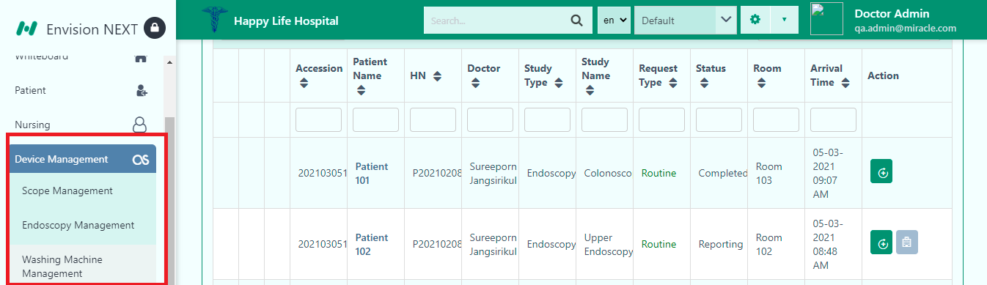

Scope Management
In the Scope Management, the user will find the Scope lists.

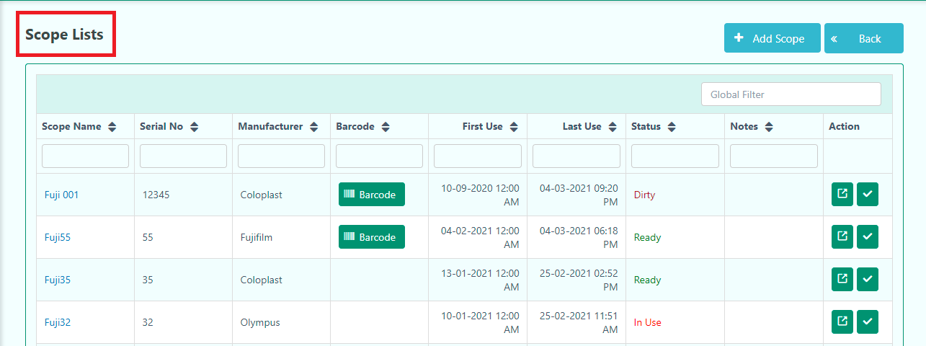

In the Scope List, the user can know the barcode, details of the scope and can active or inactive the scope from this list.
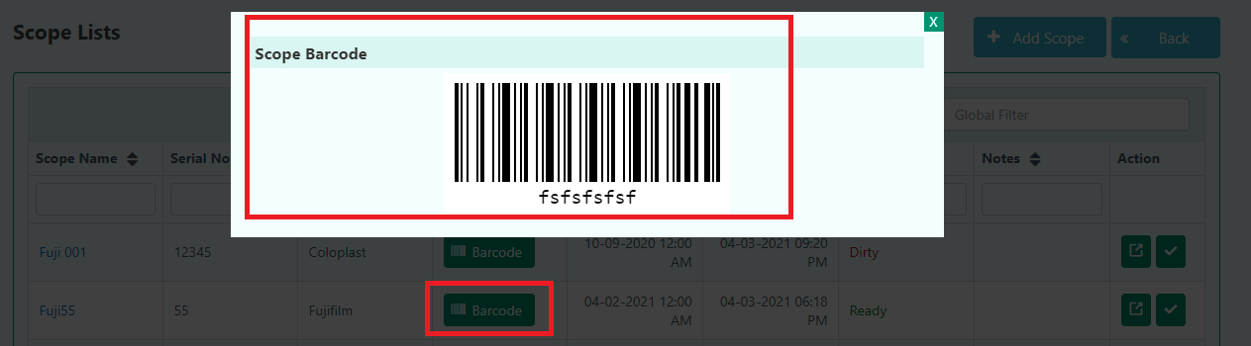

The user can easily see the scope details where the user can Edit Scope Dashboard.

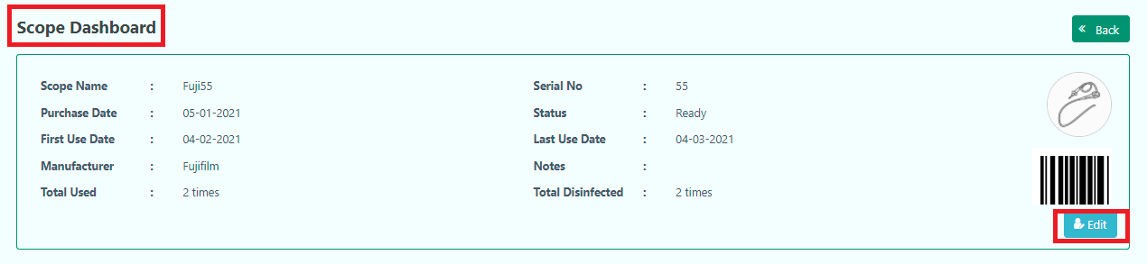

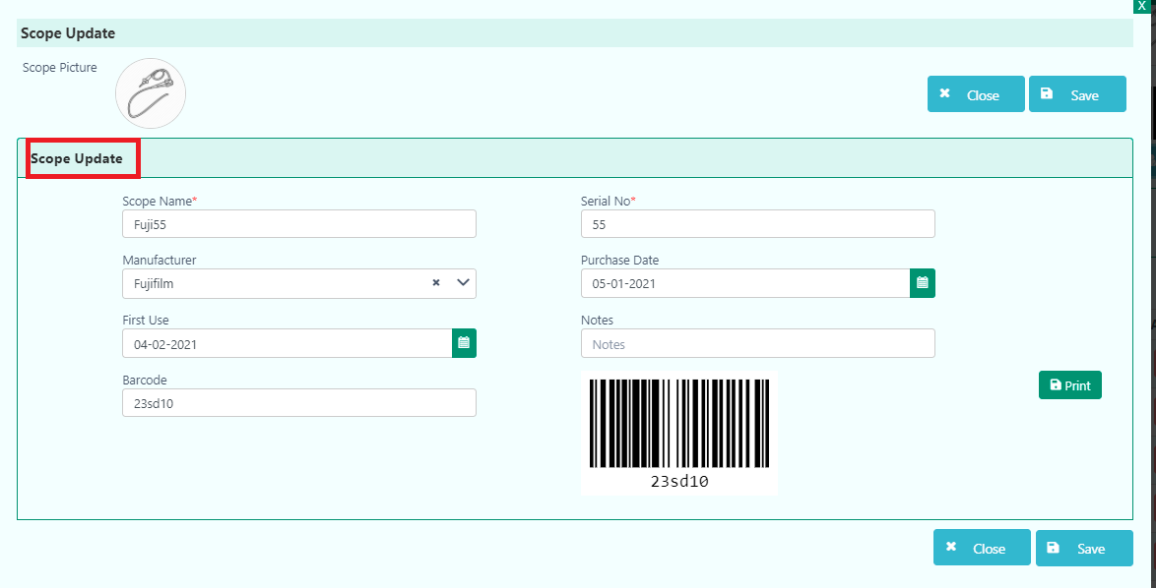
The user also finds Study Information and can Add new Study Information in Scope Dashboard.
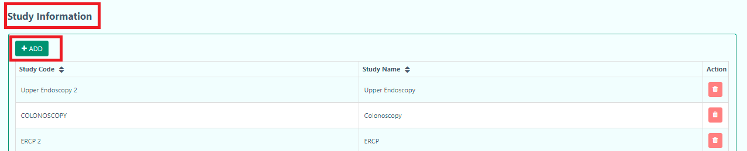

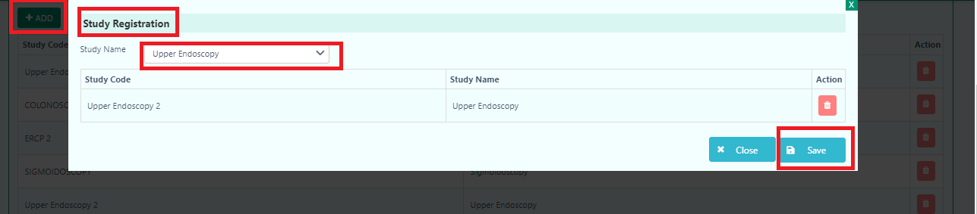

In the History area, the user can find Usage, Disinfection and Maintenance.
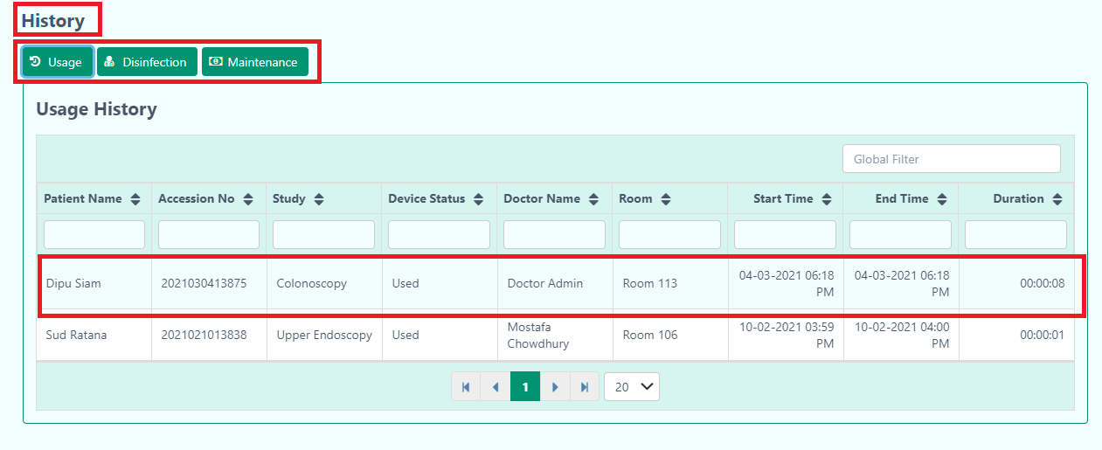

The user will find the used scope in this Usage field and disinfection scope information in Disinfection part.
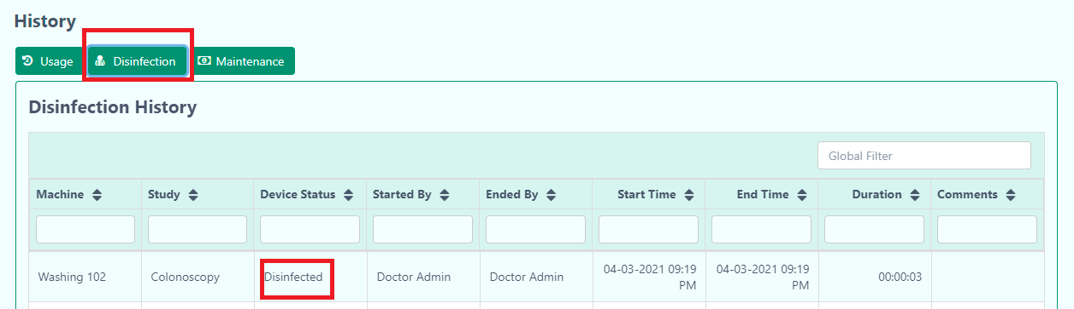

The user can simply Active or Inactive the Scope by clicking this button. While clicking the button, the user will get confirmation messages.

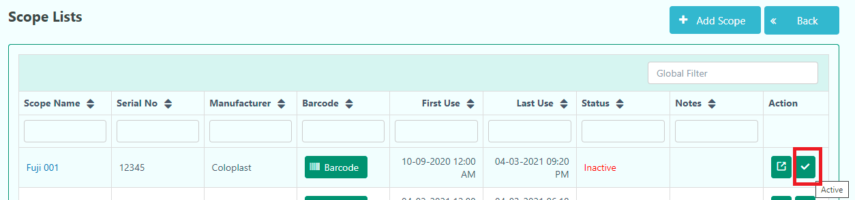

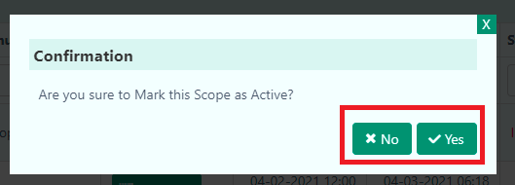

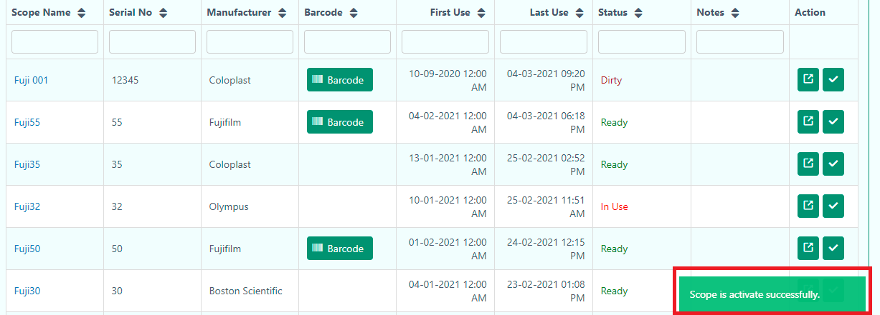

Note: When the user active the scope, the scope is ready for use in Imaging. However, when the user inactive the scope, they can’t use this machine.
Note: If the user wants to active or inactive the machine, they can simply click the (Tick) button. When the button is blur, it will indicate as Inactivate. On the other hand, when the button is green, it indicates active mode.
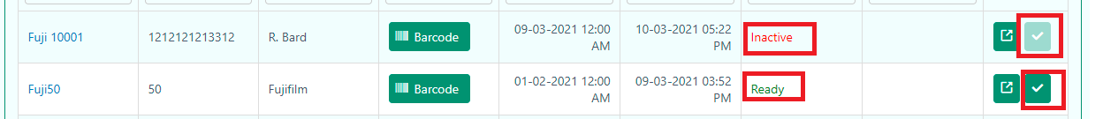

The user can add new scope through Scope lists. After clicking the Add Scope, it will take them to the Scope Registration page.

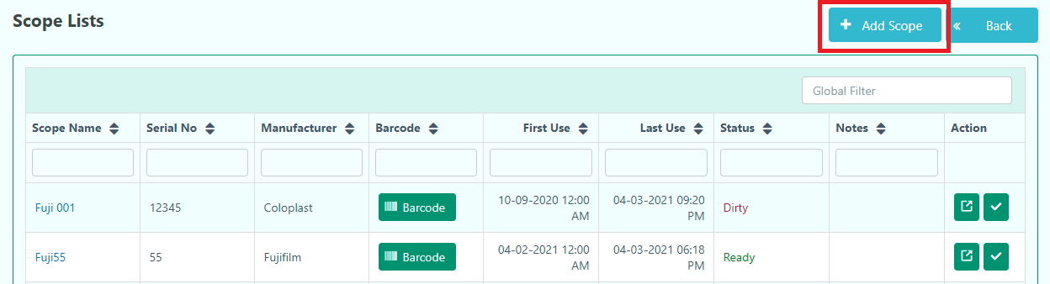

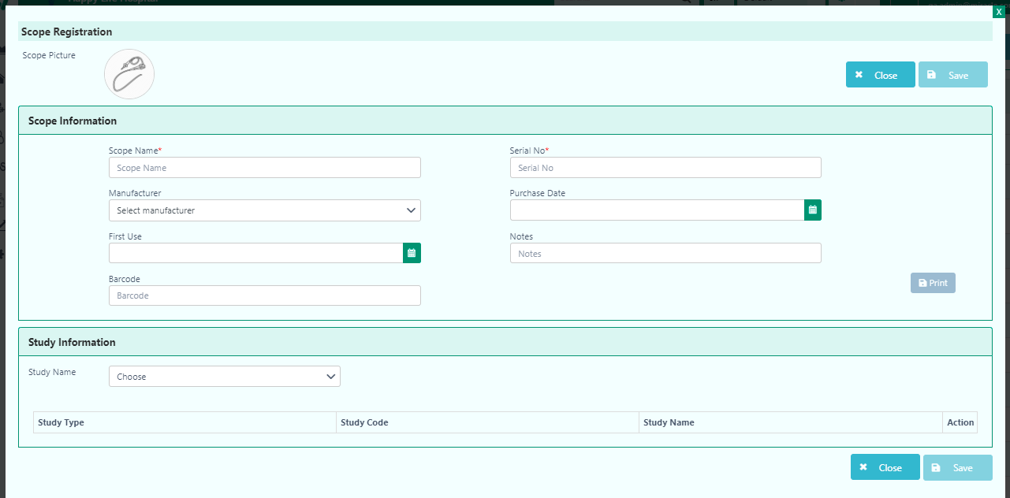
Mandatory fields are highlighted in red*

The user has to press ‘Save’ after completing the registration. Finally, the user will get a confirmation message.

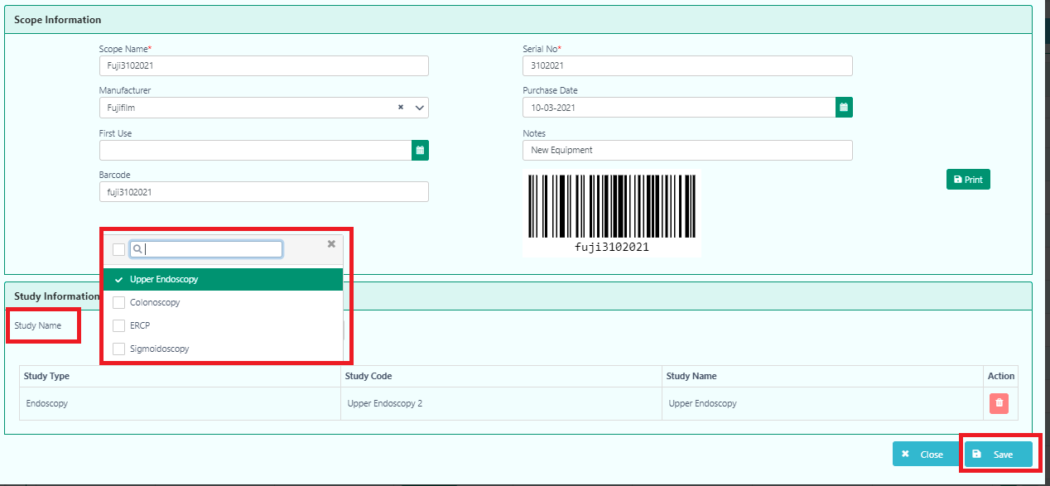

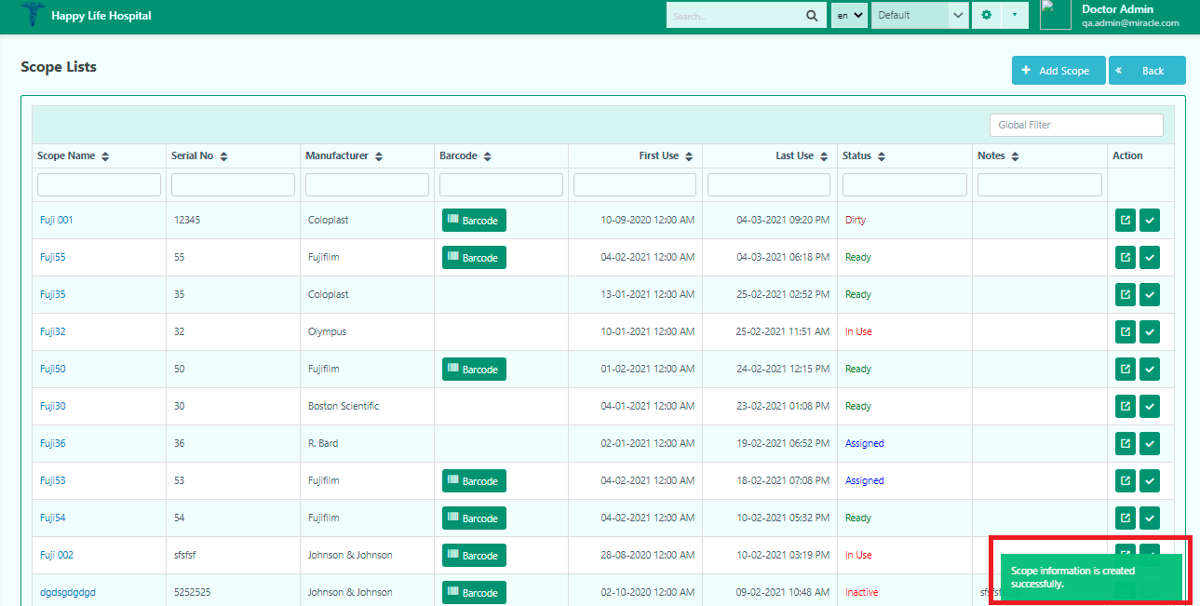

The user can use this new scope in the Imaging section.
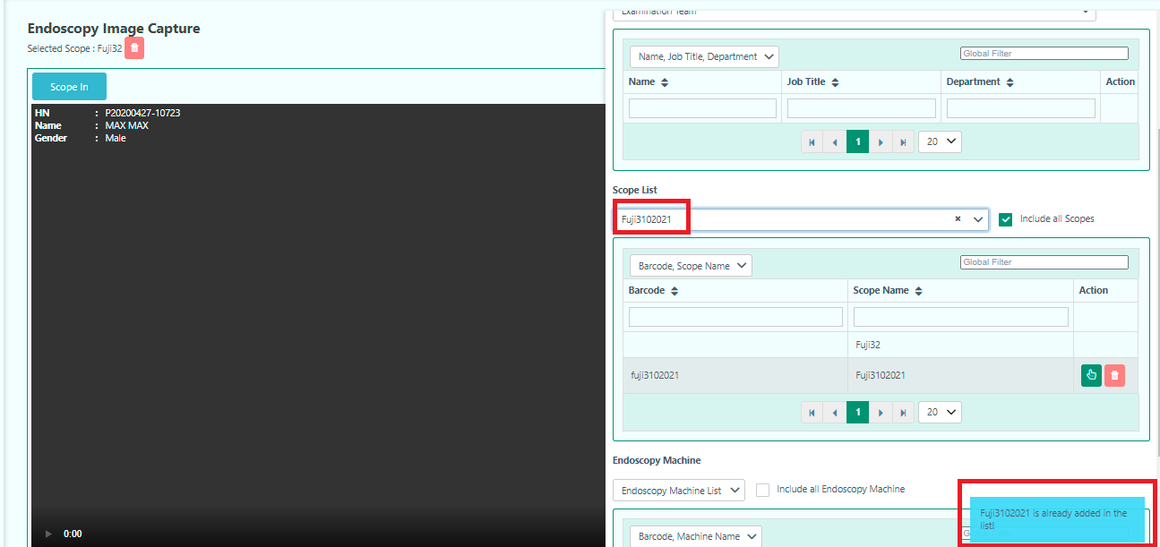

Endoscopy Management
In the Endoscopy Management, the user will find the Endoscopy Machine Lists.
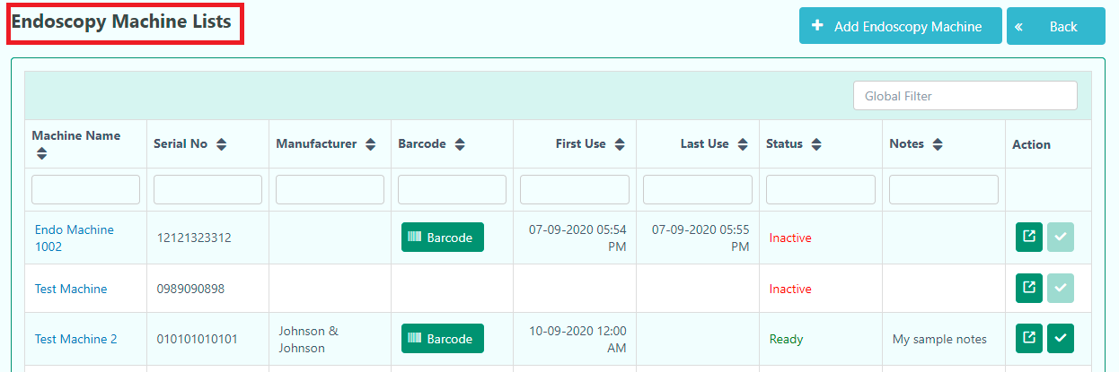

In the Endoscopy Management Lists, the user can see the Barcode, details of the Endoscopy and active or inactive the machine for use.
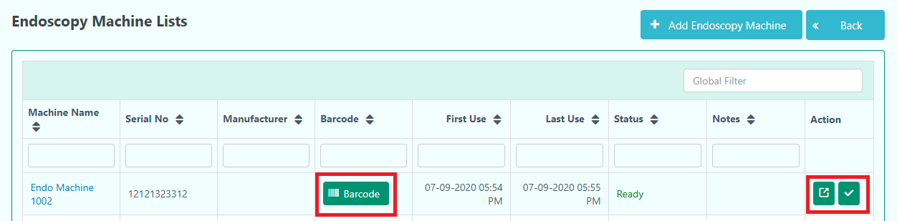

Updated-10/3/2021

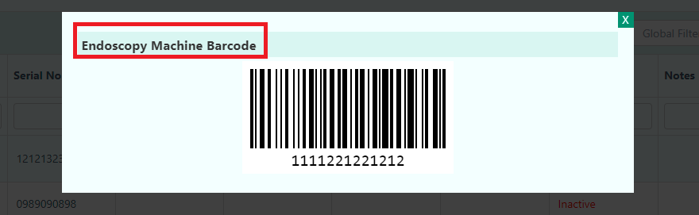

Note: When the user activates the Endoscopy machine, the machine is ready for use in Imaging. However, when the user inactive the Endoscopy machine, they can’t use this machine.

Note: If the user wants to activate or inactive the machine, they can simply click the (Tick) button. When the button is blurred, it will indicate as Inactive. On the other hand, when the button is green, it indicates active mode.

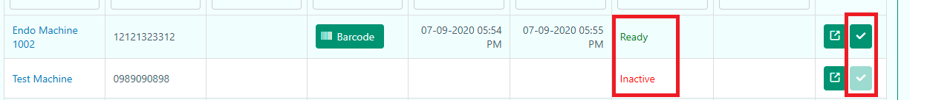

The user can easily see the Endoscopy machine details where the user can Edit Endoscopy Machine Dashboard.
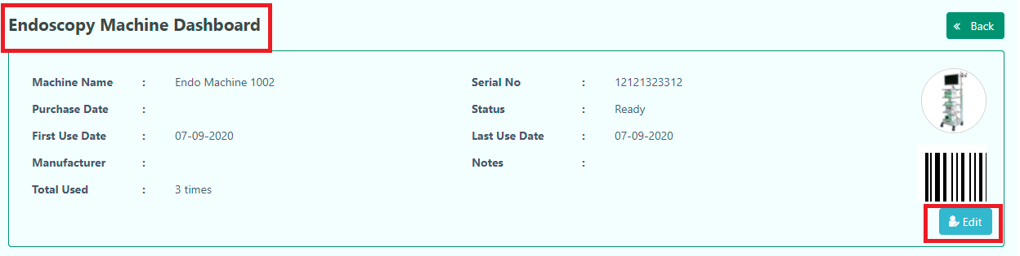

The user can also see the History of usages and maintenance record.
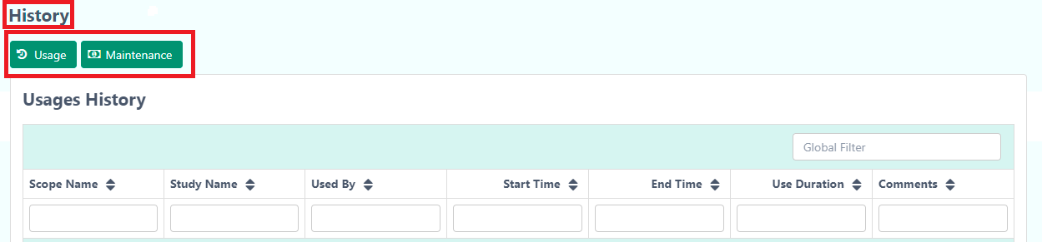

The user can add a new Endoscopy machine through Endoscopy Machine lists. After clicking the Add Endoscopy Machine, it will take them to the Endoscopy Machine Registration page.
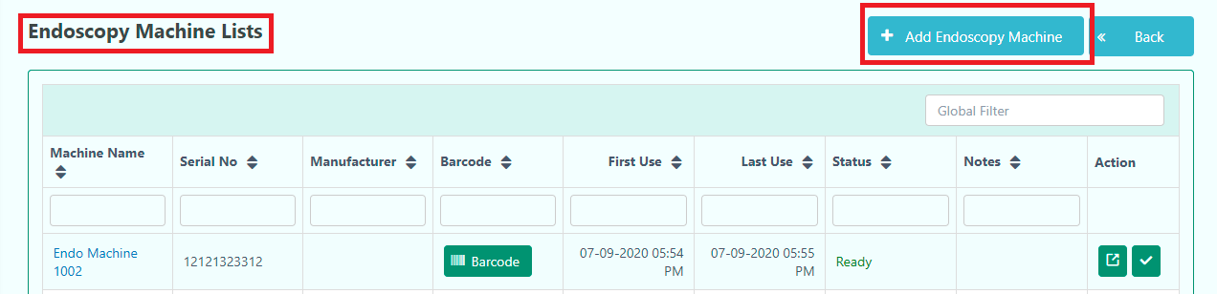
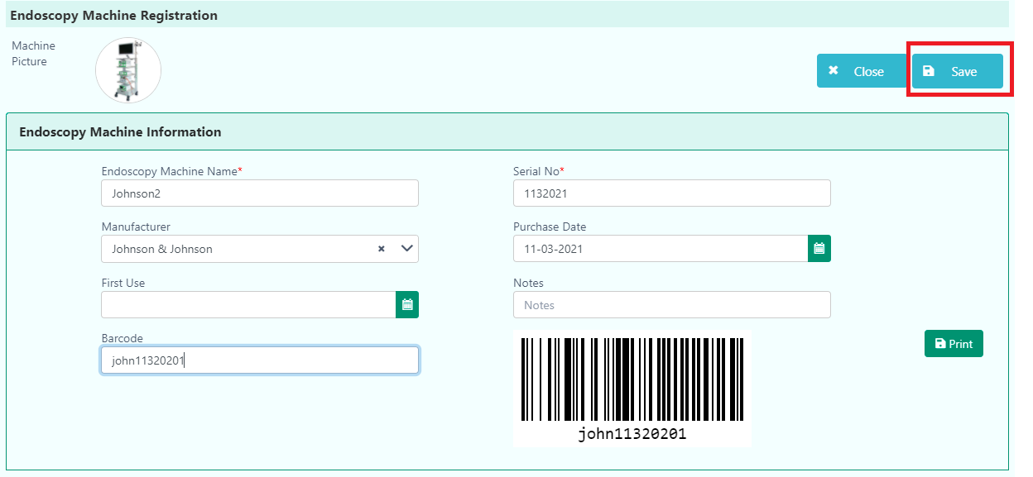
Mandatory fields are highlighted in red*

The user has to press ‘Save’ after completing the registration. Finally, the user will get a confirmation message.
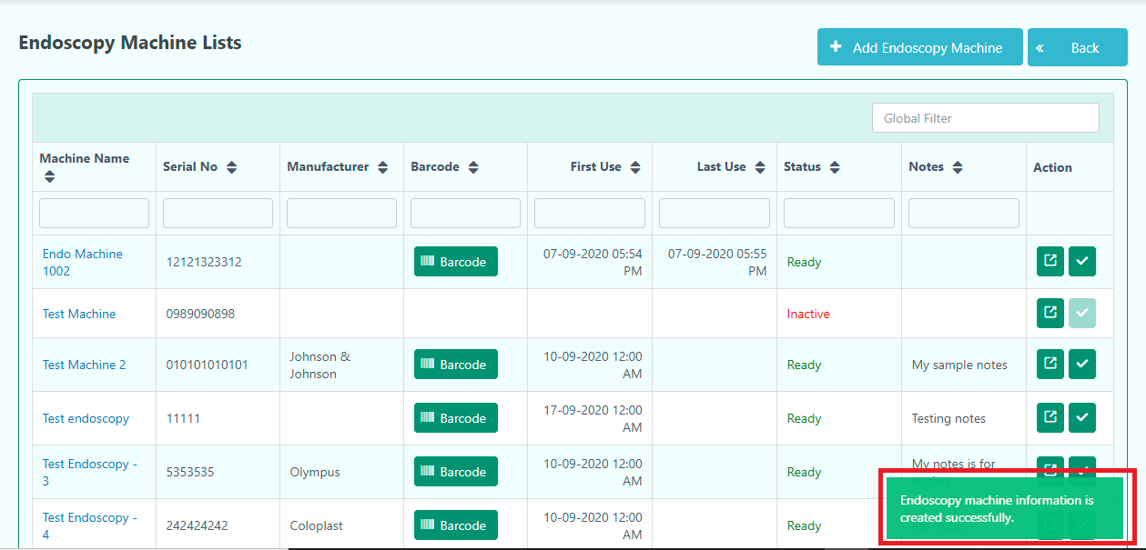

The user can use this new Endoscopy Machine in the Imaging section.
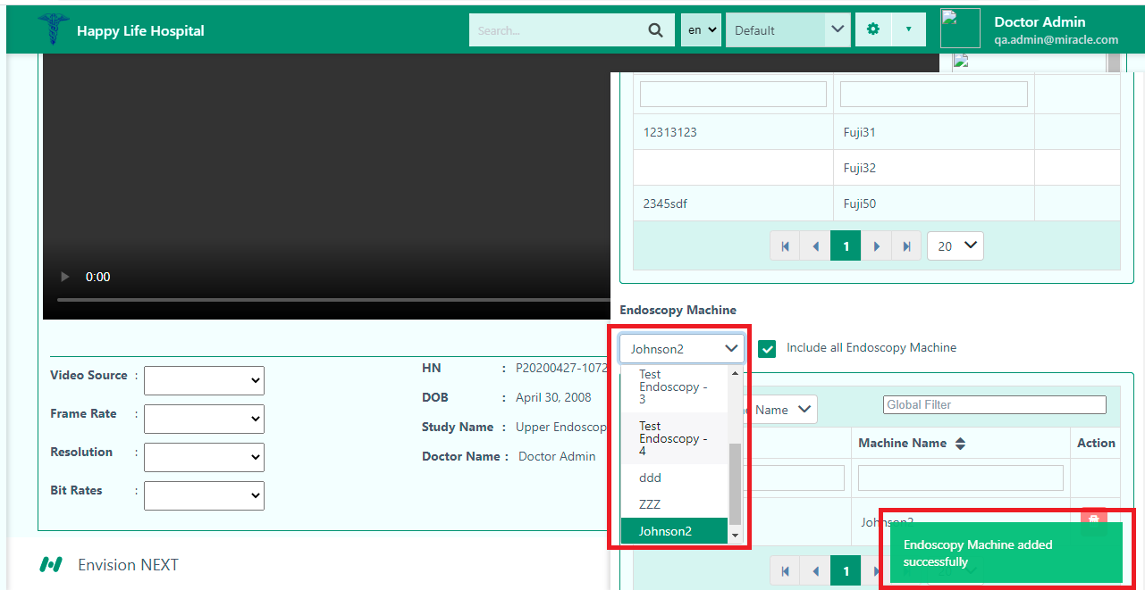

Washing Machine Lists
In the Washing Machine Lists, the user will find the lists of washing machines.

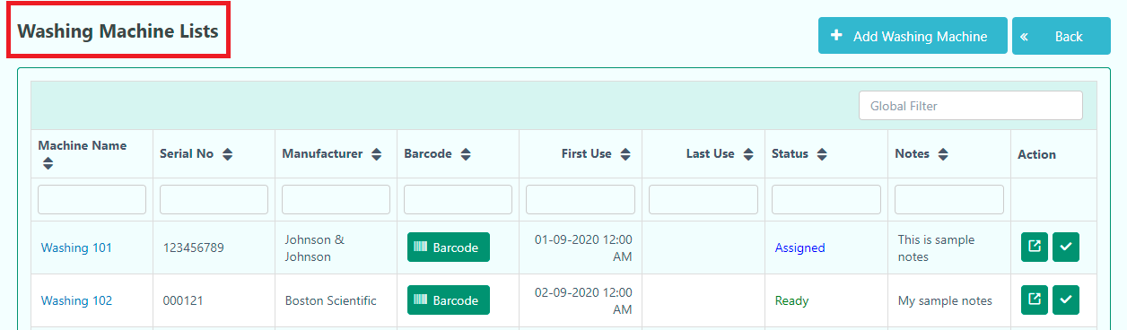

In the Washing Machine Lists, the user can see the Barcode, details of the Washing Machine and active or inactive the machine for use.

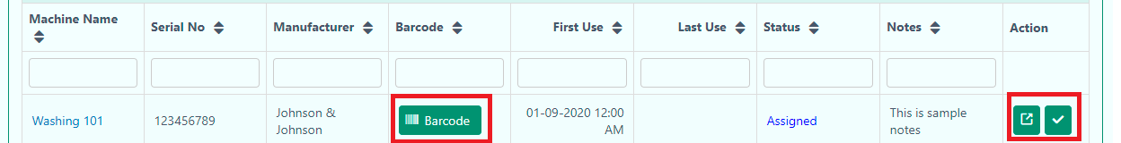
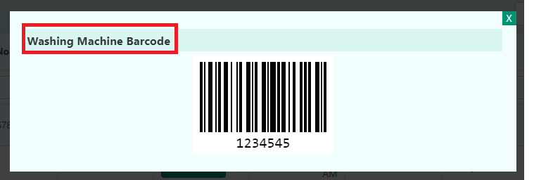
Note: When the user activates the Washing machine, the machine is ready for use in Imaging. However, when the user inactive the Endoscopy machine, they can’t use this machine.

Note: If the user wants to activate or inactive the machine, they can simply click the (Tick) button. When the button is blurred, it will indicate as Inactive. On the other hand, when the button is green, it indicates active mode.
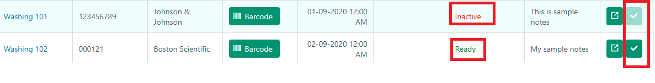

The user can easily see the Washing machine details where the user can Edit Washing Machine Dashboard.
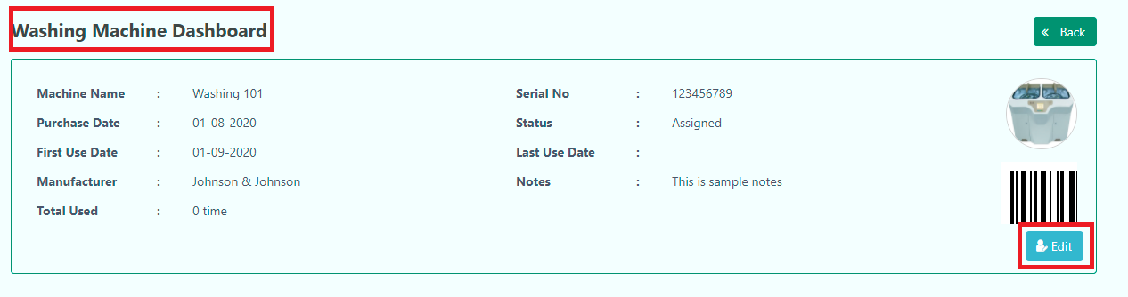

The user can also see the History of usages and maintenance records.
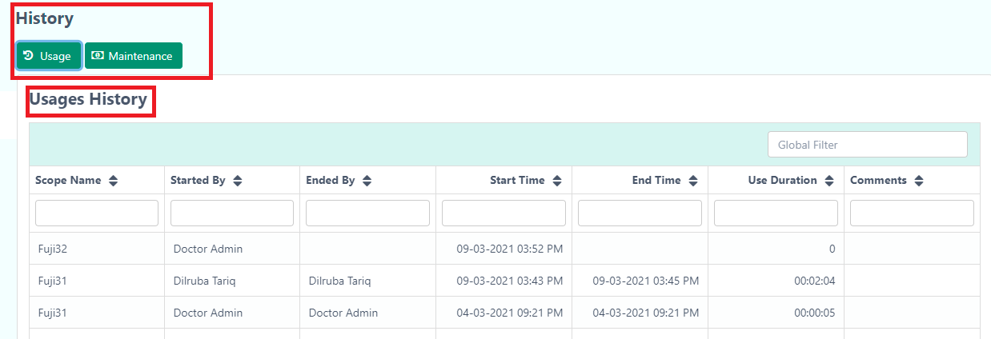

The user can add a new Endoscopy machine through Endoscopy Machine lists. After clicking the Add Washing Machine, it will take them to the Washing Machine Registration page.
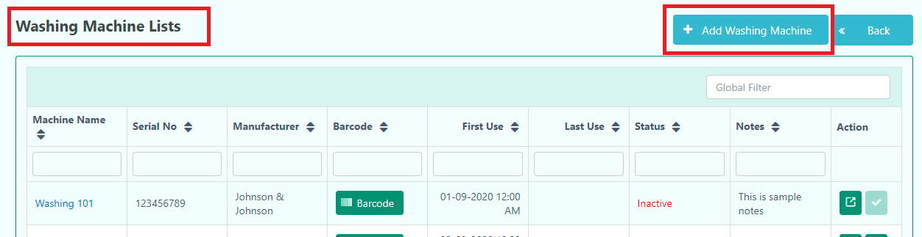

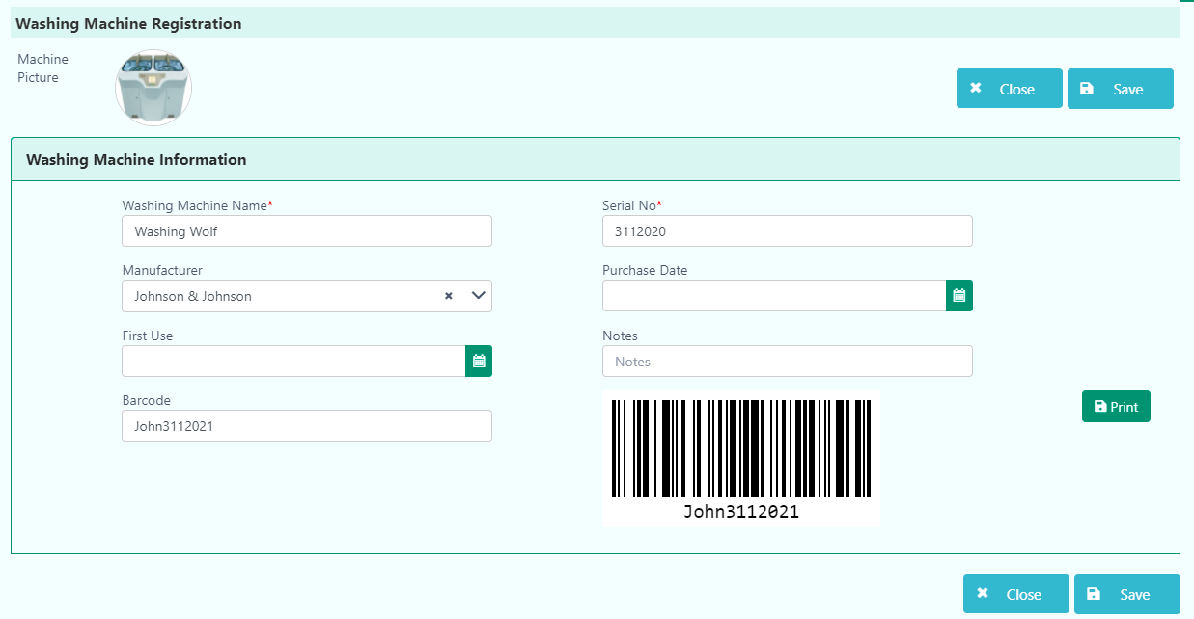
Mandatory fields are highlighted in red*

The user has to press ‘Save’ after completing the registration. Finally, the user will get a confirmation message.
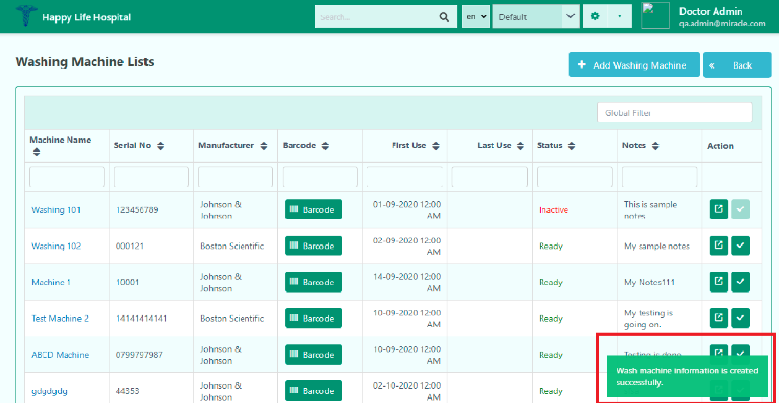

The user can use this new Washing Machine in Washing and Disinfection section.
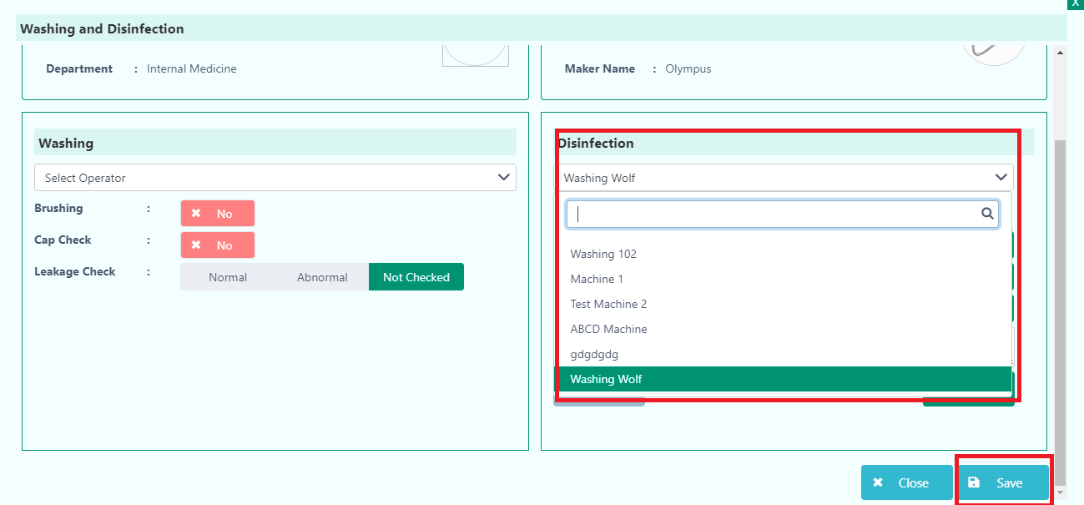
After clicking the Save button, the user will get a confirmation message.

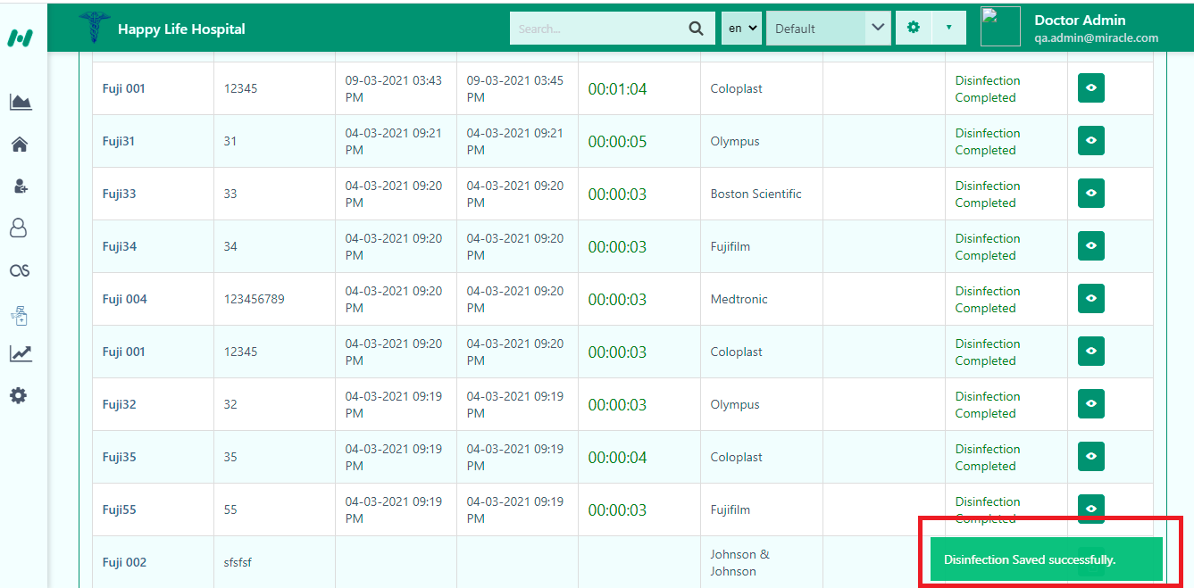

Updated-3/12/2021

Disinfection Worklist
In the Disinfection Worklist, the user can disinfect scope when it is used for the patient in the Imaging. The user can’t use the scope when it is already used. They have to confirm the disinfection to use the scope again.
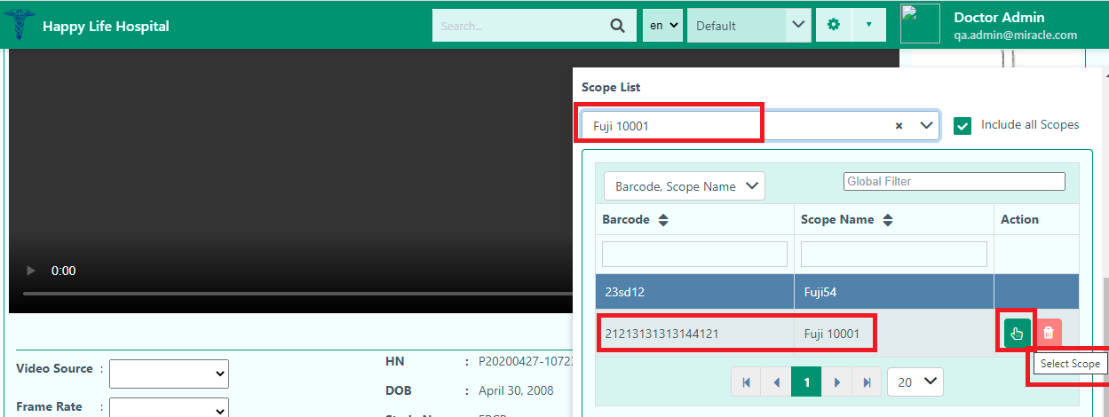

When the user selects the scope for the Imaging, the scope will be ready to use. After clicking the Scope In button, the user can’t use this scope for another patient until the scope is disinfected in the Disinfection Worklist.



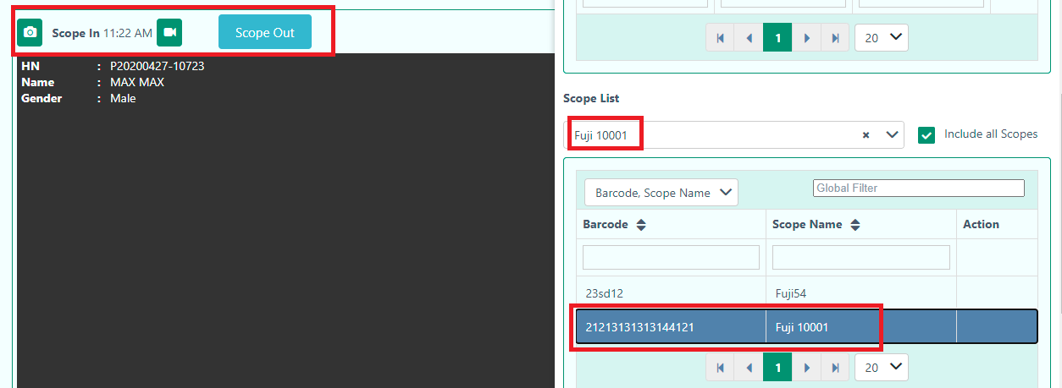

Note: When the user presses the Scope in button, the Action list in the right corner becomes disable. The user should disinfect the scope later to use it again.


The user will find this scope in the Disinfection Worklist. There are two parts in this section.
- Washing
- Disinfection

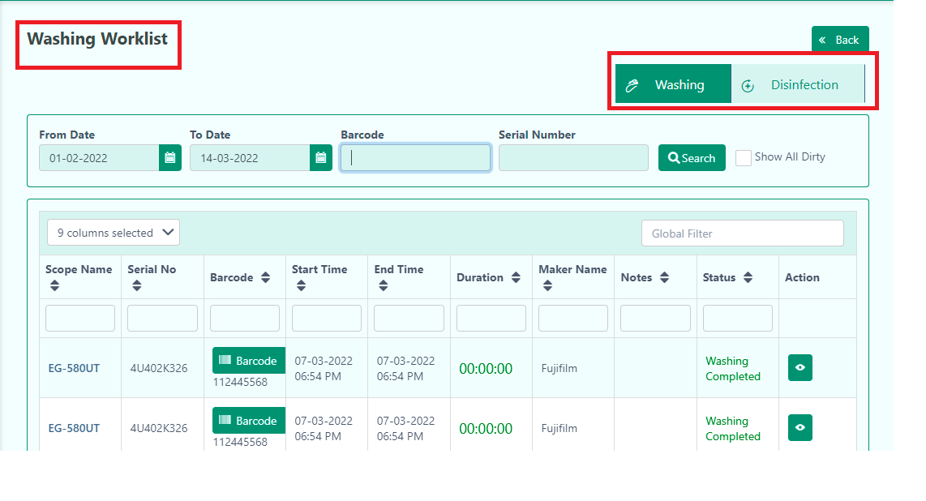

Note: The user can search any user scope with Barcode and Serial Number. The user will see the dirty scope by searching with Date. It is a by default searching option.
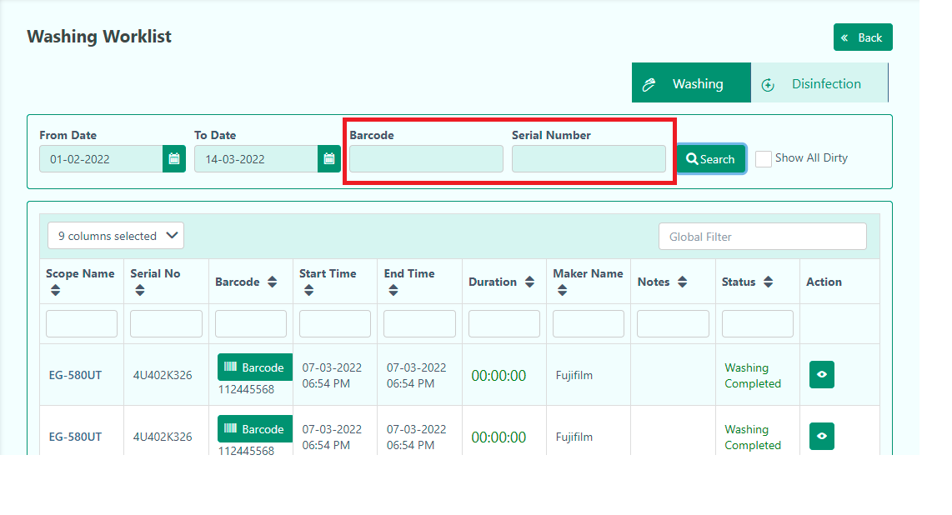
When the user searches the dirty scope with Barcode or Serial Number, the searching option with Date will disappear.

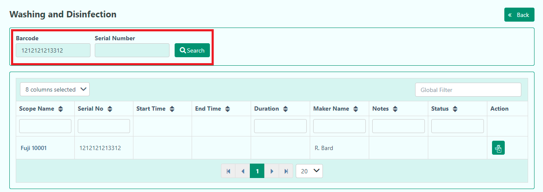

The user presses the Scope Out button in the Imaging section, the Status will show Dirty in the Working Worklist.
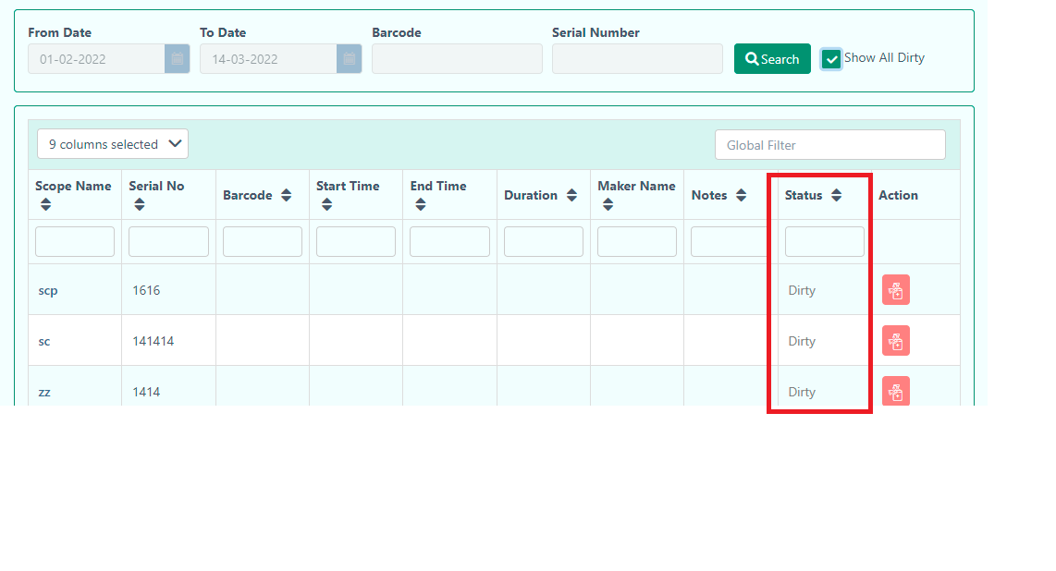

Note: In the above right corner, the user will find the Show All Dirty checkbox where they can see only dirty scopes in the lists.
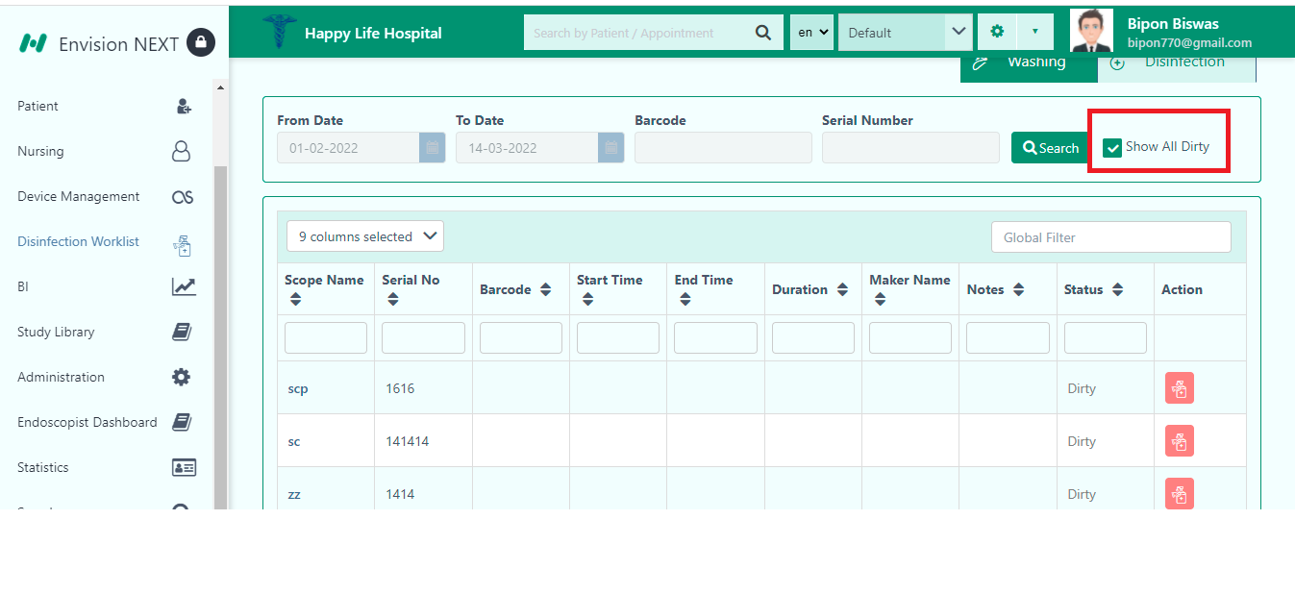

Washing

In the Washing part, the user will find both completed and dirty scope. But if the user check the Show All Dirty then they will only get dirty status.


By clicking the view washing button, the user will find the details of the Washing.

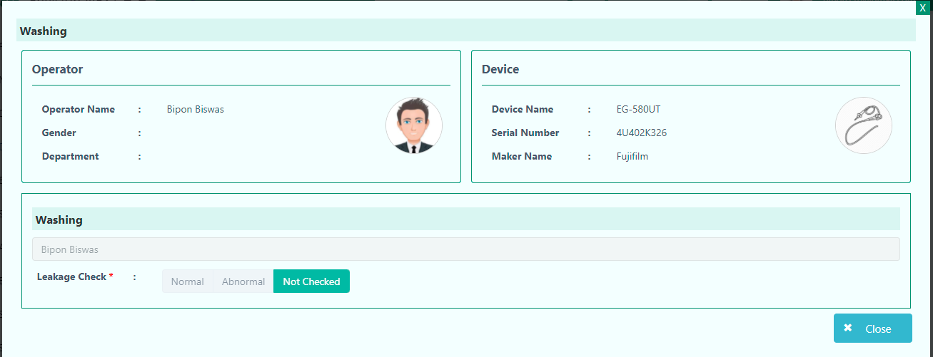

The user will find the dirty scope and can wash by clicking this button.

In the Washing part, the user has to select the operator from the dropdown for washing.
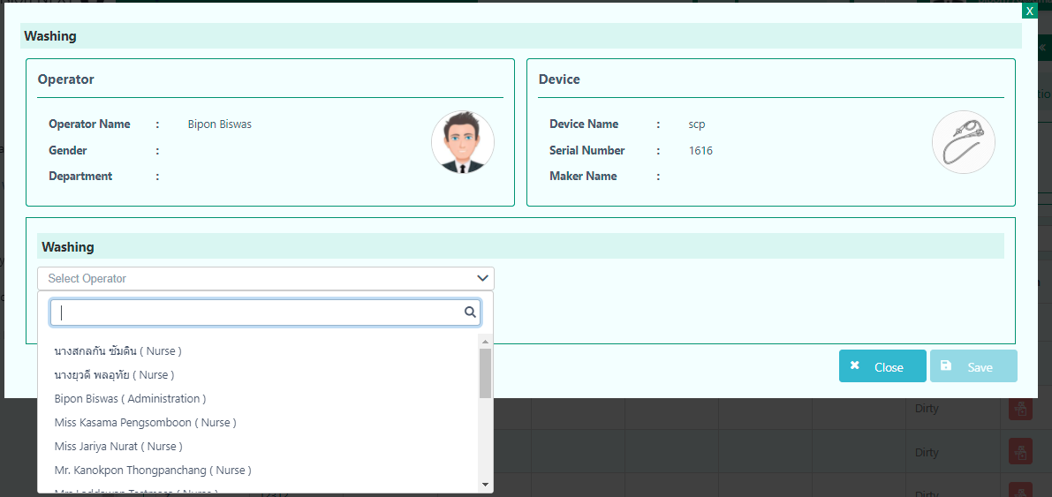
After selecting the operator and leakage check status, the user has to click the Save button. The user will get a confirmation message after that.
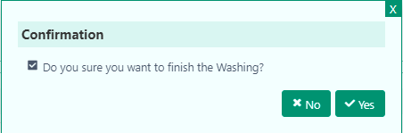
Note: Leakage check is mendatory *.

Disinfection
In the disinfection part, the user must select the washing machine.
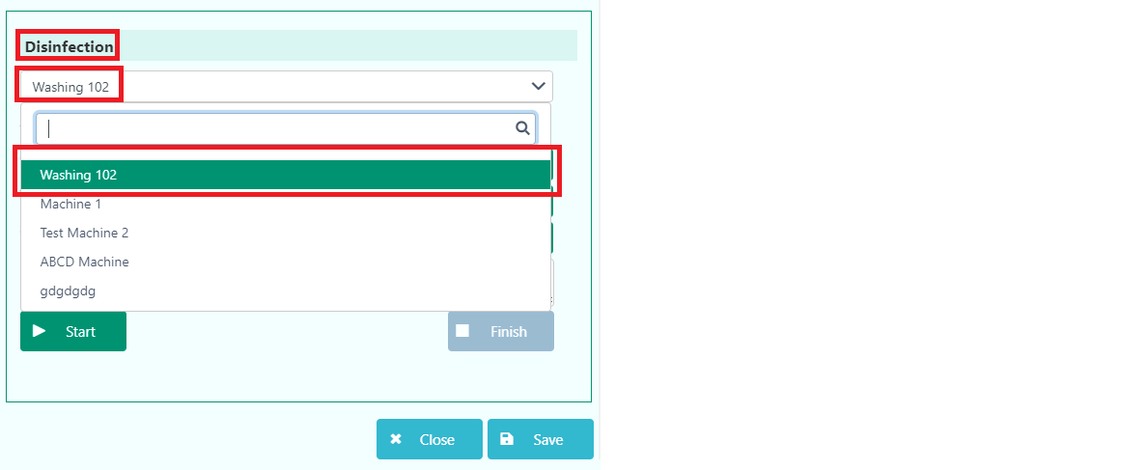

The user can check some fields and provide notes if necessary, in the Disinfection section. Then, the user can press the Start button to begin the disinfection procedure of the scope.

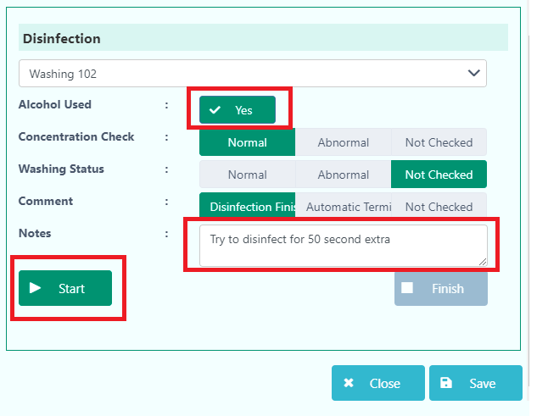
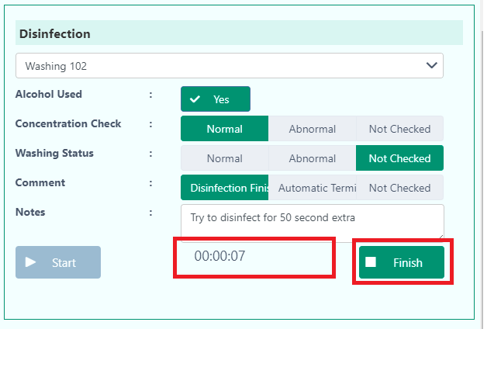
It also shows the time scale when the user presses the Start button. When the user ensures the disinfection of the scope, they have to press Finish to stop the procedure. They will get a confirmation message for finishing the procedure. After clicking the ‘Yes’ button it will give a successful message to the user. This disinfected scope can be ready to use for another patient.

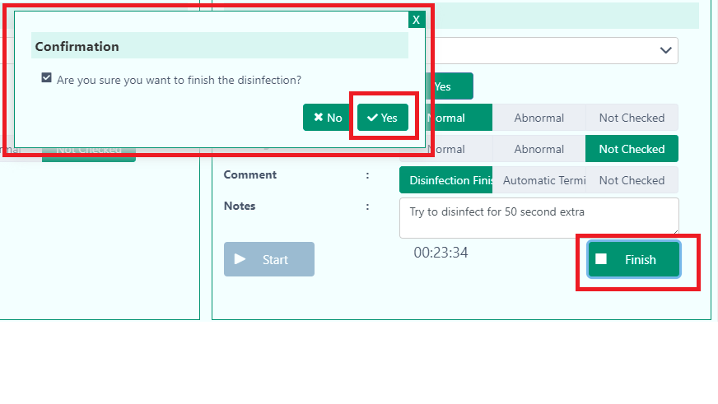

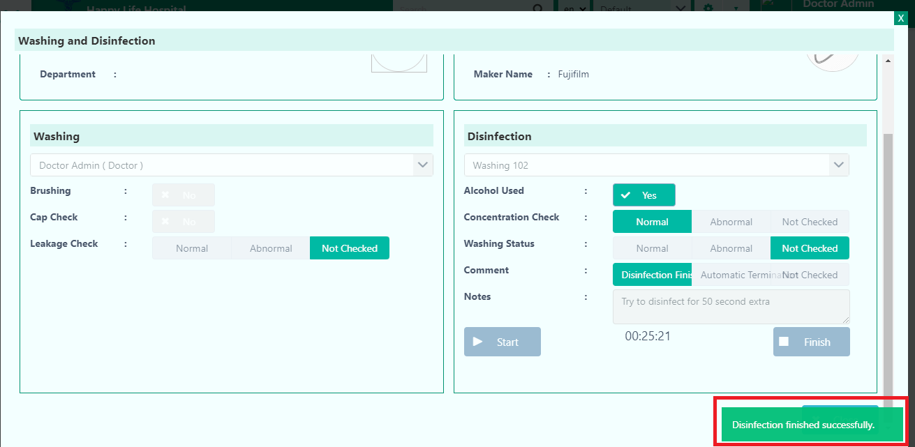

The user will get detailed information of this disinfected scope in Washing and Disinfection lists.
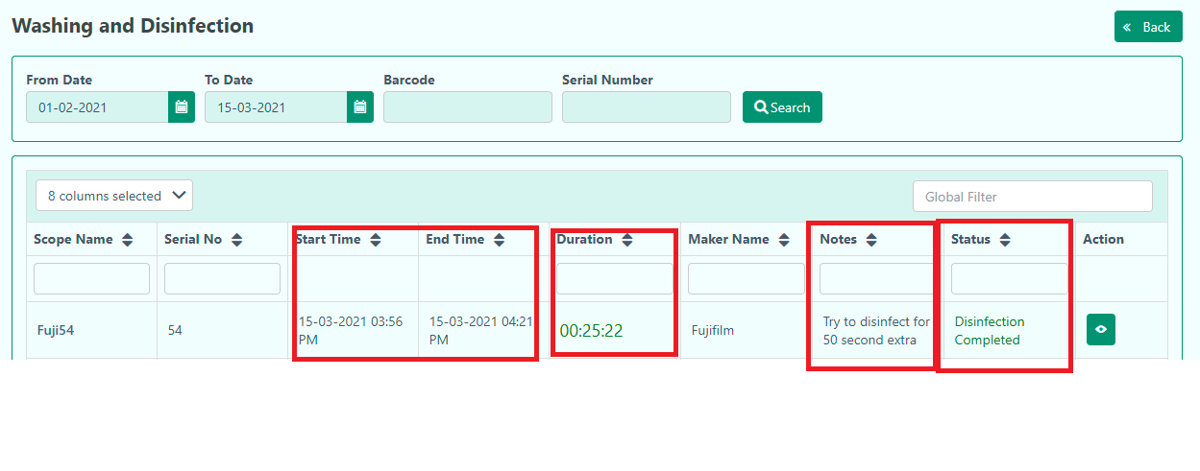
The user can know the start and end time of disinfection procedure, duration of the disinfection, status and notes of the scope.
The user can also view the washing and disinfection page again by simply click the right corner button.
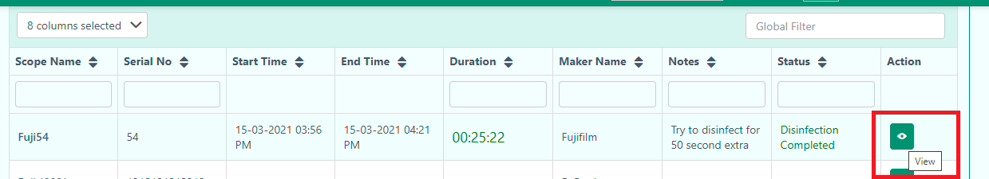
Updated-15/3/2021

BI

In this Business Intelligence section, the user will get raw data and statistical data for better visualization.
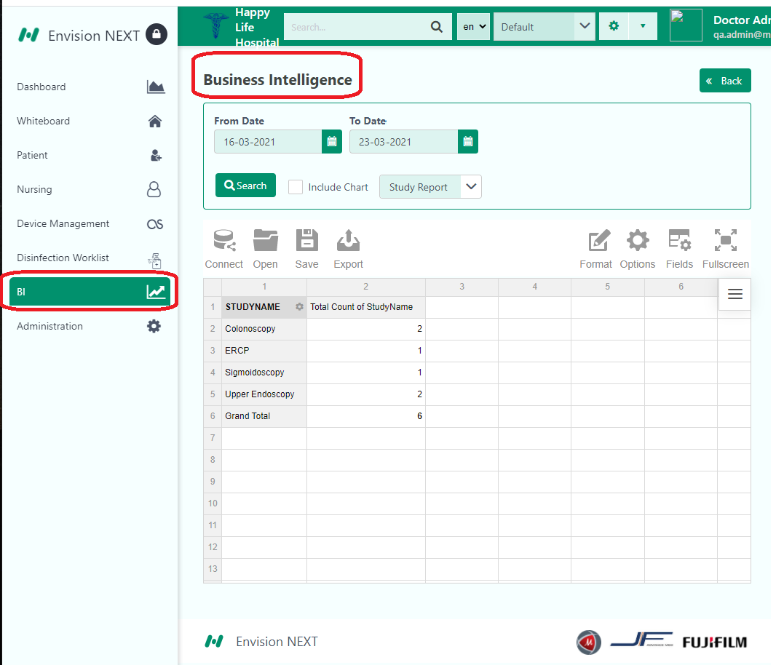
In the first part, the user can search data, From Date -To Date. They can also select whether they want to see Study Report or Scope Report from the dropdown.

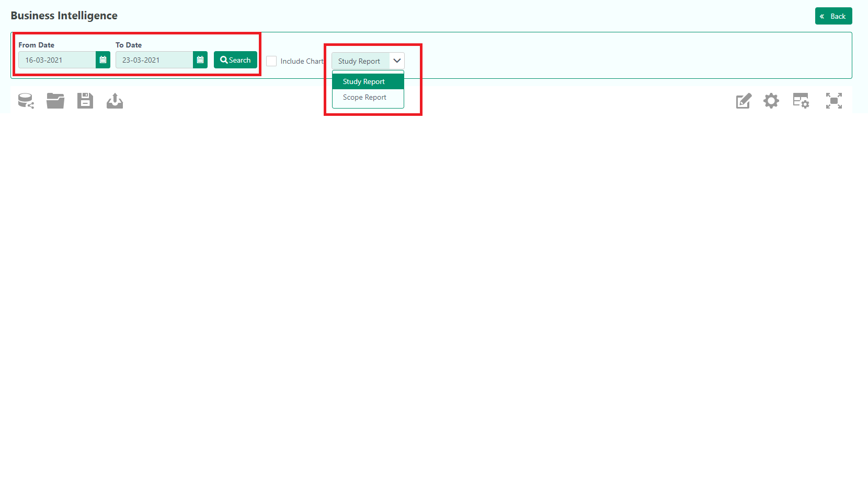
If the user wants to visualize the data, they have to click the Include Chart.

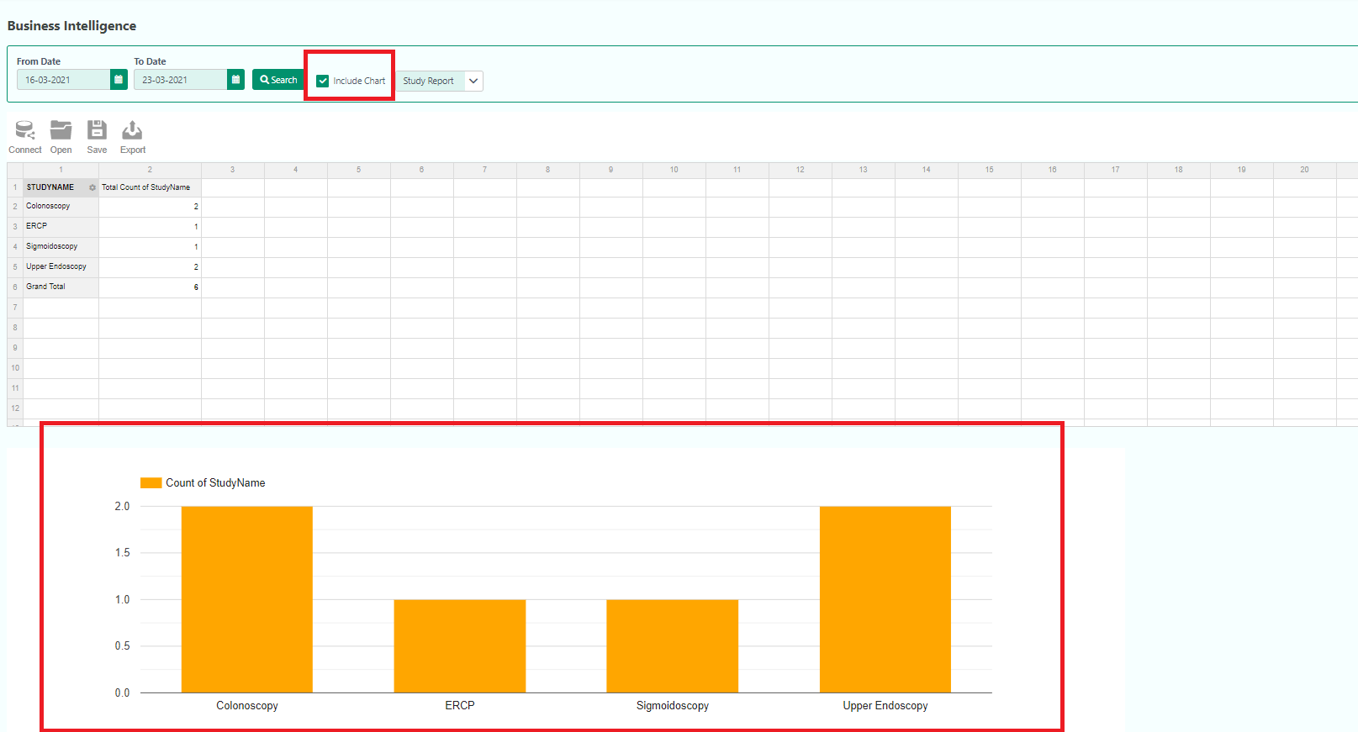

In the left corner users will find some functions like- Connect, Open, Save, and Export.

Connect
In this option the user can connect any data from-
- To Local CSV
- To Local JSON
- To remote CSV
- To remote JSON

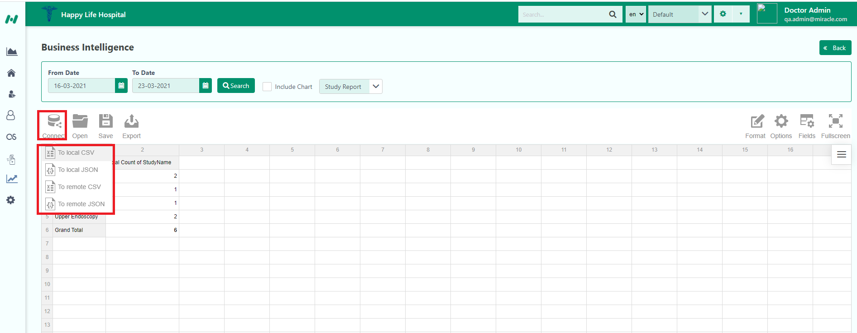

They can also open Local Report or Remote Report from Open option.
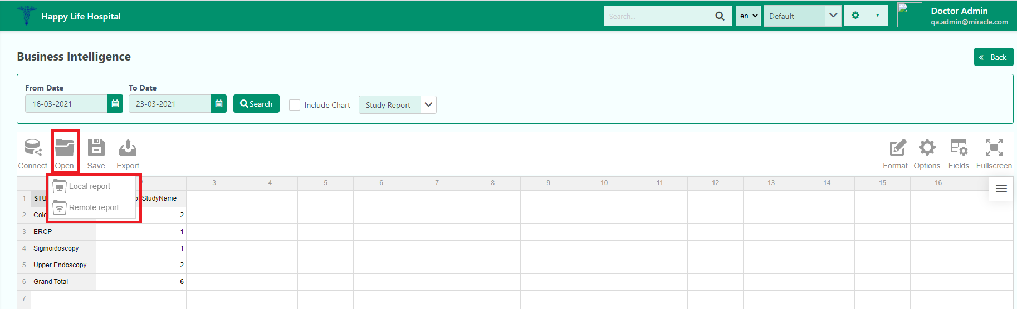

The user can also Print, export to HTML, Excel and PDF format by clicking in the Export option.

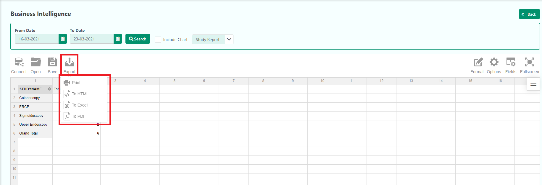

In the right corner, the user will find Format, Options, Fields, and Full Screen functions.

The user can easily format the data by clicking in the Format. The user will find Format cells and Conditional formatting inside the Format dropdown.
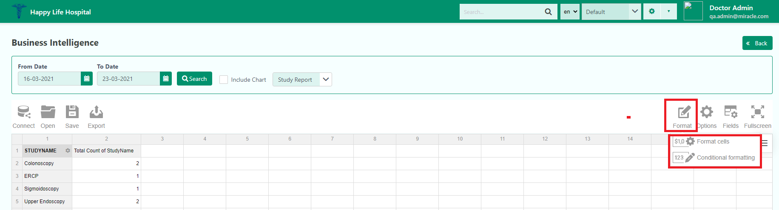

In the Format cells, the user will find some basic format changes options.
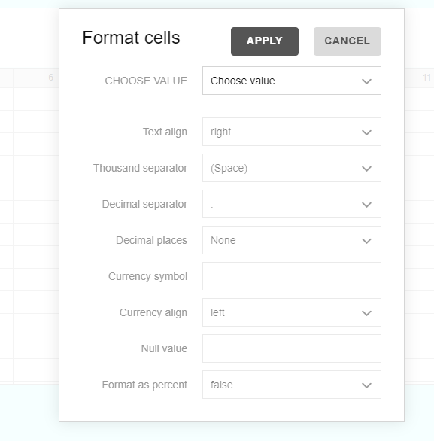
In the Conditional formatting, the user will first find a pop-up window where they have to choose ‘+’ button for further proceeding.
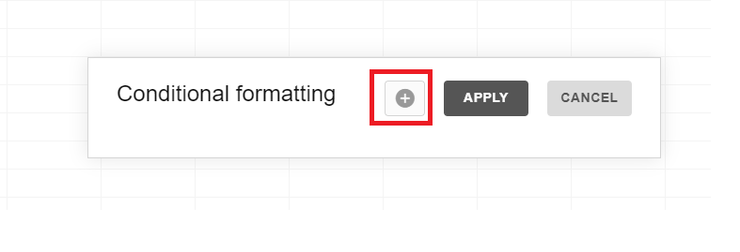
There they can choose the format either less than, less than or equal and so on. Moreover, they can also choose colour to those format changes.
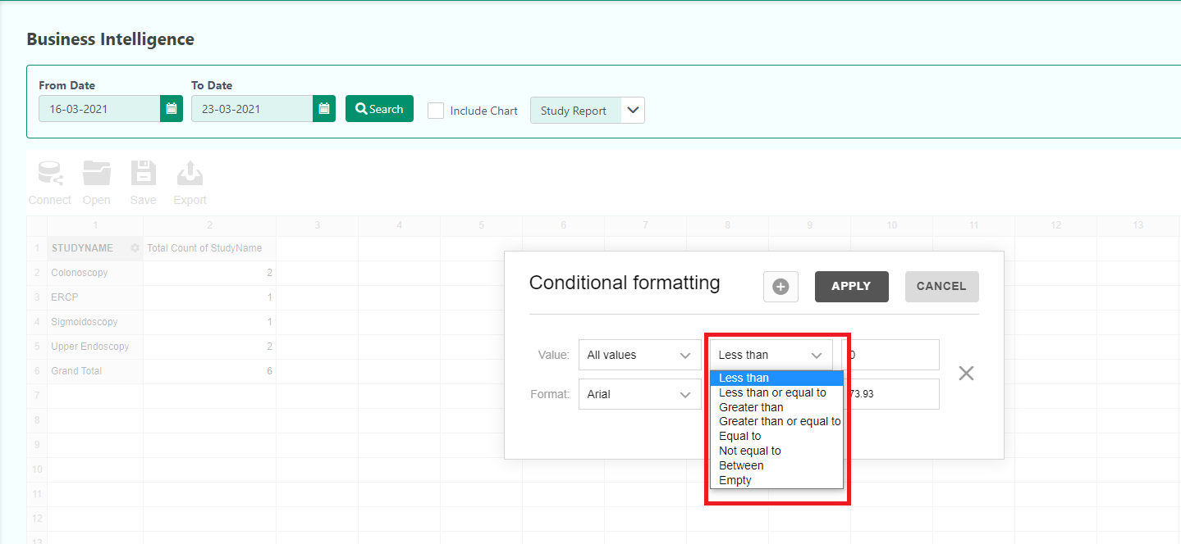

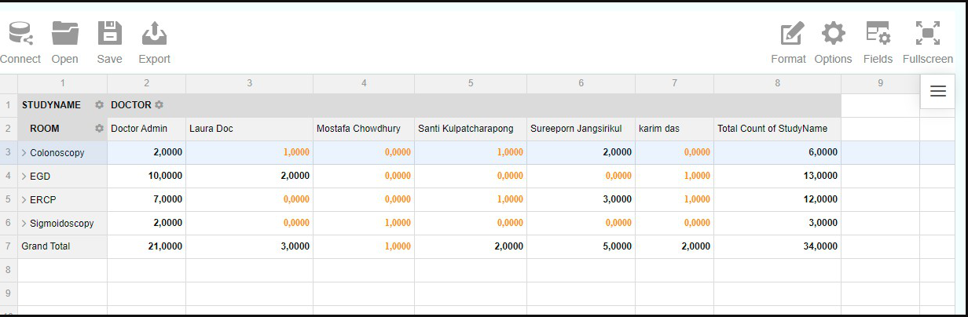

In the Option, the user can choose Layout options of the data.
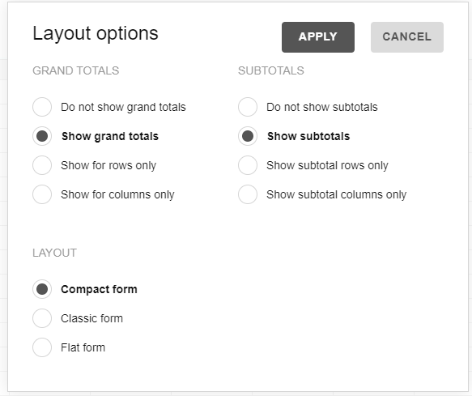
The user can drag and drop fields to arrange the data inside the Fields option.

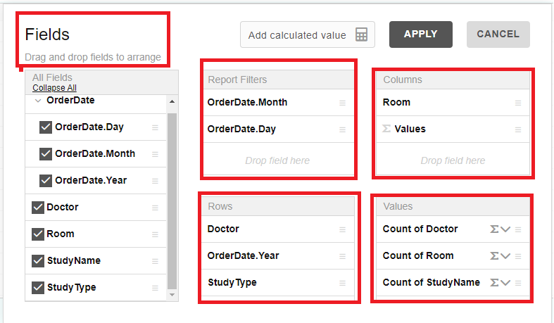

Note: The user can Add calculated value from the Fields.
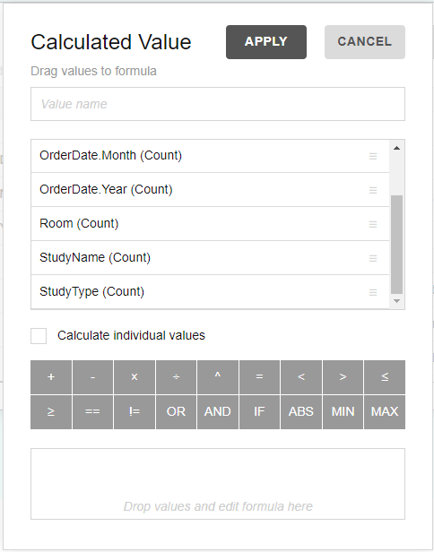

Finally, they can maximize the screen with the Fullscreen option.

Updated-23/3/2021

Administration

This section will help the user to set up the whole settings. The user can customize-

- Video Settings
- Update Organization
- Room Management
- User Management
- Study Library
- Capture Settings
- Study Management
- Support Ticket Lists
- Locked Reports
- Examination Team
- PACS Worklist
- Consumable Items
- Patient List
- Dynamic Dashboard
- Add Post
- Calendar Settings
- Audit Trails

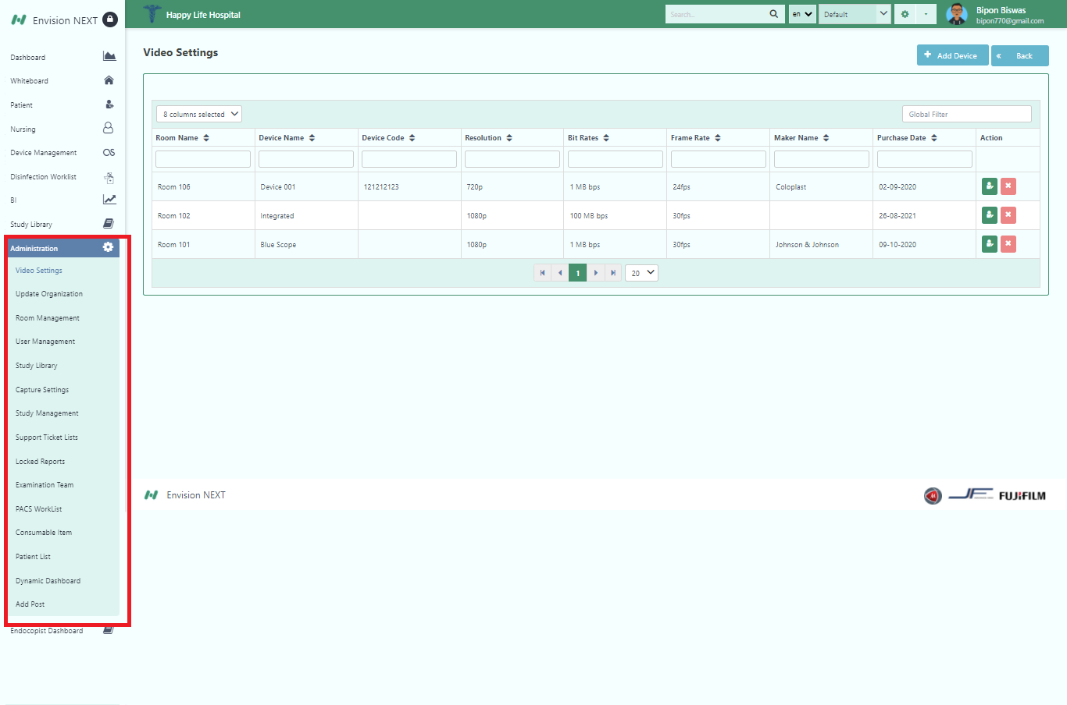

Video Settings
In this section, the user can Add Device for capturing video.
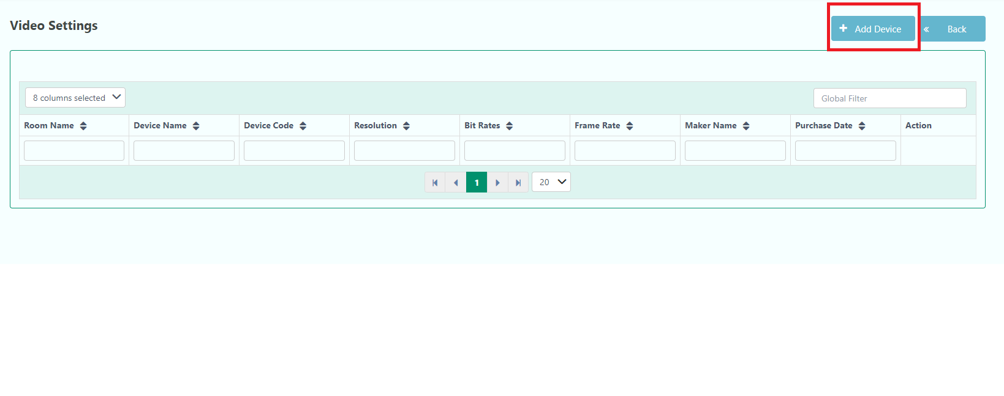
By clicking in the Add Device, the user will get a pop-up form. They have to fill up the form for adding a new device for the Video.
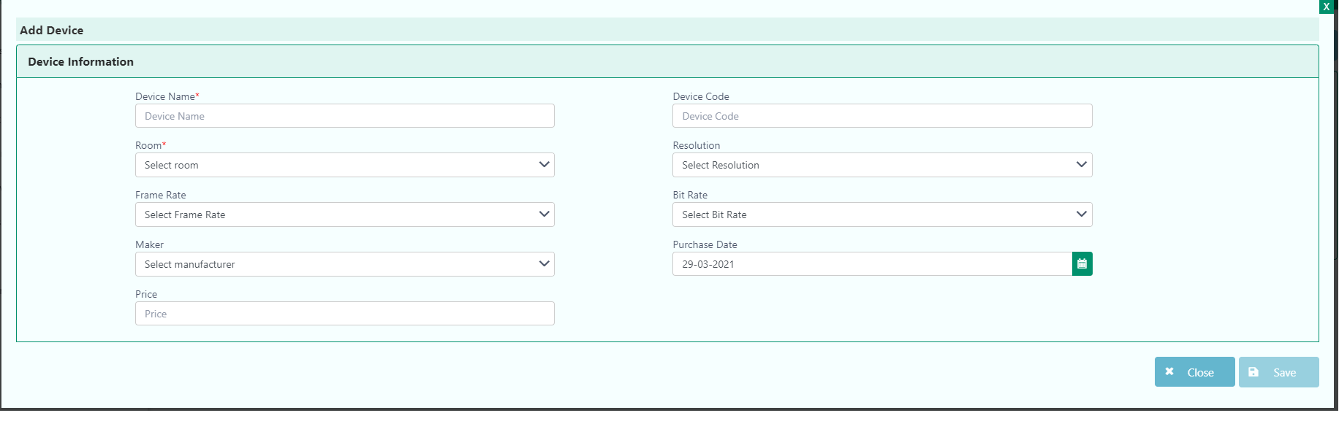
Mandatory fields are highlighted in red*

After filling the form the user has to save the device by clicking the Save button.
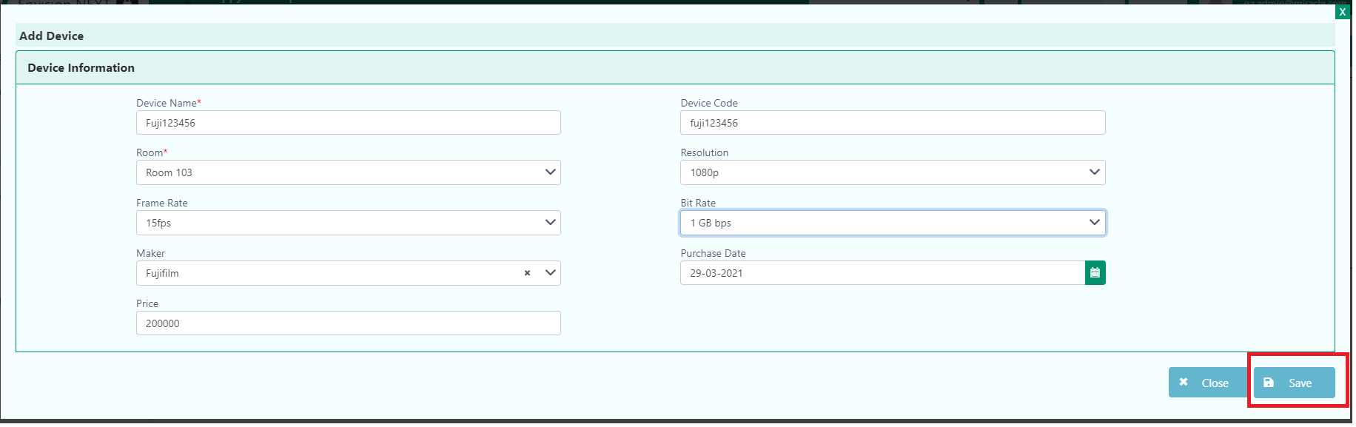

The user will get successful notification after clicking the Save button.

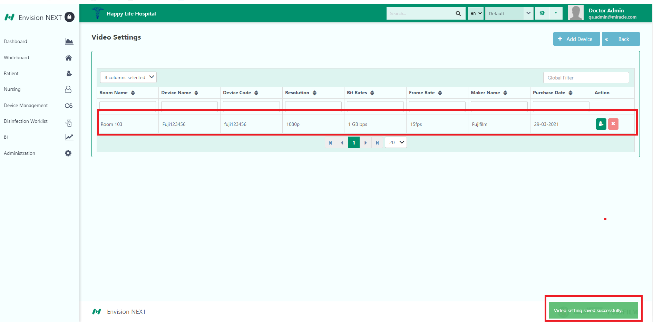

Note: The user can delete or edit the video settings with the help of the above red marked button.

Update Organization
In this section, the user can update organizational information.
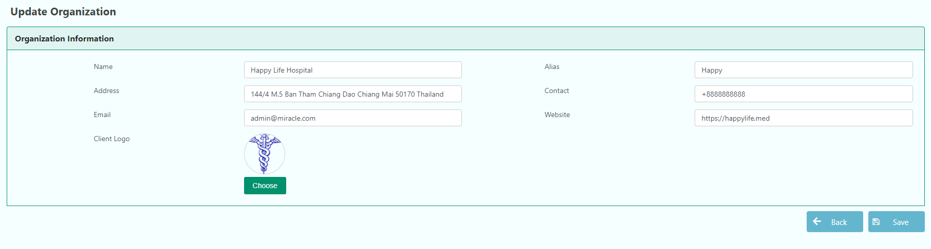
The user can also change some organizational settings by clicking the right corner button “Org Settings”.
After clicking the button, the user will get the Update Organization and Custom Form section.
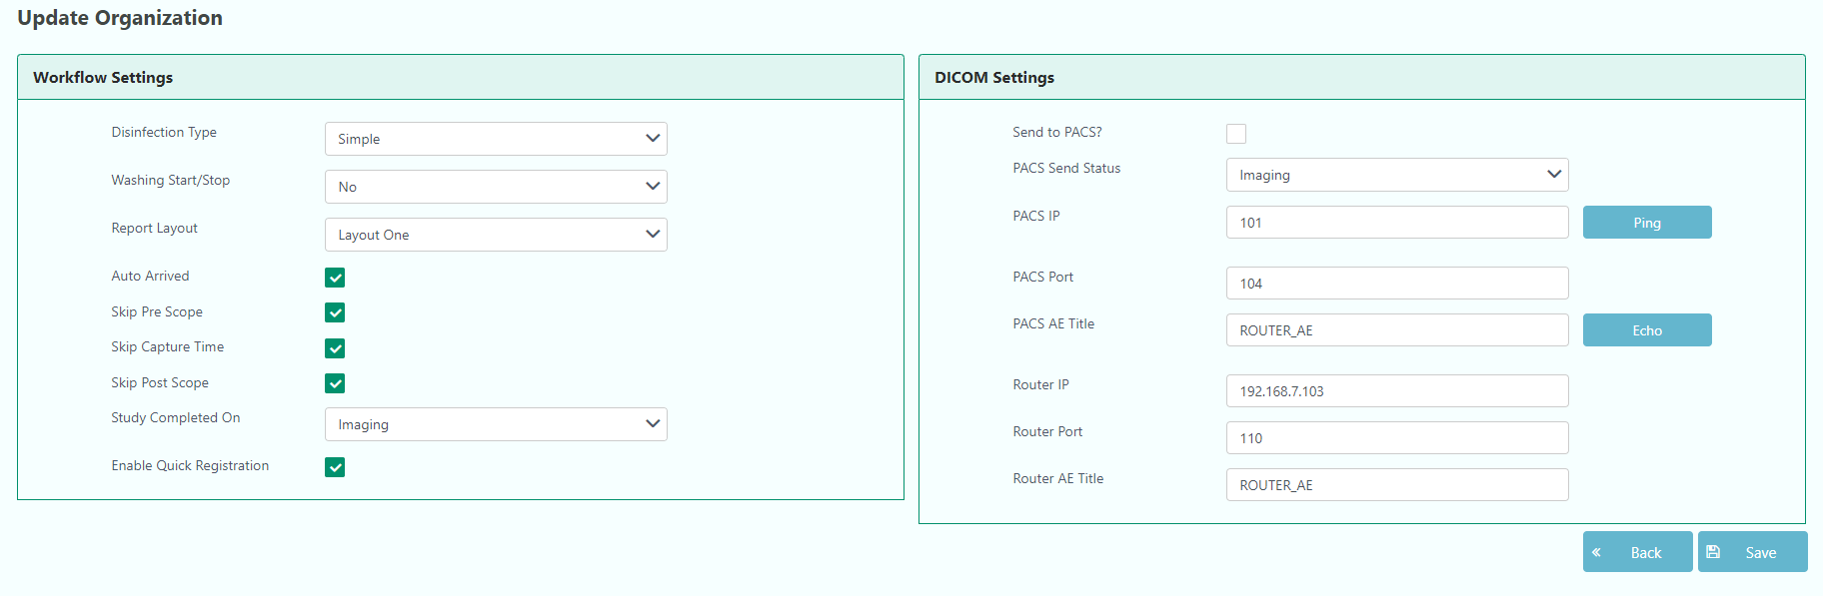

Inside the update organization, there are two parts.
- Workflow settings.
- DICOM settings.

In the Workflow settings, the user can configure Disinfection type, Washing Start/Stop, Report Layout, and Study Completed on.
Moreover, the user can also configure DICOM settings.

The user has to click the Save button after configuring the Update Organization.

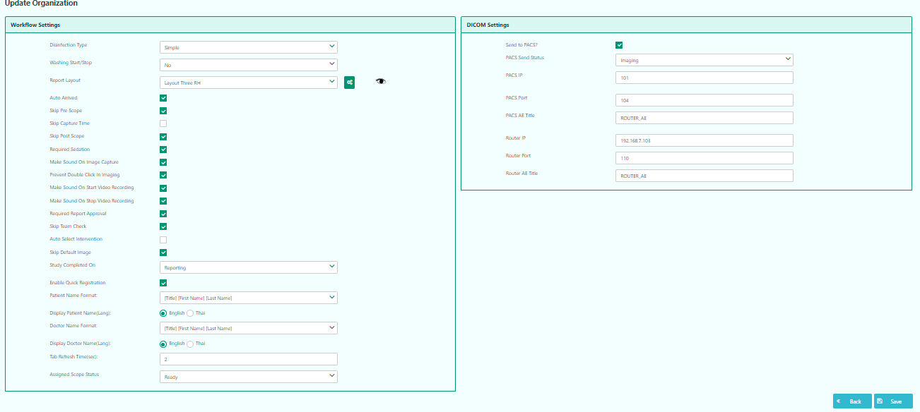

The user will get a notification after successfully updating the organization.
Room Management
To add a new room or know about the details and make the room active/inactive, the user can manage from this section. The user can see lists of the room from this part.
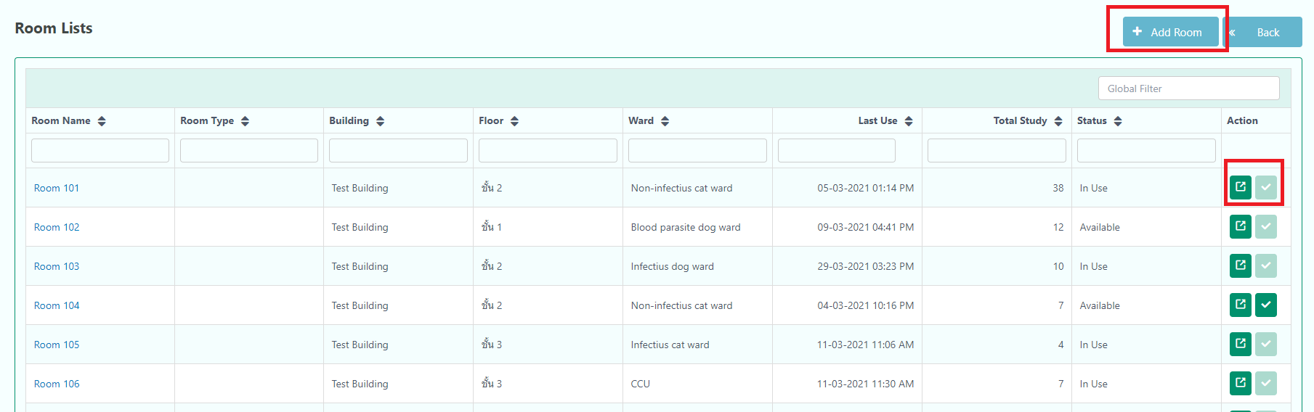

The user can add a new room by clicking in the Add Room. It will take them to Room Registration.

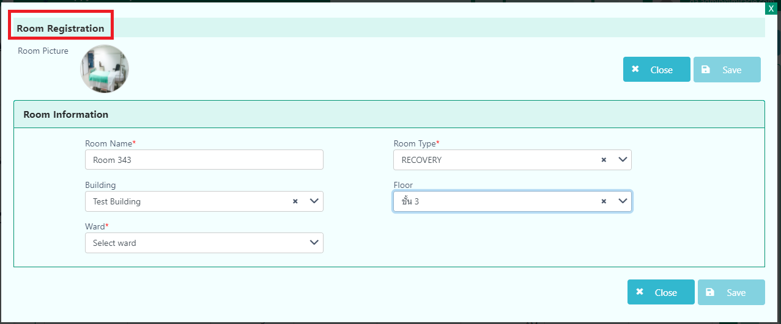
Mandatory fields are highlighted in red*

User Management
The user can edit, add a new user, and map the role of the users in this section.
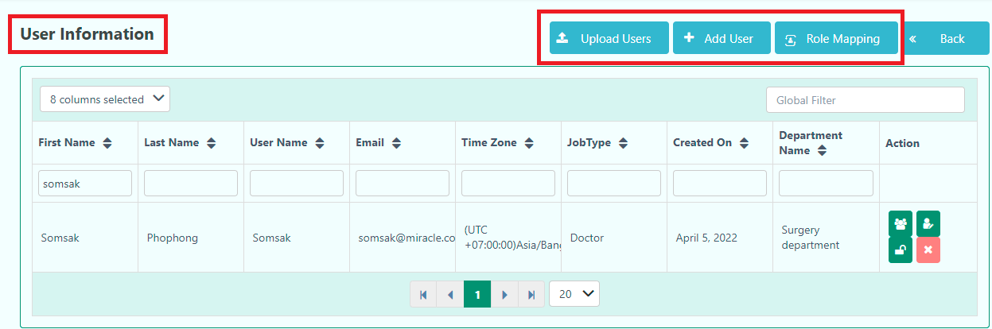

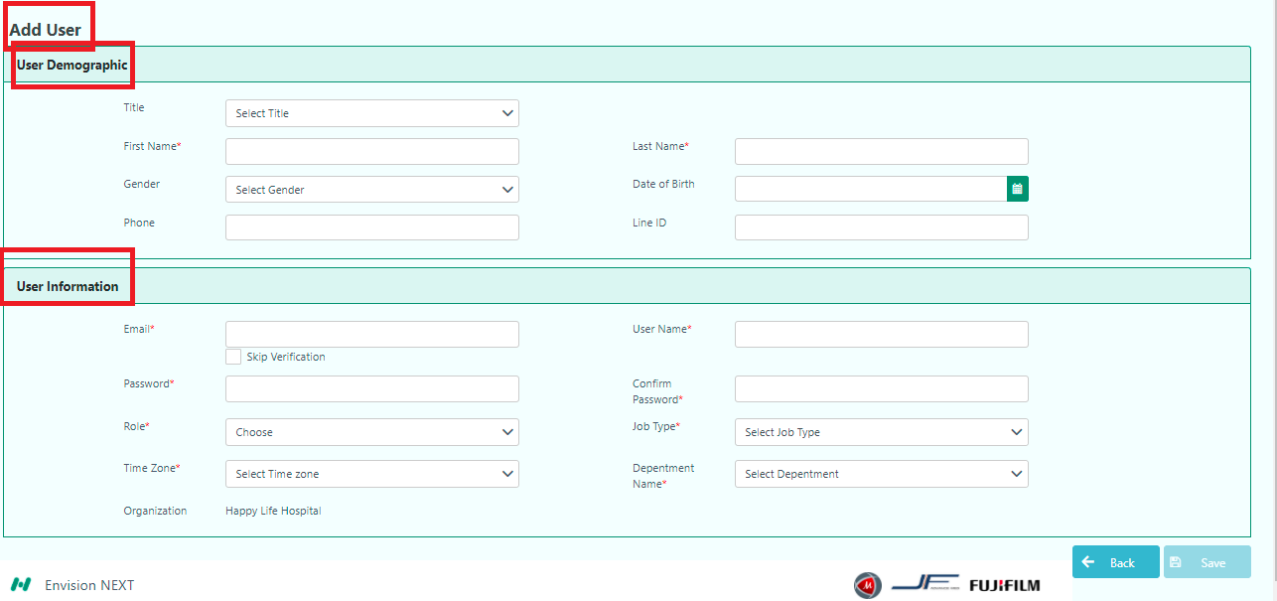

Mandatory fields are highlighted in red*

In the Role Mapping, the user can add roles and map roles for other users. They can also edit and assign the role of the user with the help of mapping.
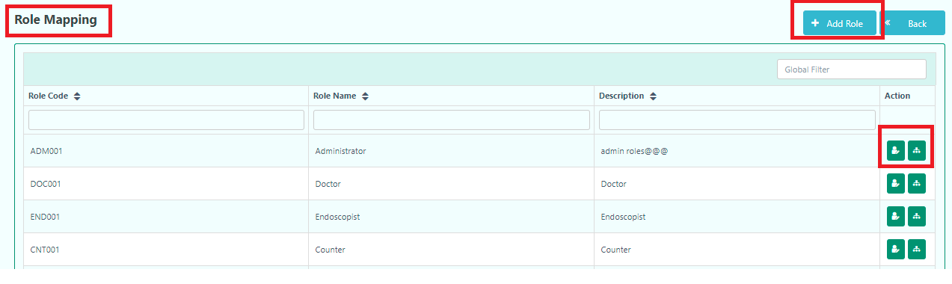
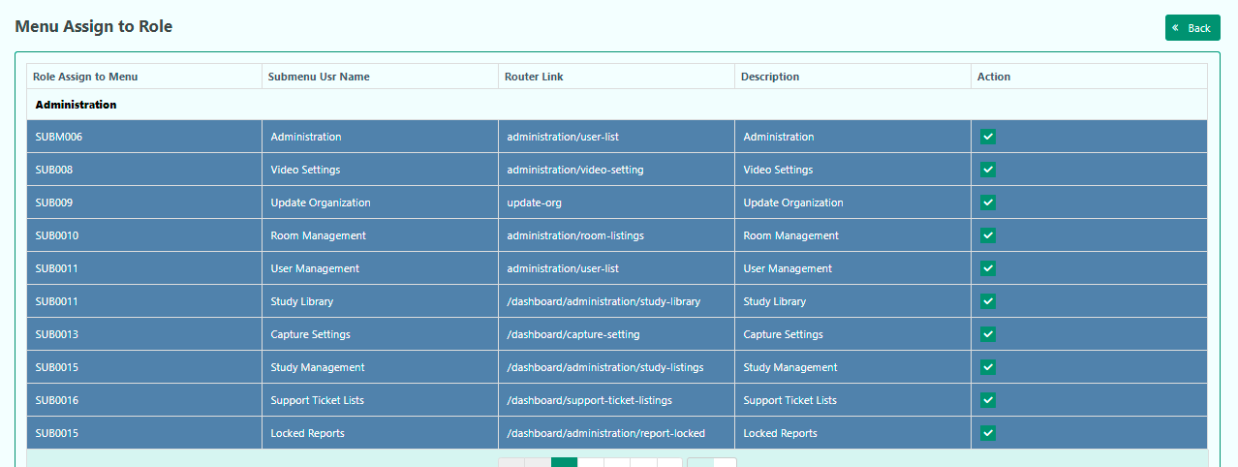

In the user information there are four Action buttons.
- Edit Team Role
- Edit
- Reset Password
- Delete

Edit Team Role
The user can update team role by clicking this button.

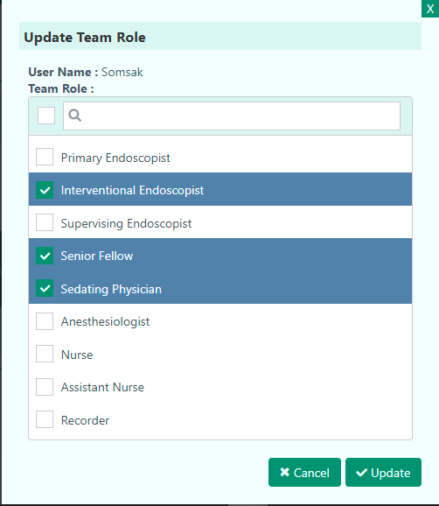

After selecting the role, the user has to click the Update button.

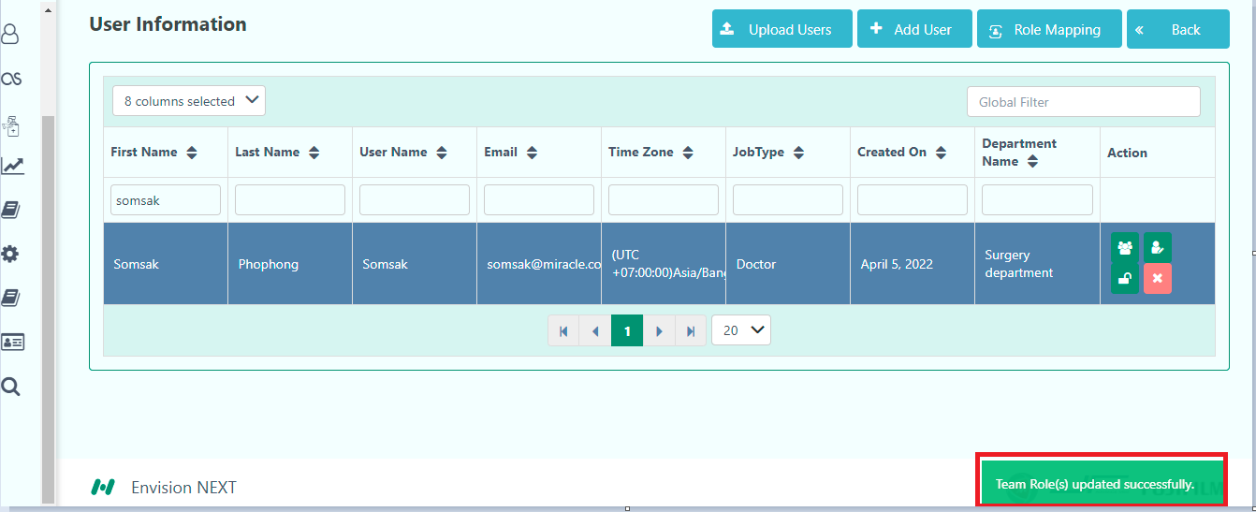

Finally, they will get a confirmation message after clicking the update button.

Study Library
When the doctor saves the report for study, those data are stored in the study library.
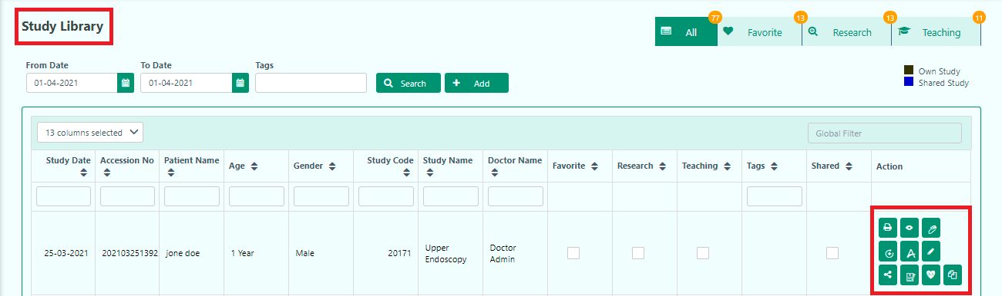

In this section, the user can
- View Report
- View Schedule
- View Preparation Data
- View Recovery Data
- PACS(PICTURE ARCHIVING & COMMUNICATION SYSTEM)
- Edit
- Share
- Resource Allocation
- Vital Sign
- Study Files

Capture Settings
The user can set the capture settings in the Capture Settings Entry. The user has to select Study, Time, Capture Type. When the user clicks None, it won’t take any captured file. The Pre capture image from the starting portion of the video. It will capture the first 2 seconds of the video image. The Post captures an image from the ending portion of the video. It will capture the first 2 seconds of the video image. Both capture images from both portions of the video. It will capture the first 6 seconds of the video image.

The user can also update or reset the data of the capture settings.
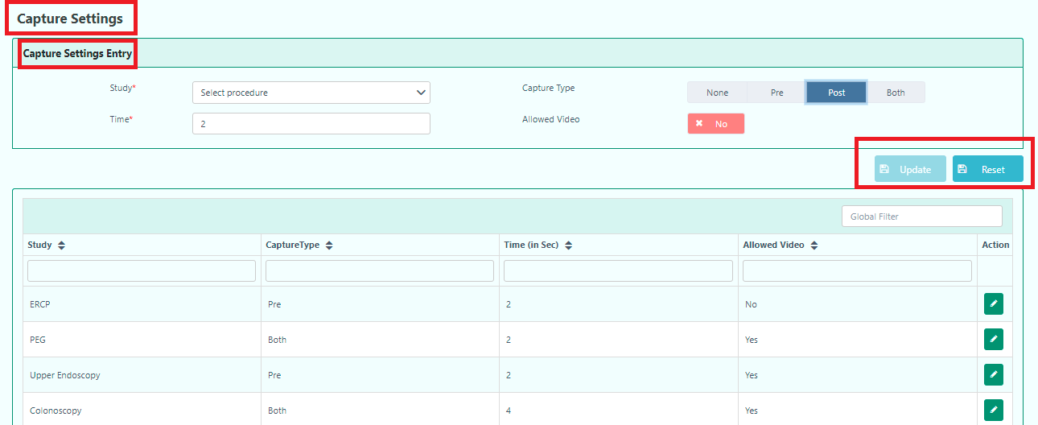

Study Management
The user will get study lists from the Study Management. They can see the details of the Study management and can Active/Inactive the study management from the Study Lists.

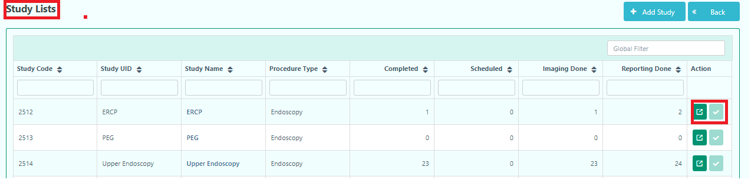

To add a new study, the user has to click the Add Study button. This action will take to Study Registration pop-up form.

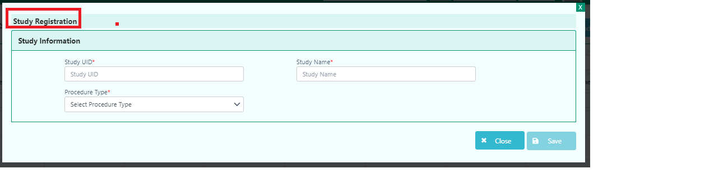
Mandatory fields are highlighted in red*

Support Ticket Lists

When the user faces problems, they can take help from the Support.
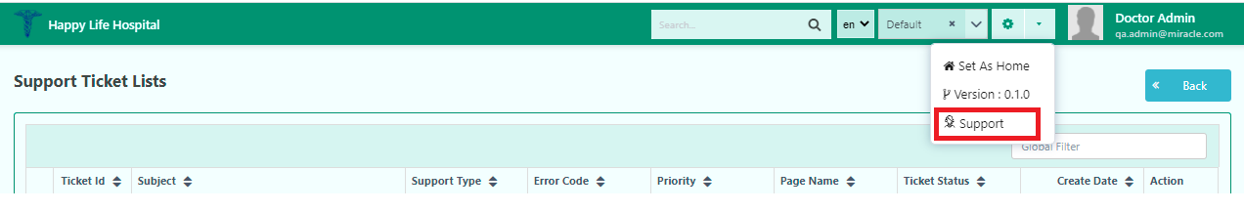
They will find those support at the Support Ticket Lists.
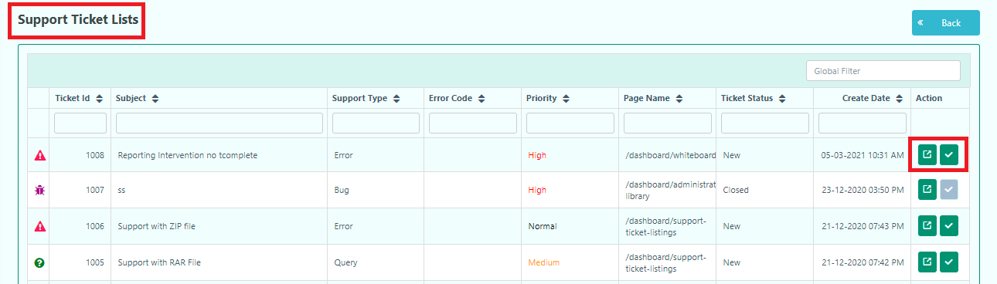

The user can see the details of the tickets. They can also Active/Inactive the tickets from the Support ticket Lists.
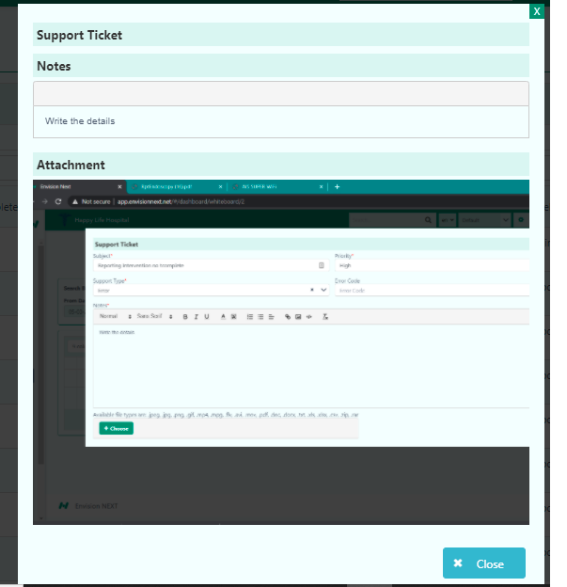

Locked Reports
The user can not access other user’s reports. However, the admin can unlock the report by clicking on the Unlock button. It will help the other user to access that report.
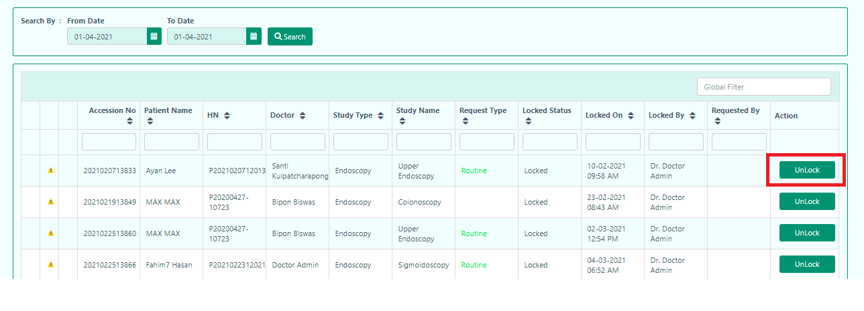

Examination Team

Here, the user can add an examination team. The user can add a team, edit, inactive, and delete an examination team from this option.
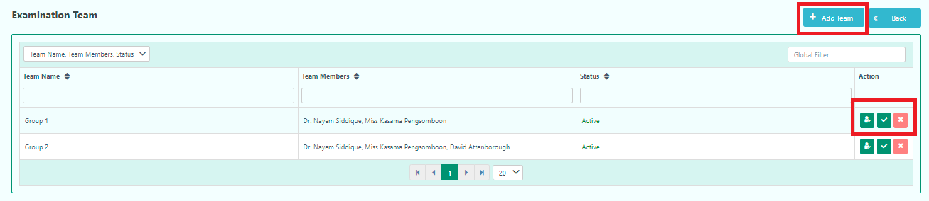

The user can Add a team by clicking on the Add Team button.

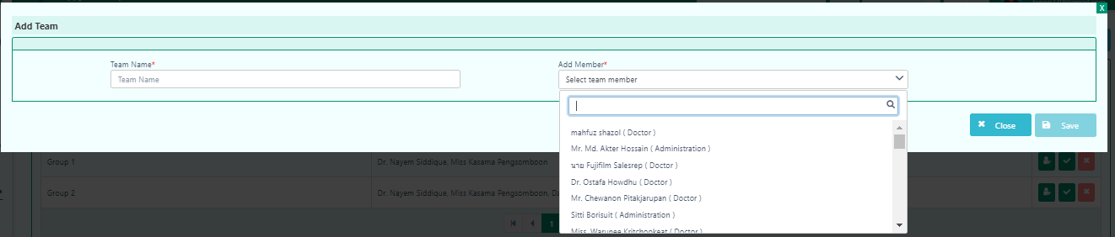

Mandatory fields are highlighted in red*

PACS Worklist

The user can configure PACS(PICTURE ARCHIVING & COMMUNICATION SYSTEM) and see the details of the patient regarding PACS settings.
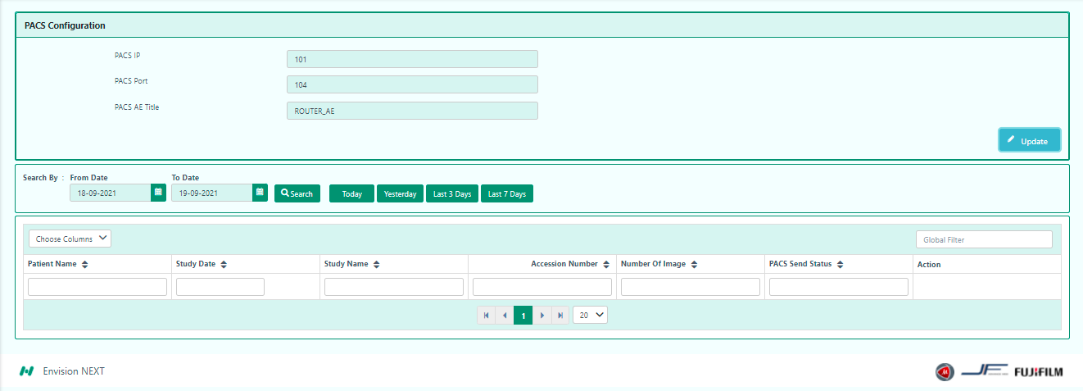

Consumable Item

The user can add consumable item from this settings. They can also add new consumable item by clicking Add Item.
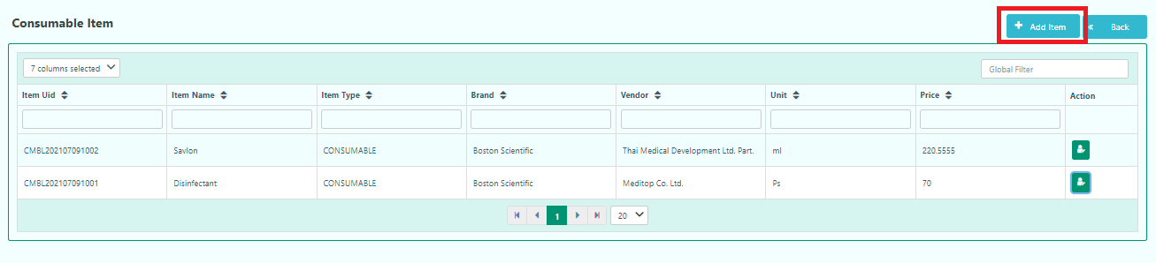

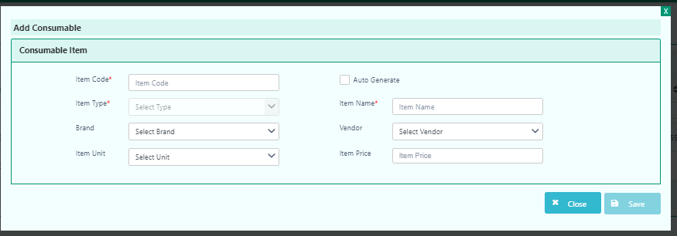
Mandatory fields are highlighted in red*

The user can also add consumable item from Imaging, and Reporting.
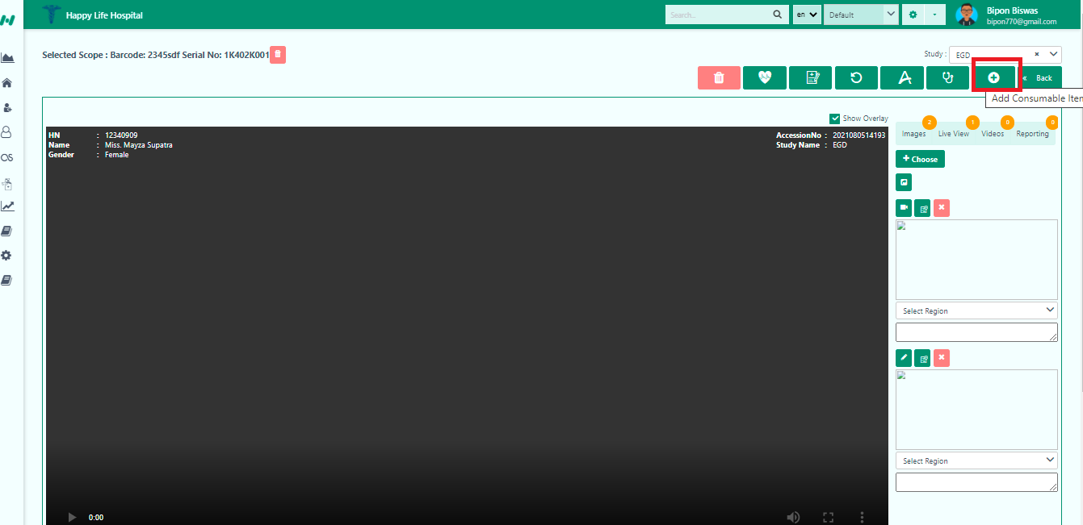

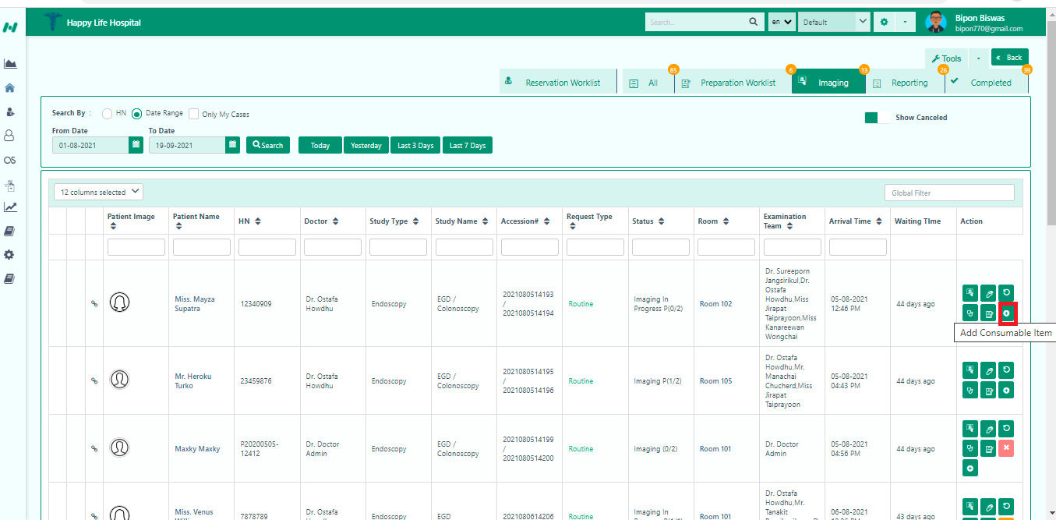

Patient List
The user can check the patient lists from here. They can Active/Inactive, Delete and Add to blacklist from this patient list.

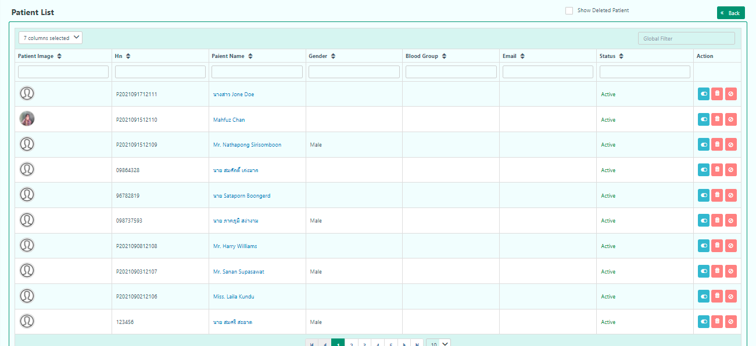

Moreover, they can also see the deleted patient by simply clicking in the Show Deleted Patient.

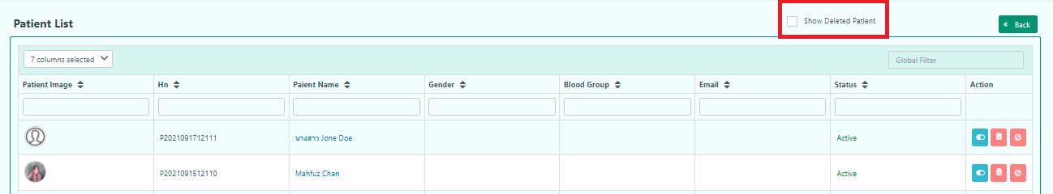

Dynamic Dashboard

The user can see the daily update from this dashboard. They can know about the Recovery Room, Arrival Worklist, Imaging Worklist.

Add Post
Here, the user can post content regarding health.

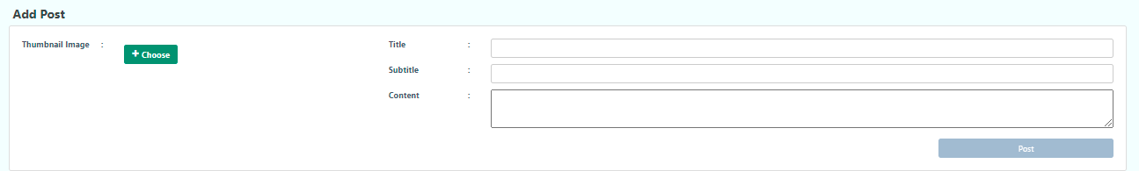
The user can add a thumbnail image, title of the content, subtitle and main content.

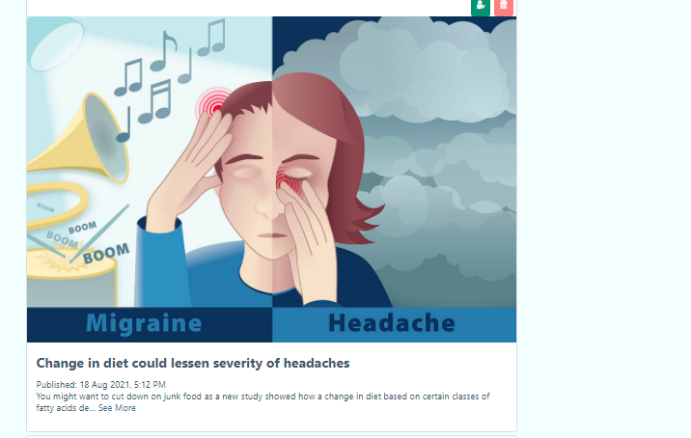

Calendar Settings

The user can customize the calendar with-
- User Experience
- Add holiday/Block Room
- Calendar Cell Color Setup
- Calendar Event Color Setup

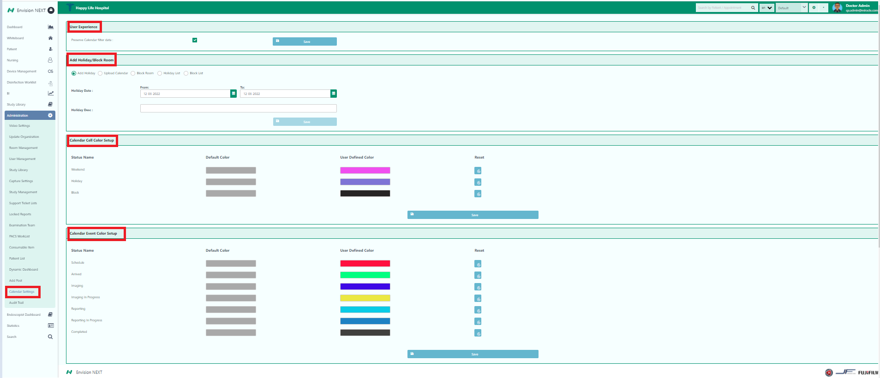

Example-
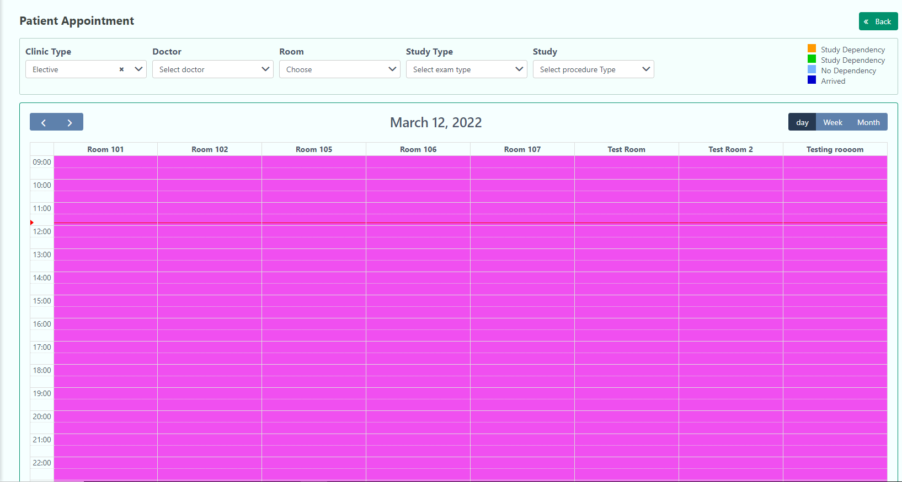
Weekend

Audit Trail

In this section, the user can know the details of usage of this application.

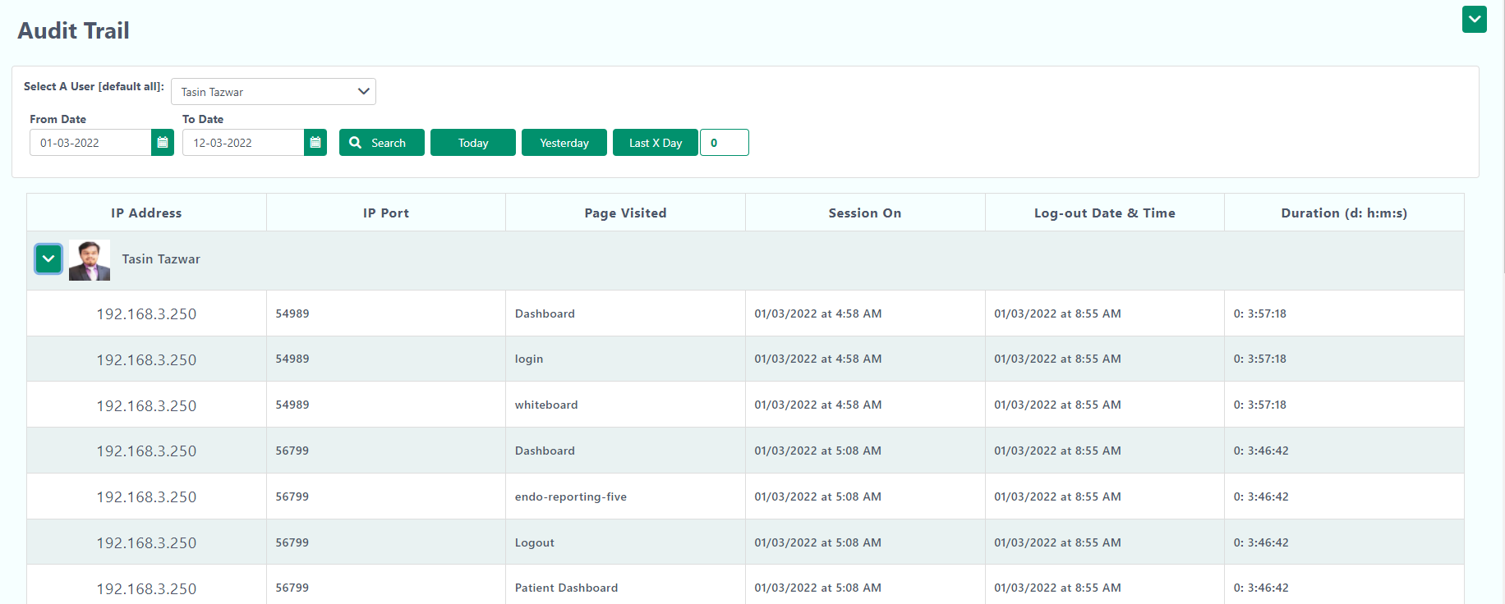

The above right corner, the user can view the data visually by clicking this  button.

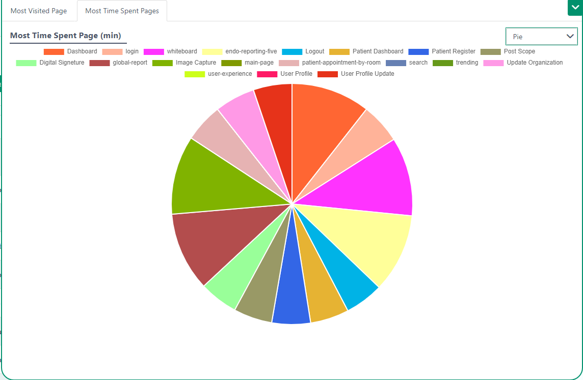

Endoscopist Dashboard

In this section, the user will find the details of the endoscopy of a patient.

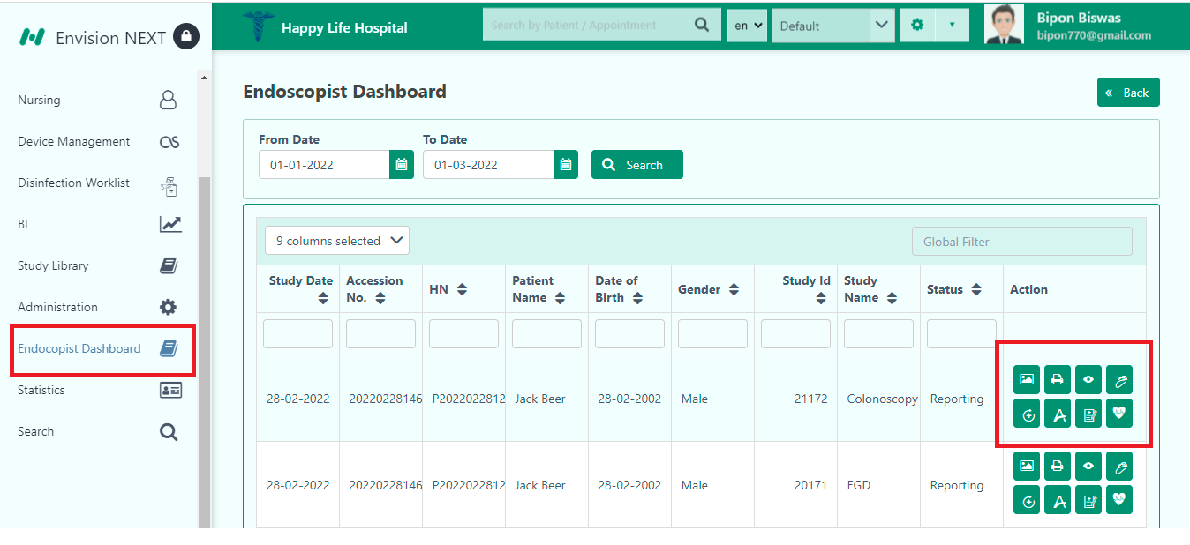

The user can operate the dashboard by clicking these buttons.
- Study Image
- View Report
- View Schedule
- View Preparation Data
- View Recovery Data
- PACS
- Resources
- Vital Sign

Study Image- The user can view the images of the study. They can also download the selected files or can download all files from here.
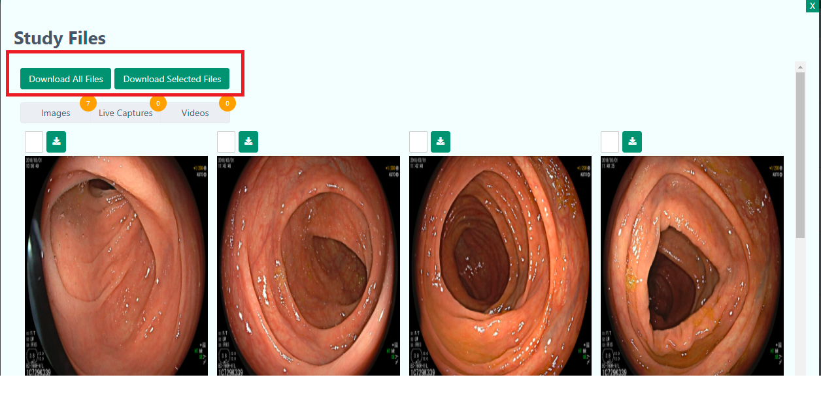
View Report

The user can view the report of the patient by clicking this button.

View Schedule

The user can view the patient appointment and study details from here.
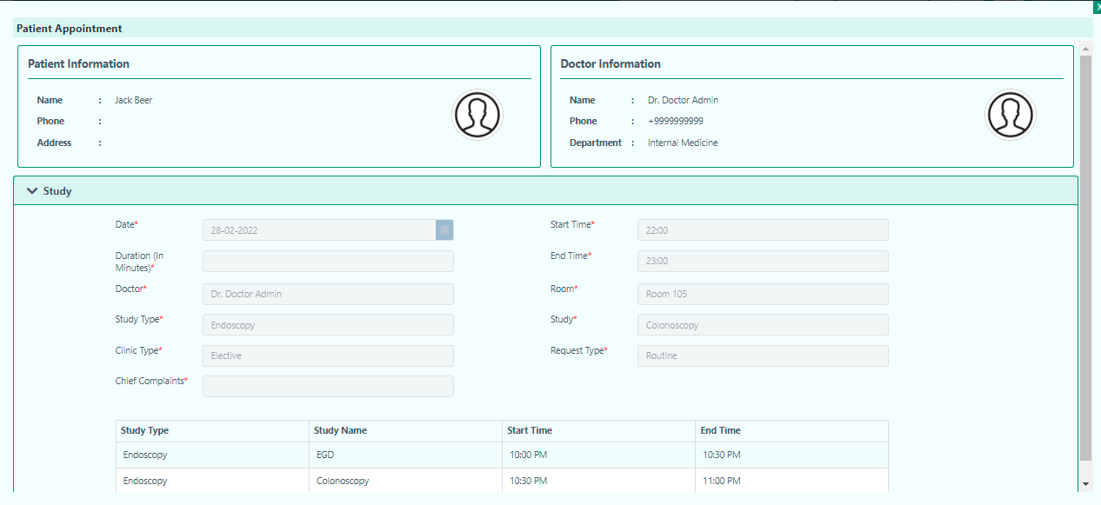

View Preparation Data

The user can view preparation data from here.

View Recovery Data
The user can view the recovery data by clicking this button. It will redirect to the Post Scope page.

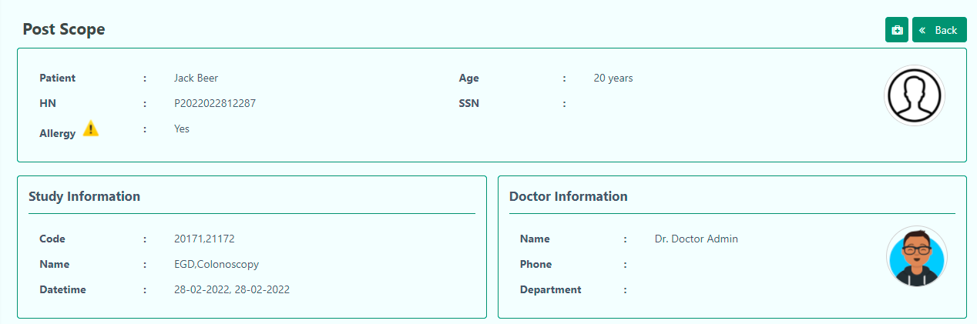

The user can also add consumable items from the Post Scope page.
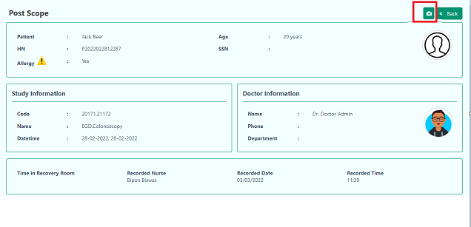

PACS(PICTURE ARCHIVING & COMMUNICATION SYSTEM)

PACS is a web-based archiving and communication system that improves an imaging centre's productivity and profits by offering correct patient care. ENVISION NEXT PACS is used to assist hospitals in the capture, management, storage, and viewing of diagnostic images. Following the scan, diagnostic pictures are generated from modalities and transferred to PACS in electronic form. After receiving diagnostic pictures via PACS, technologists can verify the following imaging with the operations done. After reviewing and validating the images, radiologists can begin reading them and making diagnoses.

Resource Allocation

The user can view endoscopy preparation from here which includes- examination team, scope list, and endoscopy machine.

Vital Sign

The user can add vital signs from here.
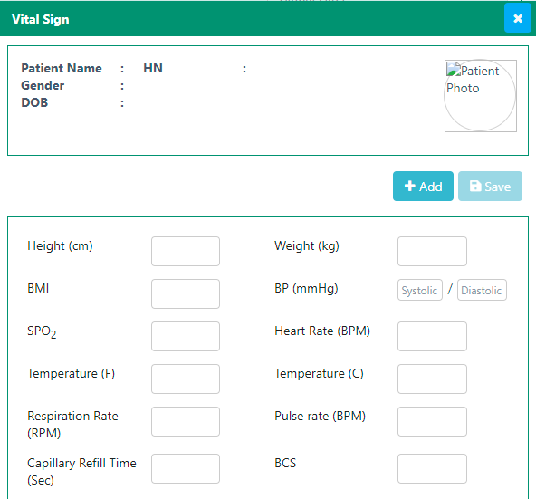

Statistics

The user can view all reports from Reports dropdown.

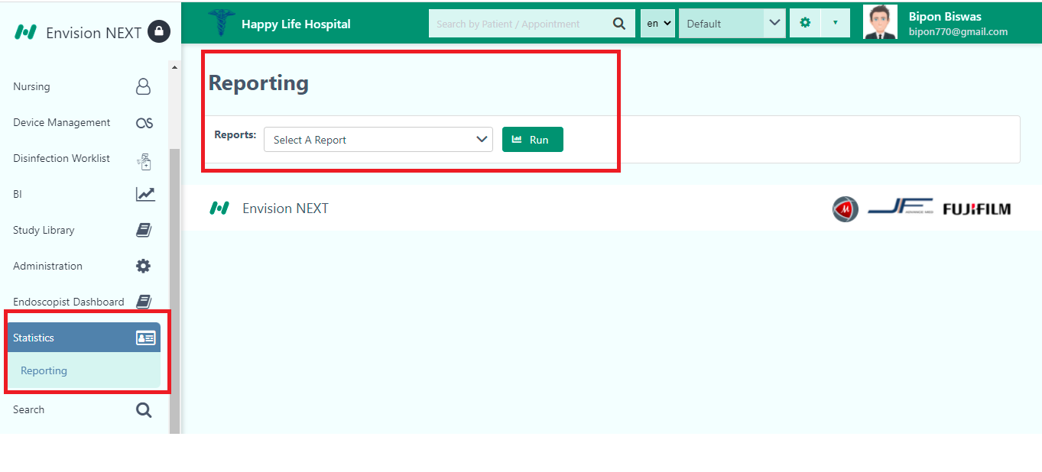
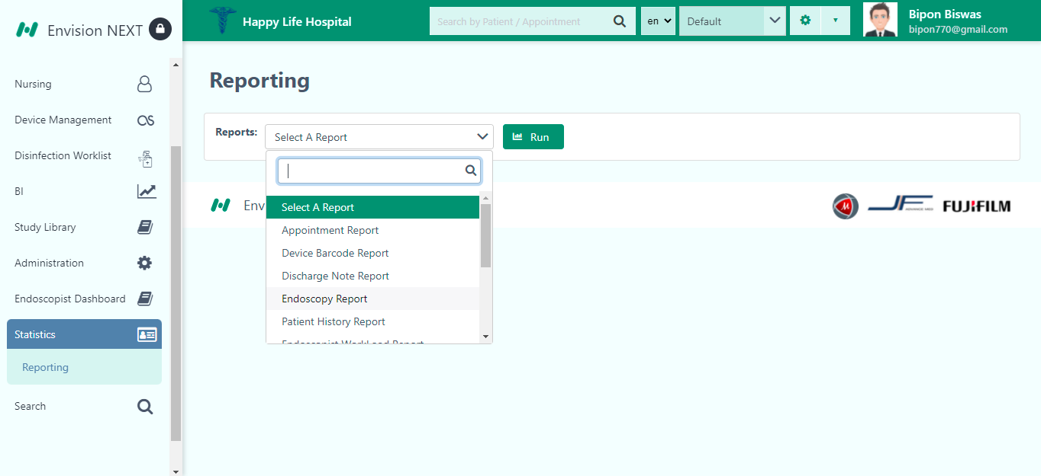

Search

The user can search anything regarding study from here.
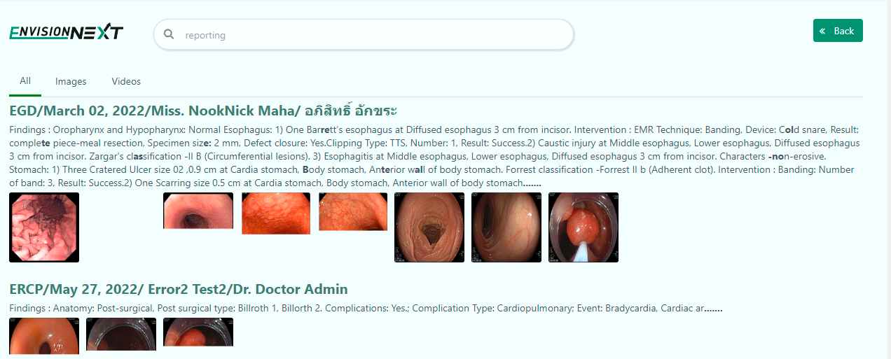
They can also search images from here only.
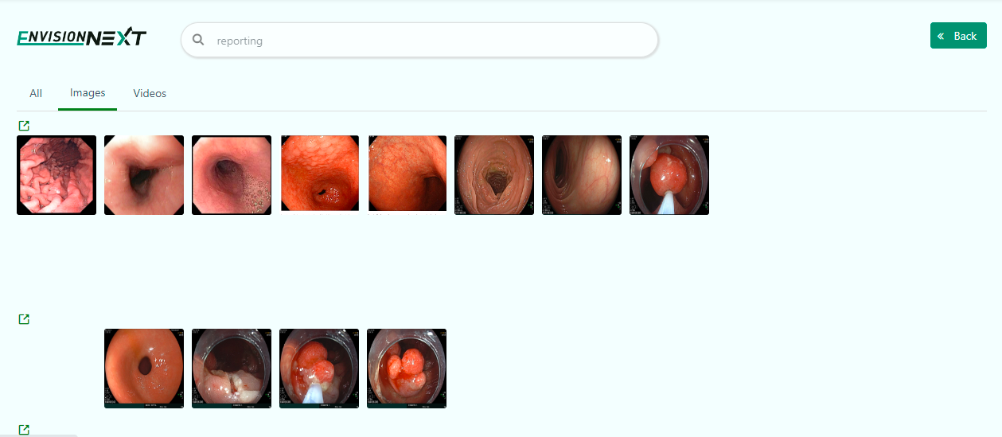

Finally, they can also find video contents from advance search.
